Fiction
Here is where you can find all of our chapter books! Books like Harry Potter, Diary of a Wimpy Kid, Hunger Games, and much, much more!
Each book has an AR (Accelerated Reader) score on the spine.
Top number : Book’s reading level
Bottom number : the points for the book’s quiz
AR
5.5
6 pts

Unscramble the words!
ansfyta ____________
oarncme ____________
eeccnis citifon ____________
aedvnetur ____________
iorlshaitc citifon ____________
ysrmyte ____________
Word Bank:
Mystery Adventure Romance HistoricalFiction ScienceFiction Fantasy

Question: What is your favorite book? (Write this on your map)

Monthly Genre and National Month
Here is where I display books about different topics for the month.
One side is about genres, or different types of books
The other side is about the National Month, which is the subject that is celebrated for that whole month.

Genres
Action, Adventure, Comedy, Mystery, Fantasy, Historical fiction, Horror, Romance, Science fiction, Thriller, Western
National Months
National back to school month, Hispanic Heritage month, Black History Month, National Writing Month, Women’s History Month

Question: What is your favorite season? (Put this on your map)

Topic of the Week
Here you can find books and information about a unique topic every week!
Also you can put a topic into the suggestion box!

Trivia Questions
- What is the name of the fat orange cat that loves lasagna?
_______________________________________________
- What do you call a kitten that does somersaults in the air?
_______________________________________________
- Write three facts about WildCat, the robot cat.
_______________________________________________
- Name 5 cat characters in books.
_______________________________________________
- Why do cats hate water?
_______________________________________________

Question : Tell me something you’d like to know more about! (Put this on your map)
Library Computers
The library has a few computers that you can use for research, AR tests, and looking up books.
Here are a few rules for using the computers.
- The computers ______ for school or ____________ only
- Please be ____________ of other ___________ using the computers
- No games
- Use only appropriate __________
- No _______ or drink.
- Please ask Mrs. ______ if you have any ___________!
Word Bank
questions Classwork websites food Endo respectful students are

Question: What pets do you have? (Put this on your map)
Non-Fiction

This section has all of the books based on fact! There are books in many categories including biography, business, cooking, health and fitness, pets, crafts, home decorating, languages, travel, home improvement, religion, art and music, history, self-help, true crime, science and humor.
These books are sorted by number which decided by what topic they are about. Match the numbers below to their topic.

000 Science
100 History and Geography
200 Technology
300 Arts and Recreation
400 Literature
500 Computer Science and Information
600 Religion
700 Social Studies
800 Language
900 Philosophy and Psychology
Question: What is your favorite subject? (Put this on your map)
Autobiography and Biography

7 19 22 8 22 / 26 9 22 / 25 12 12 16 8 / 4 9 18 7 7 22 13 / 26 25 12 6 7 /
21 26 14 12 6 8 / 11 22 12 11 15 22 / 12 9 / 18 13 21 15 6 22 13 7 18 26 15 /
11 22 12 11 15 22 / 7 19 9 12 6 20 19 12 6 7 / 19 18 8 7 12 9 2.
25 18 12 20 9 26 11 19 2 / 18 8 / 26 13 / 26 24 24 12 6 13 7 / 12 21 /
8 12 14 22 12 13 22 ' 8 / 15 18 21 22 / 4 9 18 7 7 22 13 / 25 2 /
8 12 14 22 12 13 22 / 22 15 8 22.
26 6 7 12 25 18 12 20 9 26 11 19 2 / 18 8 / 26 13 / 26 24 24 12 6 13 7 / 12 21 / 26
/ 11 22 9 8 12 13 ' 8 / 15 18 21 22 / 4 9 18 7 7 22 13 / 25 2 / 7 19 26 7 /
11 22 9 8 12 13.
A=26
Question : Who is your favorite singer or actor? (Put this on your map)
Sora
What is Sora?
Sora is a digital resource for books and audiobooks. All you need is your gmail login information and you can start checking out books! You can also access other libraries if you have a library card for them!
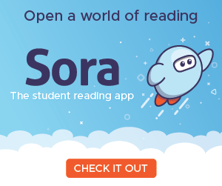
Follow the directions on the pole or ask Mrs. Endo if you have any questions.

Question: Tell me a book you would like to read on Sora. (Put this on your map)
Checking Out and Rules
You can check out anything you want: Books, Graphic Novels, Non-fiction books, etc. When you want to check out, bring the book to the Librarian, Mrs. Endo.
You can check 3 books at a time
You can check out the book for 3 weeks
You can renew as many times as you need to
Every day the book is overdue, it is 10 cents a day to a max of $5.00
If you lose the book, you have the pay to replace it
Please be gentle with the books
Please return the books to Mrs. Endo or into the Library Book Drop
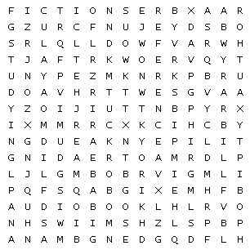
adventure | audiobook | author
biography | fiction | Graphic novel
librarian | library | overdue
reading | reference | studying
Question: What is the librarian’s name? (Put this on your map)
Reference
Here you can find books about almost every topic and can learn lots about different things. This section is good to help with research or just to learn cool facts to tell your friends.
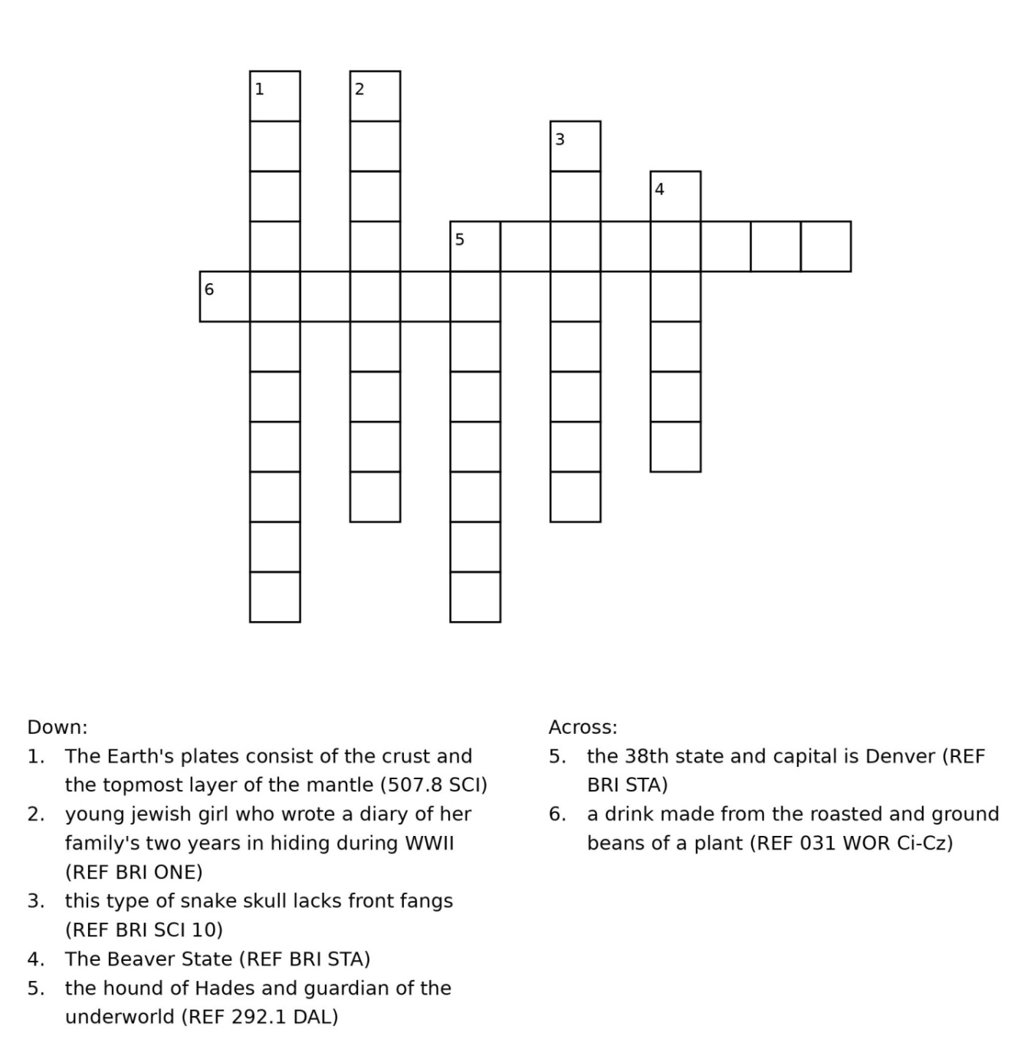
Question: Use the books to learn a fact about birds. (Put this on your map)
Graphic Novels
These are novels that use pictures and images as well as text to help tell a story.
Graphic novels can be new stories, but they can also be adaptations of novels or classic stories.
Match the Call number to the title of the book

GN B LEE The Silver Six
GN SCI ECO The Challenger Disaster
GN HIS NAU Lumberjanes
GN F EME The Boy Who Became a Dragon
GN HA Exploring Ecosystems with MaxAtom
GN KIM Brain Camp
GN F LIE Zebrafish
GN F STE Almost American Girl

Question : What is your favorite color? (Put this on your map)

