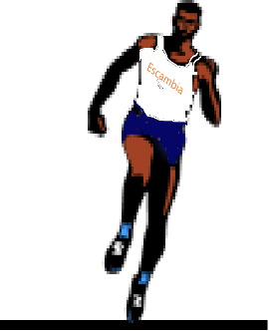
2025
EHS
TRaCK & FieLD SCHeDuLe

Date | Opponents | Place | Time
2/8(Sat) | Preseason Inv. | Pine Forest | TBA
2/14(Fri) | Andrews Inv. | Gulf Breeze | TBA
2/22(Sat) | Aggie Inv. | Pine Forest | TBA
2/25(Tues) | Milton/Gulf Breeze | Milton | 4:00pm
3/1(Sat) | Running Wild Inv. | Pine Forest | TBA
3/4(Tues) | Pine Forest | Pine Forest | 4:00pm
3/8(Sat) | Viking Relays | Ft. Walton | TBA
3/15(Sat) | Wildcat Inv. | Washington | TBA
3/21(Fri) | Spring Break Inv.# | Pine Forest | TBA
3/25(Tues) | Pine Forest | Pine Forest | 4:00pm
3/28-29(Fri-Sat) | FSU Relays* | Tallahassee | TBA
3/29(Sat) | Golden Elite Freshman/Sophomore** | Washington | TBA
4/4(Fri) | Mobile Challenge of Champions* | UMS-Wright  Mobile, Al. | TBA
4/5(Sat) | Smokey’s BBQ Inv. | Pine Forest | TBA
4/5(Sat) | Meet of Champions* | St. Paul's Episcopal  Mobile, Al. | TBA
4/8(Tues) | Pine Forest | Pine Forest | 4:00pm
4/11(Fri) | Esc. Co. Championship | Pine Forest | TBA
4/17(Thurs) | District Meet | Pine Forest | TBA
5/2(Fri) | Regional Meet | Pine Forest | TBA
5/9(Fri) | State Meet | UNF, Jacksonville | TBA

# During Spring Break
*Individual Invite Only
**Freshmen & Sophomores Only

