My warmest thanks to the MES Administration, the Manasquan BOE, Cathy King, Kelly Gale, Donna White, Sam, Don, Harry, Mary, and EVERYONE who has helped bring this show to life.

“ The people you love will change you” My personal love and thanks to my incredibly family who is there to help every step of the way without a second thought.

ABOUT MOANA
Moana is a celebration of the rich stories of Oceania and is based on the beliefs and cultures of real people. In creating the original film, the producers at Disney Animation formed an Oceanic Trust. This group of anthropologists, cultural practitioners, historians, linguists, and choreographers from islands including Samoa, Tahiti, Mo’orea, and Fiji was integral in the creation of the film, providing feedback and notes on character design, song lyrics, and the depiction of culture onscreen. This respect and careful attention to detail was carried forward in the creation of Moana JR. for the stage. Each production of the show is supplied with a Director’s Guide, a Pronunciation Guide, and Choreography Video demonstrations, providing information, research, and best practices for respectfully celebrating Oceanic culture.

Disney’s Moana JR. is presented through special arrangement with
and all authorized materials are supplied by
Music Theatre International, New York, NY
(212) 541-4684 mtishows.com
MES Drama Club’s
production of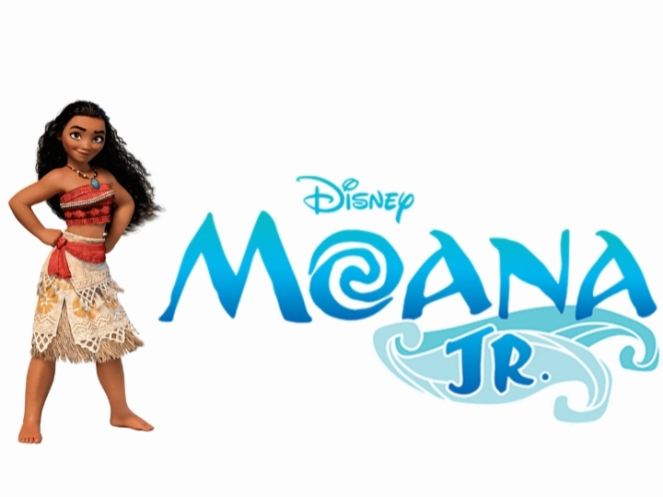

Music and Lyrics by
Lin-Manuel Miranda, Opetaia Foa‘i & Mark Mancina

Book Adapted by
Susan Soon He Stanton

Music and Orchestrations Adapted and Arranged by
Ian Weinberger

Based on the 2016 Disney film Moana

SCENES & MUSICAL NUMBERS

Scene 1: Prologue

In the Beginning… Ancestors

Tulou Tagaloa Ocean

Scene 2: The Shore/The Village

Where You Are Chief Tui, Sina, Moana, Hei Hei, Pua,

Gramma Tala, Villagers

Scene 3: The Village

Scene 4: The Shore

How Far I’ll Go Moana, Pua, Hei Hei, Ocean

We Know the Way Ancestors

Where You Are (Reprise) Gramma Tala

How Far I’ll Go (Reprise) Moana, Chief Ancestors, Ocean

Scene 5: Maui’s Island

You’re Welcome Maui, Maui Ensemble

Scene 6: Canoe at Sea

Warrior Face (Parts 1 & 2) Maui, Moana

Scene 7: Lalotai

Warrior Face (Part 3) Maui, Moana, Gate Monster, Monsters

Scene 8: Tamatoa’s Lair

Shiny Tamatoa, Left Claw, Right Claw, Shiny Ensemble

Scene 9: Canoe at Sea

Warrior Face (Reprise)/Logo Te Pate Moana, Maui, Ocean

Scene 10: Canoe at Sea, Near Te Kā

Song of the Ancestors Gramma Tala, Moana, Ancestors

Know Who You Are Moana, Ocean

Te Fiti Restored Ocean

Tulou Tagaloa (Reprise) Ocean

Scene 11: Motunui Shore

We Know the Way (Finale) Moana, Chief Tui, Sina, Pua, Hei Hei,

Ancestors, Villagers, Ocean

Bows Company

CAST

(in order of appearance)

Chief Ancestors Mia Valgenti, Ruby O’Brien, Carina Martell
Moana Ryleigh Luethold
Chief Tui Sam Edwards
Sina Briana Garcia
Hei Hei Mackenzie Heim
Pua Kettler Robinson
Gramma Tala Maeve Korth
Maui Liam Pollock
Tamatoa Zoe DeLuc
Te Kā / Te Fiti Sam Stewart

PRODUCTION TEAM

Director Krissy Sliwoski
Lighting Designer Abby Ziroli, Charlotte Dery
Stage Manager Dori Donadeo
Asst Stage Managers Jackie Stewart, Grace Buckley
Jr Stage Managers Megan Spears, Molly McCarthy
Sound Director……………………………………….Concept Professionals
Sound Manager………………………………………….……….Chloe Stevens
Asst Sound Managers………………...Carys Devine, Teagan Paradise
Spotlights……….Fernanda Morales, Cindy Garcia, Tess Gennarelli
Boat Technician………………..………….MJ Femenella, Grace Buckley
Water………………………………………….Ella McCarthy, Megan Spears
Stage Crew………...Sarah Gonzalez, Amelia Steger, Sophia Tignini, Lizzet Cordero-Lopez, Sarah Furlong Leonard
Set Construction…………………………………………………Evan Sliwoski
Under Study………………………………………Dave “The Rave” Seeley

