**Pregnancy**

**Grades 4-6, Lesson #13**

# Time Needed

30-50 minutes

**Student Learning Objectives**

To be able to...

1. Describe the process of human reproduction.

**Agenda**

1. Explain lesson's purpose.
2. Answer “Anonymous Question Box.”
3. Use the *Reproductive System Visuals* from Day 1 as needed to assist in explaining the process of conception.
4. Use *Pregnancy Visual* to assist in defining key terms.
5. Explain the role of chromosomes in pregnancy.
6. List pregnancy symptoms and discuss pregnancy tests.

This lesson was most recently edited November 2021.

# Materials Needed

**Classroom Materials:**

* *Pregnancy Visual*
* *Reproductive System Visual* from Reproductive System Day 1 lesson

# Student Materials: (for each student)

* *Pregnancy Worksheet*

# Activity

1. **Explain the lesson’s purpose.**

Explain that today's lesson will help students understand better how pregnancies develop, from a sperm and an egg to the day a baby is born.

1. **Answer "Anonymous Question Box" questions about pregnancy.**
2. **Use the *Reproductive System Visuals* from Day 1 as needed to assist in explaining the process of conception.**

*Pregnancy happens when a sperm cell and an egg cell join together. This is called* fertilization. A common way that people get pregnant is by having vaginal sex, which is the penis inside the vagina, without using a condom or other kind of birth control. During vaginal sex, sperm leave the penis in a fluid called semen. When the semen leaves the penis, it is called ejaculation. If ejaculation happens during vaginal sex, sperm can swim up into the uterus and fallopian tubes, and fertilization can happen in the fallopian tubes.

*There are other ways that people sometimes get pregnant. One way is for sperm cells to be* placed inside the vagina or uterus so they can meet an egg cell and fertilization can happen. Another way is for egg and sperm cells to meet and for the egg to become fertilized in a laboratory; then a doctor puts the fertilized egg in a person’s uterus.

*After the egg is fertilized, it will take a week or so to finish traveling down the fallopian tube* into the uterus, where it will try to attach to the wall of the uterus. That’s called ***implantation****.* Sometimes fertilized eggs are able to implant, and sometimes they are not. If it does, this is called ***conception****, and it is the beginning of a pregnancy.*

*Of course, pregnancy is only one way people start a family. Another way people choose to* make a family is through adoption. Adoption is when one person is pregnant and gives birth to a baby, but they aren’t able to raise that child themselves. In that circumstance, another person or couple will adopt the child.

*Sometimes a person chooses to be pregnant for someone else who can’t become pregnant,* which is called being a surrogate. In that circumstance people make an agreement ahead of time that one person will be pregnant, but that the other person or couple will be the parents of that child. Finally, children often live with and are raised by grandparents or other family members. It’s nice to know that there are so many ways to make a family.

1. **Use the *Pregnancy Visual* to assist while explaining the following terms:**
   * **Fetus –** the name for the developing pregnancy while it is still in the **uterus**.
   * **Placenta -** an organ that the body grows to use only during pregnancy, to provide nutrients to the developing pregnancy and help filter out anything dangerous.
   * **Umbilical cord –** connects the developing pregnancy to the **placenta** to bring nutrients.
   * **Vaginal birth –** one way that babies are born. The baby comes out of the **uterus**, through the **cervix** and out of the body through the **vagina**. Notice that the **stomach** and the **uterus** are two separate organs. The fetus is never in the stomach.
   * **Cesarean section –** another way that babies are born. The doctor makes a cut from the outside of the person’s body, through the abdomen and **uterus**, and takes the baby out.
   * **Identical twins –** when one fertilized egg divides into two, and two pregnancies start from one egg and sperm. These pregnancies grow in the **uterus** at the same time, and these two siblings will look like each other.
   * **Fraternal twins** – when the ovaries released more than one egg, and two eggs are fertilized at the same time, but each by different sperm. The pregnancies grow in the **uterus** together, but they are no more alike than any two siblings.
2. **Explain the role of chromosomes in pregnancy.**

It may help to draw this out on the board as you explain.

*Every cell in the human body has a pair of chromosomes that help determine a person’s* assigned sex – whether the doctor says someone is a boy or a girl when they are born. Egg and sperm cells only have half the chromosomes of other cells. Most egg cells have an X chromosome. Sperm cells usually have either an X or Y chromosome. When an egg joins a sperm with a Y chromosome, the newly formed cell usually has XY chromosomes and will have a male assigned sex. When an egg joins a sperm with an X chromosome, the newly formed cell usually has XX chromosomes and will have a female assigned sex.

*Intersex is the word for the many natural differences in genitals or chromosomes (such as* XO or XXX or XXY) compared to the more frequent ways that most bodies develop. When a baby is intersex, the doctor and parents may assign the baby’s sex as male or female, depending on the appearance of their genitals, or the parents may decide not to assign any sex to the baby until the child is older. Being intersex is a natural part of human diversity.

*One in every 2000 babies are born intersex, about twice as many as identical twins.*

# Explain how a person would know they were pregnant (symptoms, pregnancy test).

Describe how people obtain a pregnancy test at a drug store as well as reputable clinics that offer pregnancy tests and options counseling in your community.

**Homework:**

Students’ options:

* Family homework: Are there important things about pregnancy you want to make sure I know?
* Individual homework: Giving birth is one way that people start a family. What is another way?

**Pregnancy Visual**

**NAME DATE**

DIRECTIONS: Fill in the chart using the following terms:

fetus placenta umbilical cord stomach uterus

cervix vagina

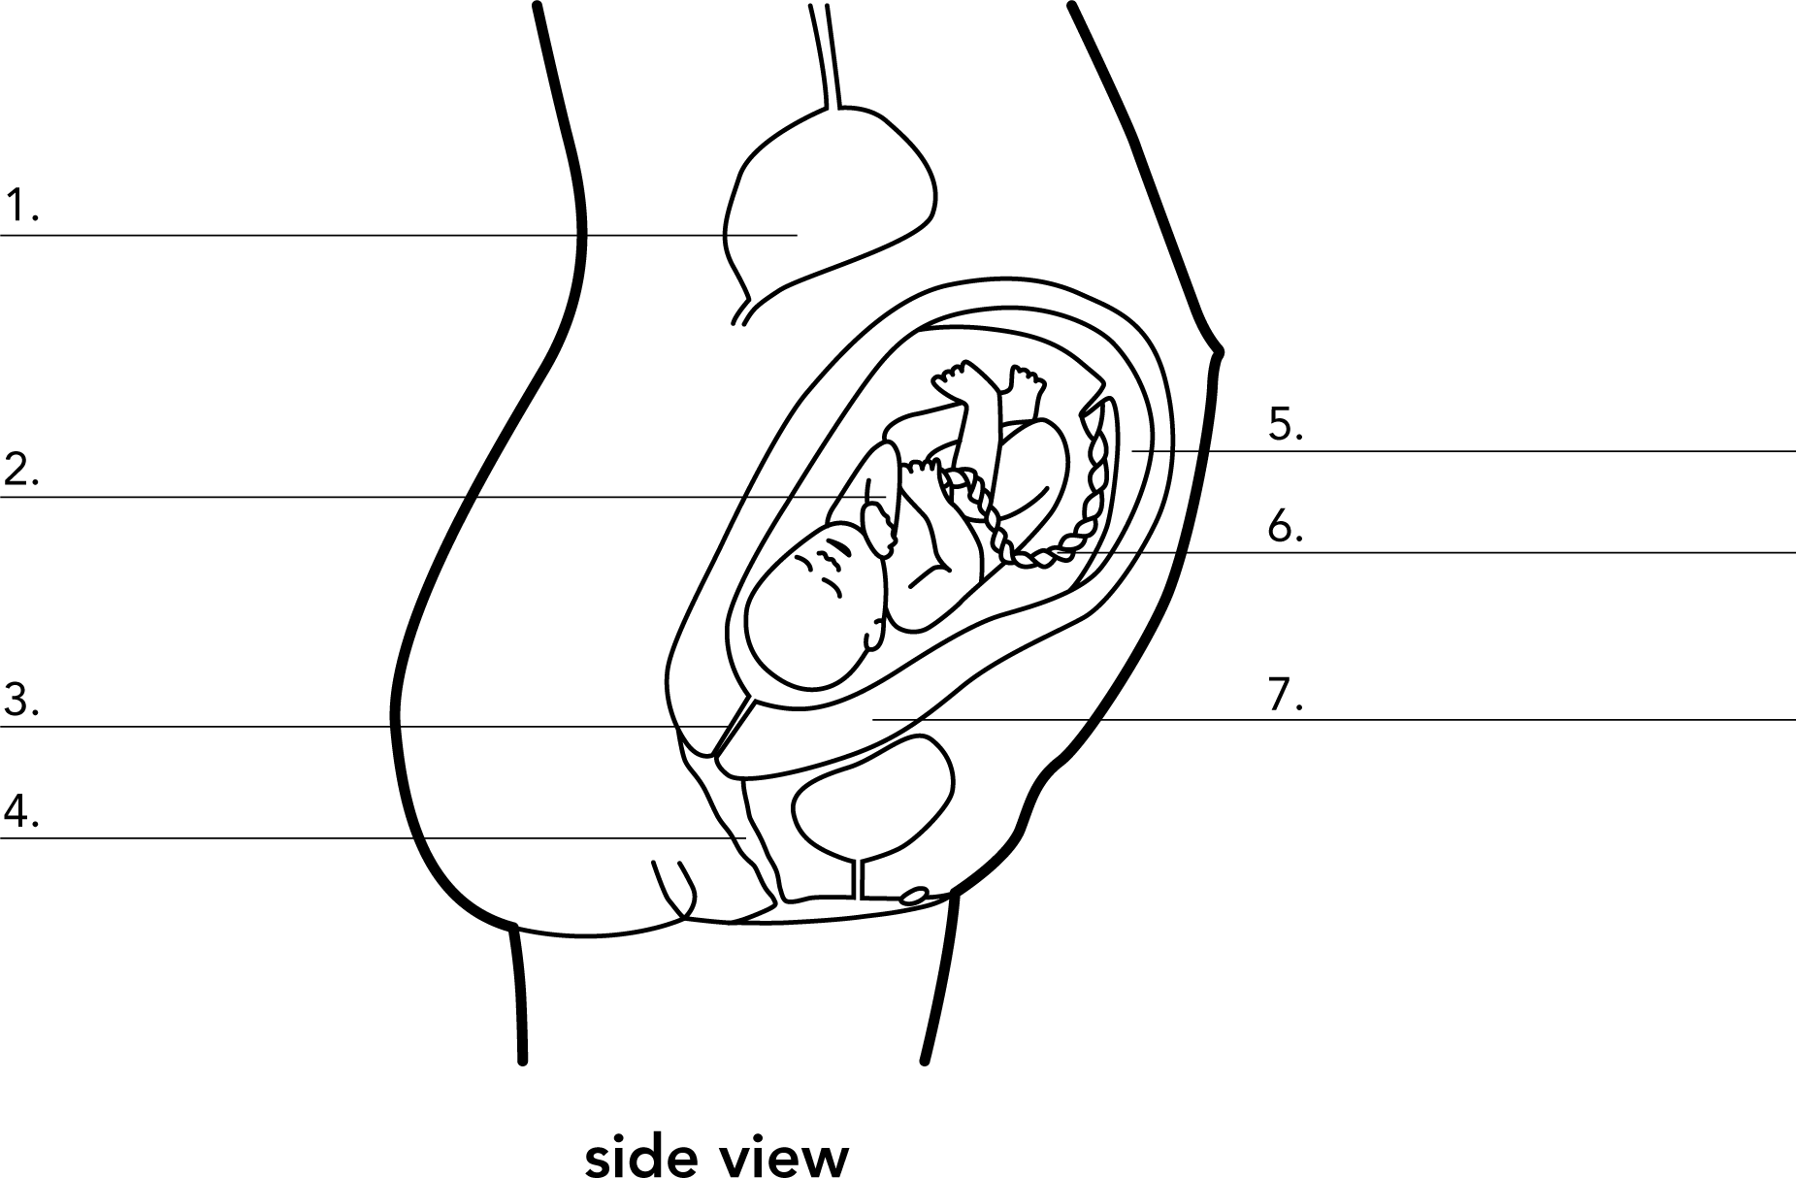

**Pregnancy Visual – Answer Key**

**NAME DATE**

DIRECTIONS: Fill in the chart using the following terms:

fetus placenta umbilical cord stomach uterus

cervix vagina

