**Reproductive System, day 1**

**Grades 4-6, Lesson #9**

# Time Needed

50-75 minutes

**Student Learning Objectives**

To be able to …

1. Label medically accurate names for parts of the reproductive system.
2. Understand reproductive organs allow humans to reproduce.

**Agenda**

1. Discuss purpose of lesson.
2. Use visuals to describe names, purposes, and locations of reproductive organs.
3. Give class a preview of tomorrow’s lesson.

This lesson was most recently edited November 2021.

# Materials Needed

**Classroom Materials:**

* *Reproductive System Visuals 1 – 4*
* Overhead projector

**Student Materials: (for each student)**

* *Reproductive System Worksheets 1 – 4* (2 sides, back-to-back)

# FLASH Key Concepts

The reproductive systems of all genders have many similarities.

People’s bodies can look very different from each other. These differences are normal and healthy.

**Activity**

1. **Explain the purpose of the lesson.**

Explain that you are doing this unit so that students will have correct information about bodies, including parts of the reproductive system. Help students understand that the drawings used in this lesson do not represent all people’s bodies

*The information about the reproductive system that we will learn today is important, just like* learning about all the other body parts and systems, so that students understand how bodies work and are prepared to discuss bodies and the parts of reproductive system respectfully with anyone they need to talk with.

*These drawings show pictures of what many people’s bodies look like, but people’s bodies* can actually look very different from each other. For example, if someone hasn’t gone through puberty yet, if they are intersex, or if they have a disability, their body might look different from these drawings. Surgery or medicine can also change the way someone’s body looks, and of course, the size and shape of everyone’s body is different. All of these differences are normal and healthy.

# Describe names, purposes, and locations of reproductive organs.

Project the worksheets to use as a visual while describing the name and function of the reproductive organs and hand out blank copies to students. Write the names in as you go, and have students do the same on their copies. Each of the words below in bold are parts listed on the worksheet/visual. Their corresponding number is provided in parentheses in the script to assist you in labeling the drawing as you are teaching. Remind students that many people’s bodies look like the pictures you are about to show, but that people’s bodies can look very different from each other. These differences are normal and healthy.

**Worksheet/Visual 1** (side view)

*This is a picture of the reproductive organs that are on the inside of someone’s body. These* are the parts that men usually have in their bodies. There are two parts on the outside. Can anyone name them? That's right, ***penis (5)*** *and* ***scrotum (8)****. The job of the scrotum is to* hold the ***testicles (7)*** *at the proper temperature, lower than 98.6 degrees, for making sperm* cells. This is a little cooler than the temperature of the rest of the inside of the body. The scrotum will move toward or away from the body to keep the testicles at this lower temperature. Sperm are important for reproduction because sperm are needed to start a pregnancy.

*Who knows the testicles other job, besides producing sperm? They also start making the* hormone testosterone when a person’s body starts changing from a child’s to an adult’s.

*Sperm are made in the testicles and then move into the* ***epididymis (3)*** *which is a long tube* tightly coiled into the back of the scrotum. The sperm stay there for about two weeks while they mature.

*Then the sperm cells travel up into the body through a tube called a* ***vas deferens (4).*** *There are two, one leading from each epididymis. The sperm travel through the vas* deferens and past the ***bladder (1)****, where urine (pee) is stored. On the way, the sperm*

*gathers fluids from several glands. The fluids and the sperm mix together to create a liquid* called semen. Eventually the semen enters the tube that will carry it out of the body, the ***urethra (6).*** *The urethra is the tube that runs through the penis. The penis is sensitive and* sometimes it gets erect, which means it gets harder. The urethra in the penis has two jobs. One job is to let urine (pee) out. That is called urination. The other job is to let semen out. That is called ejaculation. Urine and semen never come out of the penis at the same time.

*The other opening you see here is the* ***anus (2)****, where a bowel movement (poop) comes* out. Even though the bladder and anus are nearby, they aren’t actually part of the reproductive system. They have nothing to do with making a baby.

***Worksheet/Visual 2*** (front view)

*These are the same parts we just looked at, but now looking from the front instead of the* side. Let’s see if we can work together to fill these out (review these with class):

* + ***Bladder (9)***
  + ***Penis (10)***
  + ***Urethra (11)***
  + ***Vas Deferens (12)***
  + ***Testicle (13)***

**Worksheet/Visual 3** (front view)

*This is also a picture of the reproductive organs that are on the inside of someone’s body.* These are the parts that women usually have in their bodies. The reproductive systems of all genders have many similarities. I will point some of them out as we discuss these drawings.

*The opening to the outside of the body is called the* ***vagina (5).*** *This is where period blood* comes out of the body and where a baby often comes out when someone gives birth. These are the ***ovaries (1)****, where eggs cells come from. Eggs are important for reproduction* because an egg cell is needed to start a pregnancy. The ovaries also start making the hormone estrogen when a person’s body begins changing from a child’s to an adult’s***.*** *Do* you remember what part we looked at on the other drawings that were similar? Right, the testicles. There are two ovaries and they sort of take turns ovulating, with one releasing an egg one month and, often, the other releasing one the next month. When an egg leaves an ovary, it usually goes into the ***fallopian tubes (3).*** *Do you remember two tubes on the other* drawing that looked like these, and performed a similar function? That’s right – the vas deferens carried sperm cells, just like the fallopian tubes carry egg cells.

*If an egg and a sperm meet, it could be the beginning of a pregnancy. But most of the time,* the egg just travels down the fallopian tubes through the ***uterus (4)*** *and out of the body.*

*Then, a few weeks later, the period blood that was in the uterus also comes out. The period* blood comes out of the uterus through the opening called the ***cervix (2)*** *and leaves the body* through the vagina.

***Worksheet/Visual 4*** (side view)

*These are the same parts we just looked at, but now looking from the side instead of the* front. Let’s see if we can work together to fill these out.

Already covered in *Worksheet/Visual 3* (review with class):

## *Ovary (6)*

* + - ***Uterus (7)***
    - ***Cervix (8)***
    - ***Vagina (9)***
    - ***Fallopian tube (12)***

*We already learned about the vagina. The other two openings here are the anus and the* urethra. Remember, the ***anus (10)*** *is where bowel movements (poop) come out, and the* ***urethra (15)*** *is where urine (pee) comes out. When the urethra goes through the penis, like* in the other drawing, it also carries sperm. In this reproductive system there are no sperm, so it only carries pee. And the urethra is always attached to the place where urine is stored: the ***bladder (13).***

*There are two folds of skin that protect the openings to the urethra and the vagina, called*

*the* ***labia (11).*** *And in the front, where the labia meet, is the* ***clitoris (14)****. The clitoris is made* of the same kind of tissue as the penis. Like the penis, the clitoris is also sensitive and sometimes it also gets erect.

# Give class a preview of tomorrow's lesson.

Discuss tomorrow’s agenda.

* + "Anonymous Question Box” and oral questions about reproductive systems.
  + Further discussion about how parts of the reproductive system work.

**Homework:**

Students’ options:

* Family homework: Why do you think it’s important to learn about the reproductive system?
* Individual homework: Complete this sentence. One reason that it’s important for people to learn about the reproductive system is…

DIRECTIONS: Fill in the name of each body part. Use correct spelling and medical words.

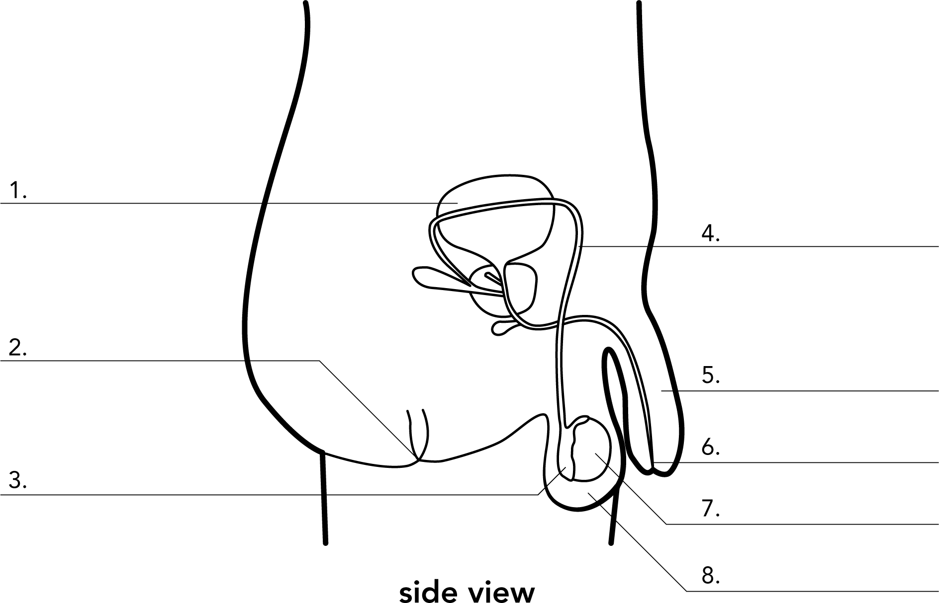

NOTE: #1 and #2 are not part of the reproductive system

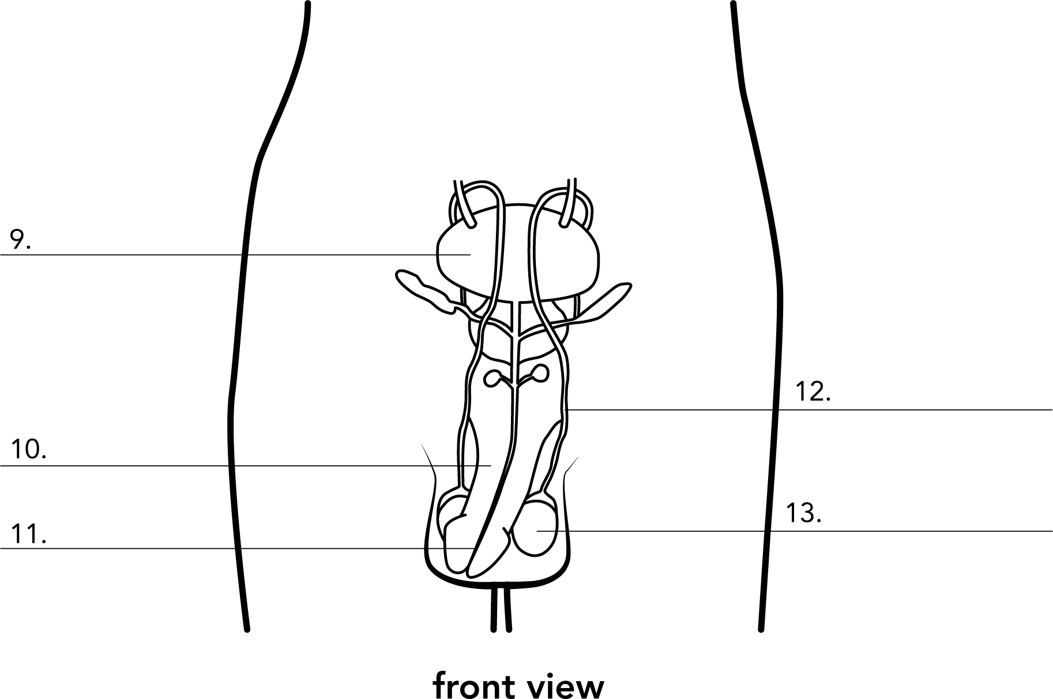

NOTE: #9 is not part of the reproductive system

DIRECTIONS: Fill in the name of each body part. Use correct spelling and medical words.

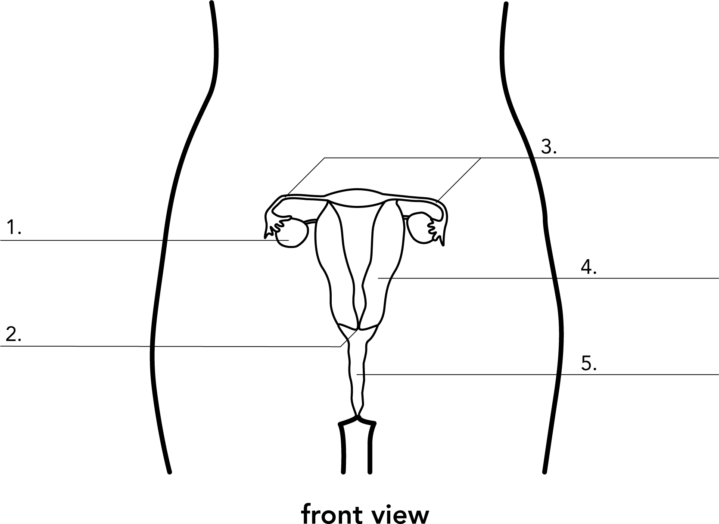

**Reproductive System Visual/Worksheet 4**

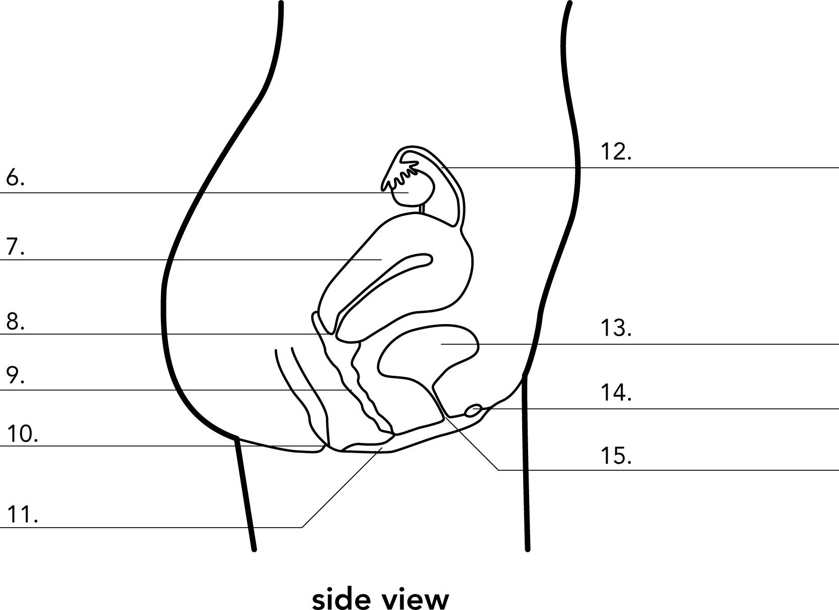

NOTE: #10, 13, and 15 are not part of the reproductive system

DIRECTIONS: Fill in the name of each body part. Use correct spelling and medical words.

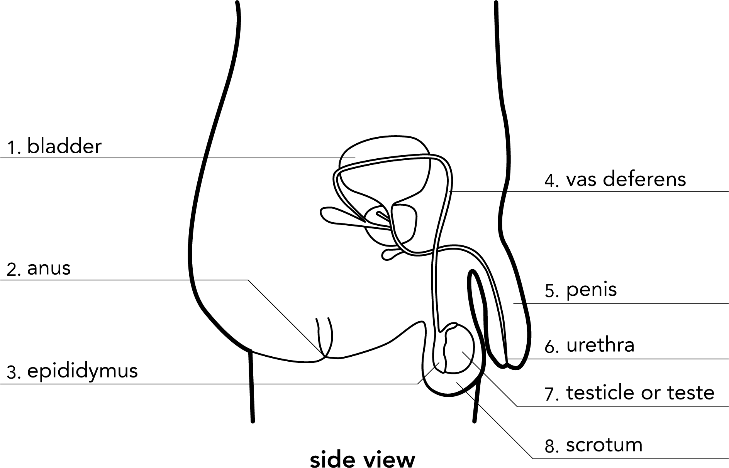

NOTE: #1 and #2 are not part of the reproductive system

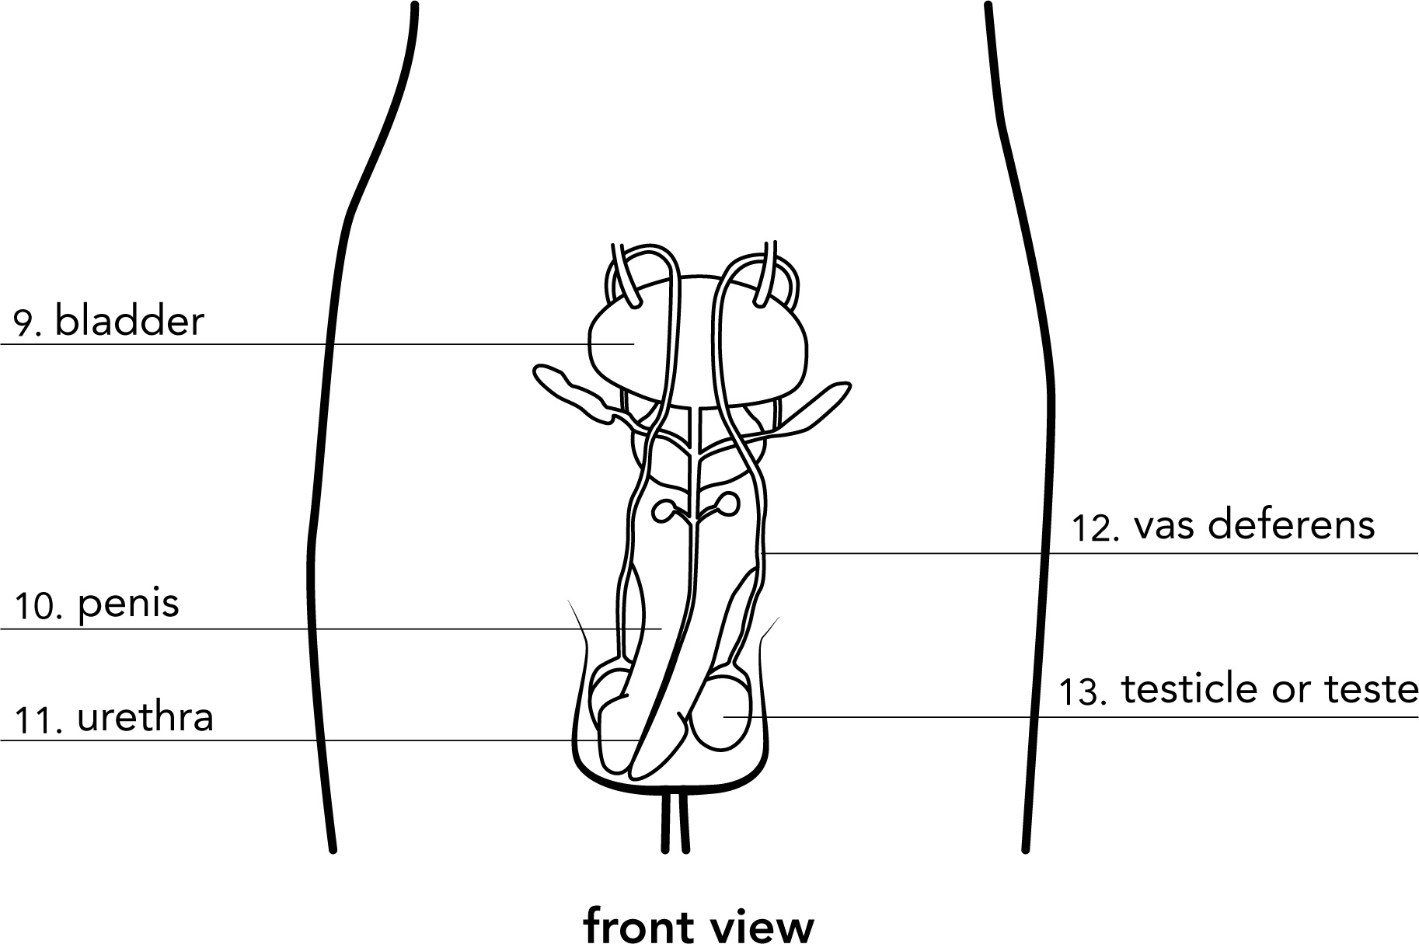

NOTE: #9 is not part of the reproductive system

DIRECTIONS: Fill in the name of each body part. Use correct spelling and medical words.

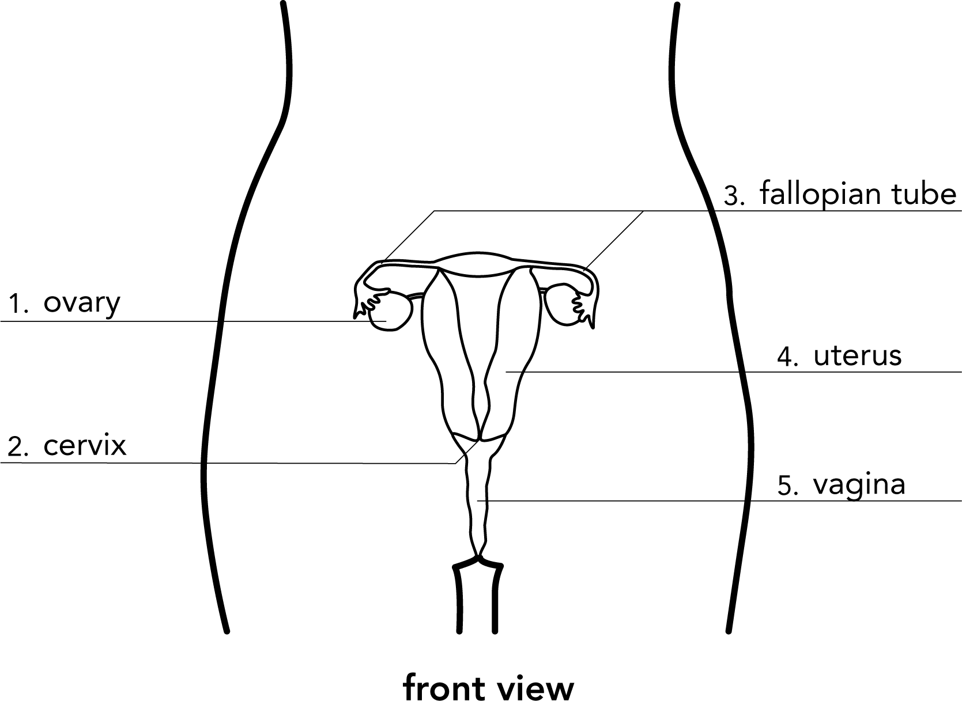

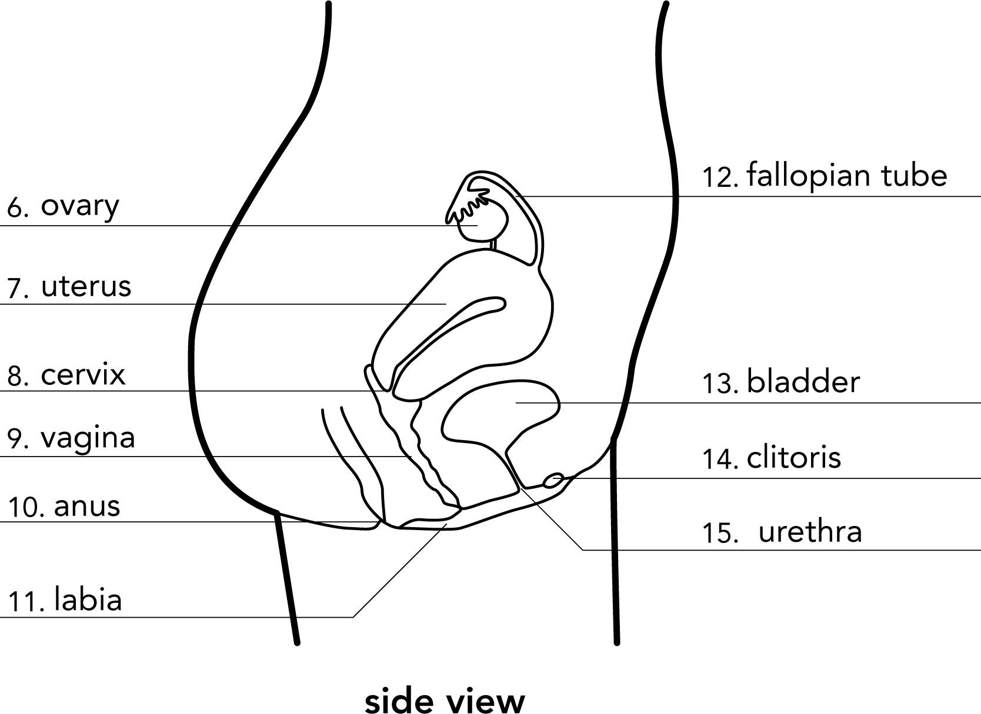

NOTE: #10, 13, and 15 are not part of the reproductive system