# Self-Esteem

## Grades 4-6, Lesson #3

### Time Needed

25-35 minutes

### Student Learning Objectives

To be able to…

1. Demonstrate ways to treat others with dignity and respect.
2. Understand ways family, friends, and peers can have a positive or negative impact on relationships and self-esteem.
3. Make an affirming statement to oneself.

### Agenda

1. Define self-esteem.
2. Describe the origin.
3. Use riddles (*Visual #1 and Self-Esteem Worksheet*) to unscramble 3 key elements of self- esteem.
4. Identify situations that *damage* self-esteem.
5. Identify situations that *build* self-esteem.
6. Answer “Anonymous Question Box” questions regarding self-esteem.
7. Use an esteem-building small group exercise.
8. Discuss the exercise to summarize the lesson.

This lesson was most recently edited November 2021.

### Materials Needed

**Classroom Materials: (1 per class)**

* *Self-Esteem Visuals #1 and #2*

### Student Materials: (for each student)

* *Self-Esteem Worksheet* (same as *Visual #2*)
* Pencils

### FLASH Key Concepts

It is important to treat everyone with caring and respect.

### Activity

1. **Define self-esteem.**

*Self-esteem means liking yourself or feeling good about yourself. People with lots of self- esteem often make healthier decisions than people with only a little. They also tend to make friends more easily, try their hardest, and cope better with mistakes. This lesson will help everyone learn how to boost their own and others’ self-esteem.*

### Describe the origin of self-esteem.

*There are lots of things adults can do to help babies and children build their self-esteem. Children gain self-esteem when people love them, play with them, and are proud of them, and when they learn new skills and try new things. We’re going to do three riddles together to figure out the 3 keys to good self-esteem.*

### Use riddles to unscramble 3 key elements of self-esteem.

Show the first scrambled key on Visual #1, but keep the others covered. Read the clue aloud and ask students to respond. Repeat with next two clues/keys. *S*tudents write the answers for each key on the *Self-Esteem Worksheet.*

CLUE for Key #1: *“Everybody needs to feel this way. You feel this way when someone chooses you to be on their team. You feel this way when your whole family gets together for a celebration. You feel this way when everybody's going somewhere and they ask, 'Aren't you coming?' You feel this way when you're home sick and somebody calls just to see if you're OK. You feel this way when somebody invites you to be in their club.”*

ANSWER for Key #1: **“I belong.”**

CLUE for Key #2: *“Everyone needs to feel this way too. Quan is only three years old; he feels this way when he puts his clothes on all by himself. Leticia is seven; she feels this way when she rides her bike for the first time. Omar is eleven; he gets this feeling by building model airplanes. Alex is sixteen; they feel this way when driving the car with their new driver's license. Dmitri uses a wheelchair; he feels this way with his new electric wheelchair that allows him to go places without being pushed. Grandpa Joseph feels this way when he takes care of his great-grandbaby for the evening.”*

ANSWER for Key #2: **“I can do things.”**

CLUE for Key #3: “Everybody needs to feel this way also. Madison is doing her chores when the phone rings. She asks her little brother, Jayden, to answer the phone. He answers it and takes a message for Madison. She says, “Thanks, kid," and Jayden feels this way. When her mother comes home, she sees that Madison straightened up and she says, “The house looks great, honey." Madison feels this way. Madison’s mom opens a shopping bag and shows Madison the graph paper Mary's been asking for. Madison grins. "You remembered," she says, hugging her. Mom feels this way.

ANSWER for Key #3: **"People appreciate me.”**

You will end up with Visual #2 looking like this:

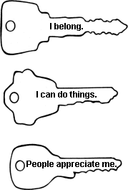

### Identify situations that *damage* self-esteem.

Ask the class to think of reasons a person might feel "I DON’T belong.” Repeat the question for “I CAN'T do things” and "People DON’T appreciate me." Point out that treating people unfairly and hurtfully is bad for self-esteem. It is important to treat everyone with caring and respect. You may need to point out that making mistakes do not cause low self-esteem; learning from our mistakes and doing things differently the next time can help build self-esteem.

### Identify situations that *build* self-esteem.

Ask the class for examples of when a person might feel "I DO belong.” Have them list times they’ve felt "I CAN do things.” Have them list times they’ve felt "People DO appreciate me.” Finally, ask them how to help build other people’s self-esteem.

### Answer "Anonymous Question Box" questions about self-esteem.

1. **OPTIONAL: Use an esteem-building small group exercise.**

In small groups, have each person go around the group saying one thing they appreciate about each other person. Remind them of the ground rule "No put-downs." This exercise will only work in a class that is experienced in small group work. It may work best later in the school year, after the class has built some rapport and a sense of community. As alternatives, see Related Activities A and B below.

### Reiterate the 3 things that influence people’s feelings about themselves.

*We all learned a lot about self-esteem today. Let’s all try to remember three things we can do to help our friends feel good about themselves*. *If people do this for each other, everyone will have better self-esteem.*

* + *Include the person (to give them a sense of belonging)*
  + *Compliment them on something they’re good at (to remind them they can do things)*
  + *Thank them for something (so they'll feel appreciated)*

## Related Activities For Integrated Learning

### Social Studies

Students can make timelines of their lives, listing things they could do at age 5, now, and things they will be able to do at age 15, age 20, and age 25.

### Art

Students can draw personal coats of arms showing: in one quadrant, one place they belong; in another, something they can do; in a third, something people appreciate about them; and in the fourth, one way they help to build other people's self-esteem.

## Homework

Students’ options:

* Family homework: We learned that self-esteem means liking yourself or feeling good about yourself. What are some things a person should do if they’re not feeling good about themselves?
* Individual homework: Compliment or thank someone. Write a few sentences about what you did, including how it felt.

**Self-Esteem Visual 1**

**Keys To Feeling Good About Yourself**

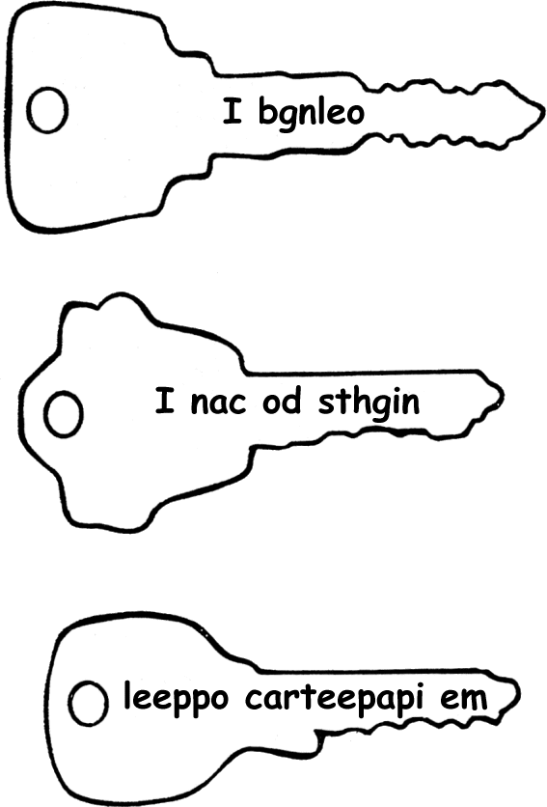

**Self-Esteem Visual 2/Worksheet**

### NAME DATE

**Keys To Feeling Good About Yourself**

DIRECTIONS: Unscramble the keys. Write the answer inside each key.

