**How to access your student aimsweb Plus Scores**

***\*\*Viewing Student Scores is now an interactive experience- items can be clicked to access further information on student scores and progress-monitoring schedules can be created from this page as well by clicking on the plus sign in the circle.\*\****

1. Go to https://app.aimswebplus.com/#/login
2. Enter Credentials

Enter Customer ID number: **72347**

Username: assigned to you this year via email

Password: whatever you chose at the start of the year

1. 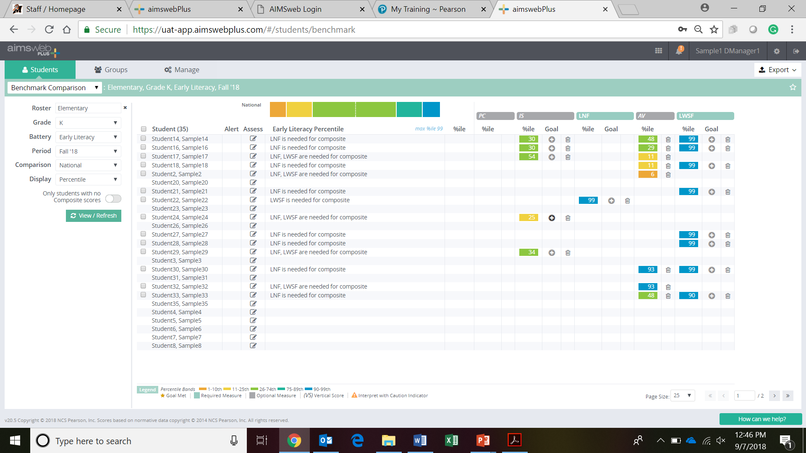Click login
2. Click on Students Tab
3. In the drop down menu click on Benchmark Comparison
4. Make sure you have the correct Roster, Grade, and Battery (Early Literacy, Early Numeracy, Reading, Math) selected
5. Make sure Comparison is on National
6. Next to Display field click on drop down and select Percentile
7. Click View/Refresh

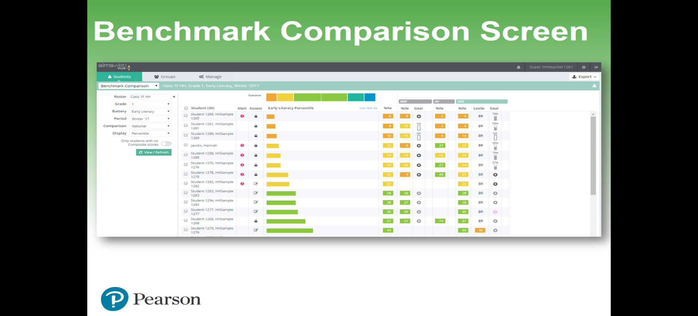

**Printing “Benchmark Comparison” reports**:

1. Follow all of the steps listed above
2. When you are viewing the Benchmark Comparison Score Screen Click on Export located on the far right upper hand corner of the screen
3. Click on Benchmark Summary Report
4. 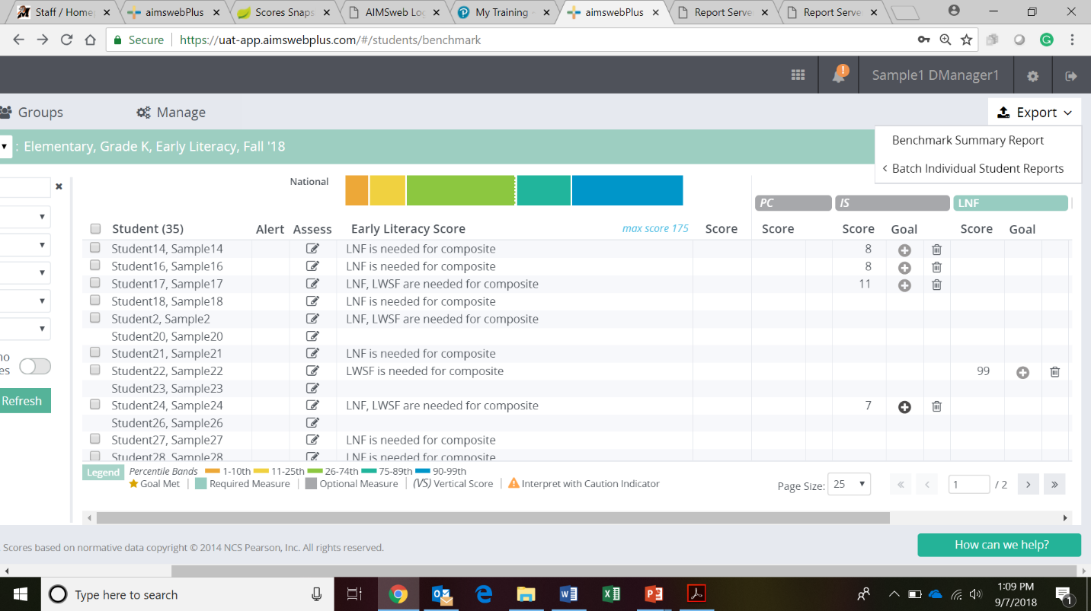Wait about 30 seconds to generate and you will notice a circled exclamation point that appears next to the bell icon
5. Click on the bell icon
6. Click on the paper clip next to the Benchmark Comparison Report
7. A PDF will be generated at the bottom of your screen
8. Open the PDF
9. 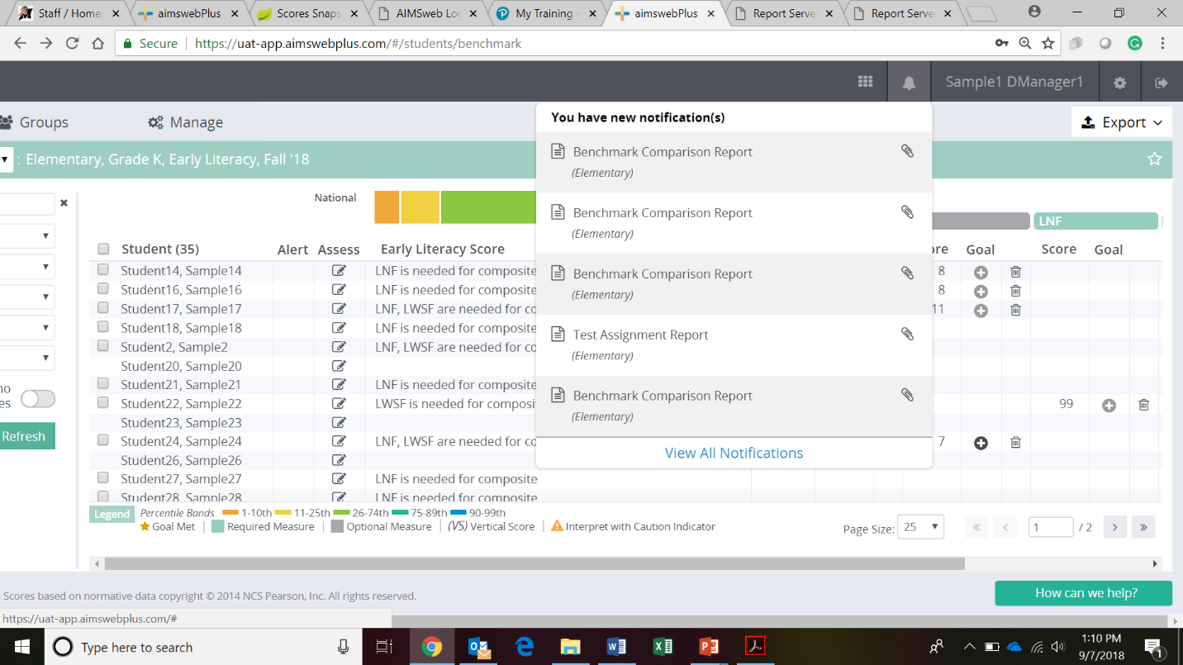Click on Print

