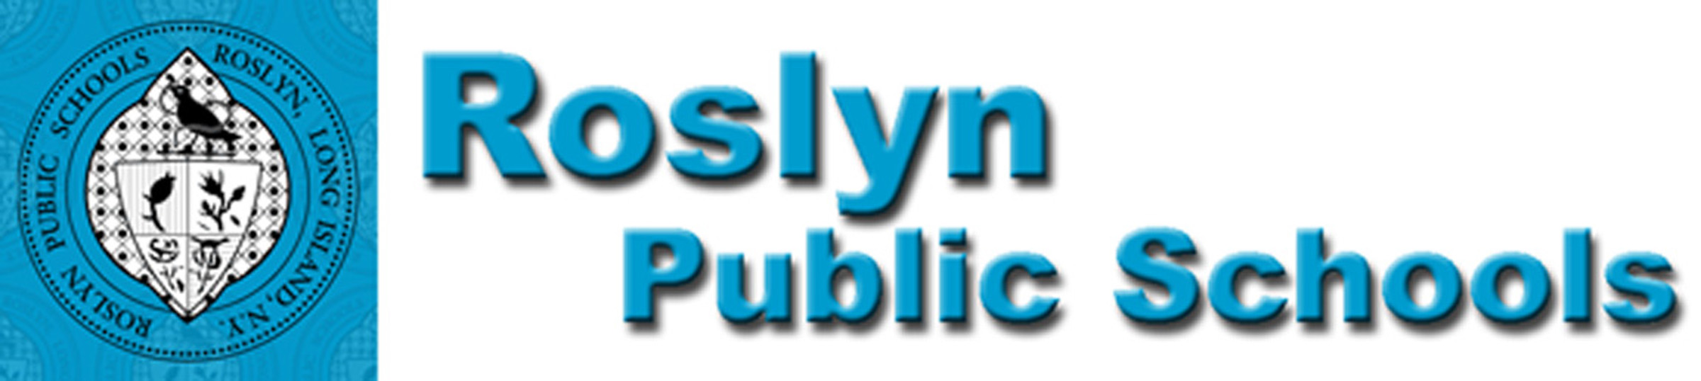
475 ROUND HILL ROAD, ROSLYN, NEW YORK 11577 (516) 801 - 5100

December, 2019
Dear Parent/Guardian of a Current Sophomore Student:

We are pleased to notify you that Roslyn Public Schools will continue taking part in New York State’s newly adopted Seal of Biliteracy Program again this year. The New York State Seal of Biliteracy (NYSSB) recognizes high school graduates who have attained a high level of proficiency in listening, speaking, reading, and writing in one or more languages, in addition to English. The intent of the NYSSB is to:

- encourage the study of languages
- identify high school graduates with language and biliteracy skills for employers
- provide universities with additional information about applicants seeking admission
- prepare students with twenty-first century skills
- recognize the value of foreign and native language instruction in schools
- affirm the value of diversity in a multilingual society

All sophomores and their families are being notified about this program now, so they can plan for completing the requirements necessary for earning the seal. We are currently working with the high school guidance department so that the counselors can discuss the Seal of Biliteracy with students and make the appropriate changes if necessary. Students will receive information about the timeline for next year’s application and acceptance process in the spring of 2017.
In the fall, we will distribute information to initiate the application process. Sophomores who wish to be eligible for the NYSSB must enroll in a level 4H (Advanced Placement language preparation course.) Application materials will be made available in the spring of their junior year. Students who wish to apply for the Seal of Biliteracy must meet the initial requirements listed below.

Initial Requirements:
- Enrollment in and completion of a Level 4H (Advanced Placement preparation) World Language course with a minimum grade of 85 for both coursework AND on the level 4H final examination
- Score of 85 or higher on the NYS Regents Examination in English Language Arts (Common Core) OR
- Score of 3 or higher for the Advanced Placement English Language and Composition Examination
Students who meet the initial requirements, and are interested in earning the seal, will be given the opportunity to start the application process and work with an advisor (their World Languages teacher) to complete a portfolio and culminating project that demonstrates fluency and excellence in English as well as another language. If you have any questions, please feel free to reach out to me, Danielle Pappas, the World Languages Chairperson. We hope you consider pursuing this honorable recognition, and we look forward to working with you.

Sincerely,

Danielle Pappas
Chairperson for World Languages & ENL
dpappas@roslynschools.org
(516) 801 – 5180

Scott Andrews
Principal, Roslyn High School
sandrews@roslynschools.org
(516) 501 – 5100

