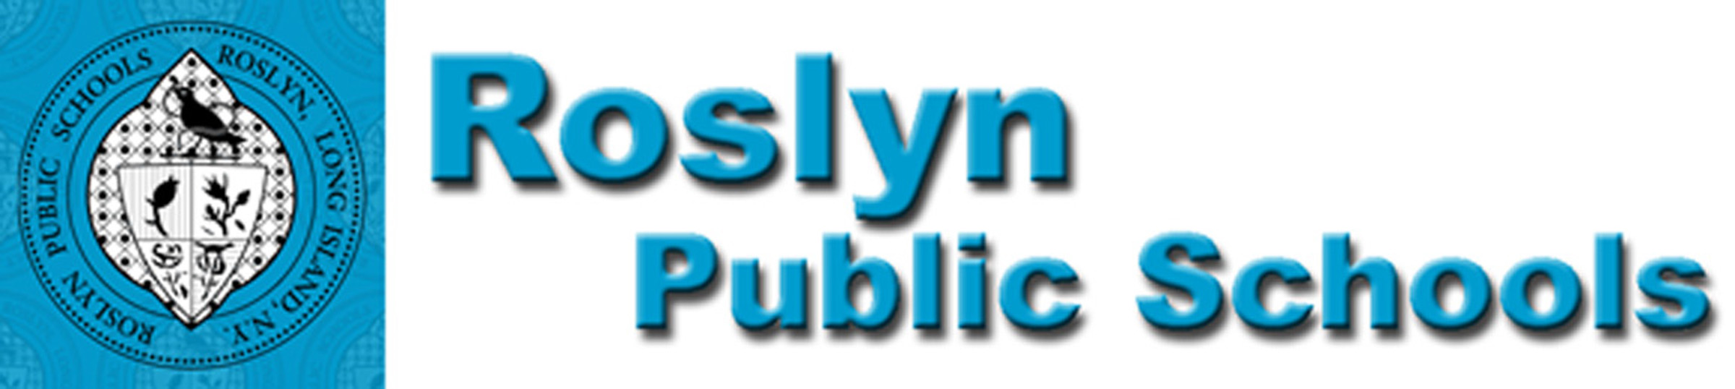
475 ROUND HILL ROAD, ROSLYN, NEW YORK 11577 (516) 801 - 5100

December, 2019
Dear Senior Student:

We are pleased to notify you that Roslyn Public Schools will continue taking part in the New York State’s newly adopted Seal of Biliteracy Program beginning this year. The New York State Seal of Biliteracy (NYSSB) recognizes high school graduates who have attained a high level of proficiency in listening, speaking, reading, and writing in one or more languages, in addition to English. The intent of the NYSSB is to:

- encourage the study of languages
- identify high school graduates with language and biliteracy skills for employers
- provide universities with additional information about applicants seeking admission
- prepare students with twenty-first century skills
- recognize the value of foreign and native language instruction in schools
- affirm the value of diversity in a multilingual society

Seniors currently enrolled in Advanced Placement language courses will receive information about the timeline for this year’s application and acceptance process in mid-February. Students who wish to apply for the Seal of Biliteracy must meet the initial requirements listed below. Students who meet these requirements, and are interested in earning the seal, will be given the opportunity to start the application process and work with an advisor (their World Languages teachers) to complete and submit a portfolio that demonstrates fluency and excellence in English as well as another language. (This portfolio will contain work completed during class time.)

World Language Requirements:

- Completion of a Level 4H World Language course with a minimum grade of 85 for both coursework AND on the level 4H final examination
- Completion and submission of a portfolio

English Requirements:
- Score of 85 or higher on the NYS Regents Examination in English Language Arts (Common Core)
- Score of 3 or higher for the Advanced Placement English Language and Composition Examination
- Complete all 11th and 12th grade ELA courses with an average of 85 or higher (1 point)
- Present a culminating project, scholarly essay or portfolio that meets the criteria for speaking, listening, reading and writing to a panel of reviewers. (2 points) – (The portfolio requirements are fulfilled in class during the course of the school year.)

If you have any questions, please feel free to reach out to me, Danielle Pappas, the World Languages Chairperson. We hope you consider pursuing this honorable recognition, and we look forward to working with your child.

Sincerely,

Danielle Pappas
Chairperson for World Languages & ENL
dpappas@roslynschools.org
(516) 801 – 5180

Dr. Scott Andrews
Principal, Roslyn High School
sandrews@roslynschools.org
(516) 501 – 5000

