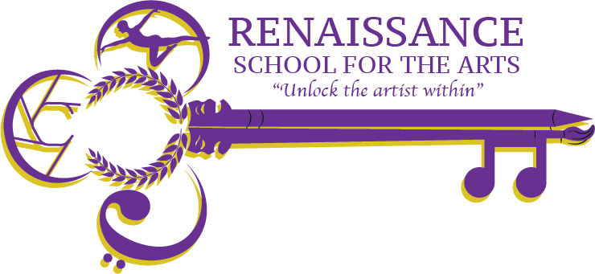

**Renaissance School for the Arts Governance Board Agenda**

**Appleton West/RSA High School Room 229**

**Wednesday, March 19th 2025 at 4pm**

Video Call Link: Video call link: <https://meet.google.com/stf-dbhk-bsd>

Or dial: ‪(US) +1 585-491-8552‬ PIN: ‪297 713 409‬#

More phone numbers: https://tel.meet/stf-dbhk-bsd?pin=4229996170847

| **Agenda Item** | **Action to be taken, by whom** | | **Time** |
| --- | --- | --- | --- |
| Welcome & Call to Order | **Action;** John K | | 4:00pm |
| Public Discussion | **Public Discussion** | | 4:00 pm to 4:10 pm |
| Approval of Minutes  https://drive.google.com/drive/folders/1RmgXcRbDMFbKvN3OAY6RMBfXZNkGODij | **Action;** John K | | 4:10pm |
| RSA Update | **Discussion;** John R | | 4:15pm |
| 2025 -2026 Board Roster | **Discussion;** John K  Welcome Valerie Medina - Education Manager Trout Museum for the Arts | | 4:35pm |
| Any Other Business | **Discussion;** for the good of the group, John K | | 4:40pm |
| Adjourn | **Action;** John K | | 4:45pm |
| Next Meeting | April 16th, 2025 – Room 229 & Virtually | |  |