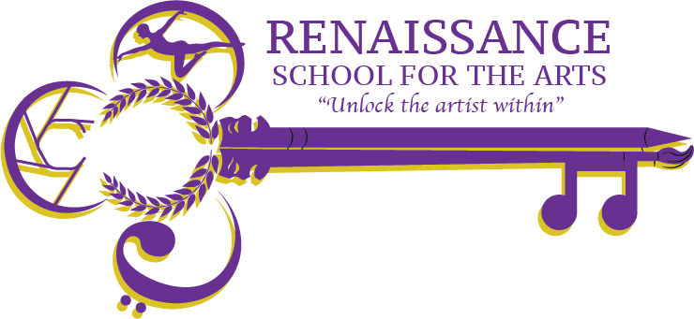

**Renaissance School for the Arts Governance Board Agenda**

**Appleton West/RSA High School Room 229**

**Wednesday, November 20th at 4 pm**

Video Call Link: Charter Board Meeting

Wednesday, December 18th 4:00 – 5:00pm

Time zone: America/Chicago

Google Meet joining info

Video call link: <https://meet.google.com/hwd-ewjy-zjo>

Or dial: ‪(US) +1 225-442-0117‬ PIN: ‪641 152 622‬#

| **Agenda Item** | **Action to be taken, by whom** | | **Time** |
| --- | --- | --- | --- |
| Welcome & Call to Order | **Action;** Board | | 4:00pm |
| Approval of Minutes  [November '24 Minutes](https://docs.google.com/document/d/1GWvcXzRMFZPb_6AUAmT_BKpNU6WUbpc9_htxU59ieto/edit?tab=t.0) | **Action;** Board | | 4:05pm |
| RSA Update | **Discussion;** John R   * [Grid 2024](https://www.canva.com/design/DAGZppgHT7w/p6bKpXgcRQceo6ITMgn1oQ/view?utm_content=DAGZppgHT7w&utm_campaign=designshare&utm_medium=link2&utm_source=uniquelinks&utlId=h27c1b4d0c5) * Auditions * Winter Arts Festival/Winter Gallery Night   + Tue. Jan, 14 and Thurs. Jan 16 | | 4:10pm |
| Board Development | **Discussion;** Board - Review of [Bylaw](https://docs.google.com/document/d/1Js3QQQHycAfUUT9kGEdJHHAtbp6GhEaiGJZCYob_EY4/edit?tab=t.0)s for term limits, respective categories, and future board members.  <https://docs.google.com/document/d/1Js3QQQHycAfUUT9kGEdJHHAtbp6GhEaiGJZCYob_EY4/edit?tab=t.0>  Frankie Gilboa <[fgilboa@troutmuseumart.org](mailto:fgilboa@troutmuseumart.org)> Tours | | 4:30pm |
| Any Other Business | **Discussion;** for the good of the group, Board | | 4:55pm |
| Adjourn | **Action;** Board | | 5:00pm |
| **Next Meeting** | Wednesday, January 15th – Room 229 & Virtually | |  |