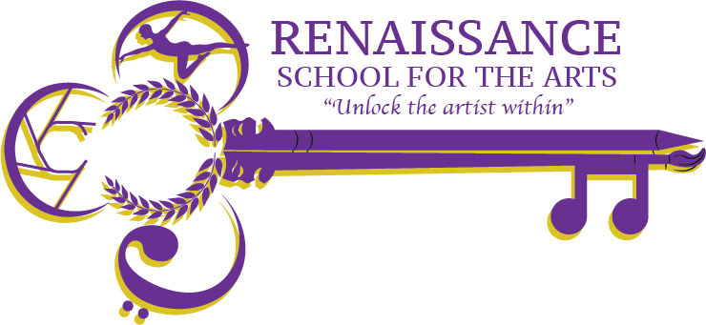

**Renaissance School for the Arts Governance Board Agenda**

**Appleton West/RSA High School Room 229**

**Wednesday, November 20th at 4 pm**

Video Call Link: Charter Board Meeting

Wednesday, November 20th 4:00 – 5:00pm

Time zone: America/Chicago

Google Meet joining info

Video call link: <https://meet.google.com/hwd-ewjy-zjo>

Or dial: ‪(US) +1 225-442-0117‬ PIN: ‪641 152 622‬#

| **Agenda Item** | **Action to be taken, by whom** | | **Time** |
| --- | --- | --- | --- |
| Welcome & Call to Order | **Action;** Board | | 4:00pm |
| Approval of Minutes  [September '24 Minutes](https://docs.google.com/document/u/0/d/1d7vsu1NnyCOpQY_YYFa3mgxDJHC4CZyrVbD9CEG1T-k/edit) | **Action;** Board | | 4:05pm |
| RSA Update | **Discussion;** John R   * December 13 Open Tours 1:00-3:00 | | 4:10pm |
| Board Development | **Discussion;** Board - Select a Board Secretary and Board VIce President. | | 4:30pm |
| Any Other Business | **Discussion;** for the good of the group, Board | | 4:55pm |
| Adjourn | **Action;** Board | | 5:00pm |
| **Next Meeting** | Wednesday, December 18th – Room 229 & Virtually | |  |