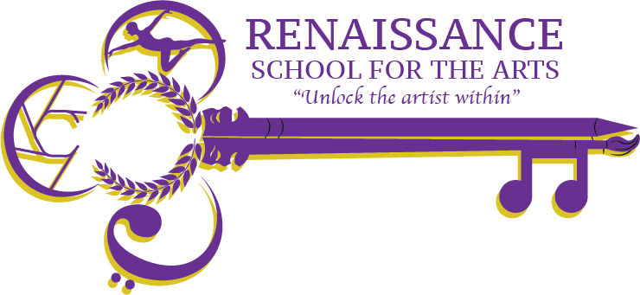

**RSA Governance Board Minutes**

**Appleton West/RSA High School Room 229**

**Wednesday, 18th September 2024 at 4pm**

| **Agenda Item** | **Action to be taken, by whom** | | **Time** |
| --- | --- | --- | --- |
| Welcome & Call to Order | **Action;** John K  John K called meeting to order 4:40pm. Quorum declared. | | 4:05pm |
| Board Discussion | **Introduction and Approval of New Board Members:**  Sue Stahl, Neil Rhines, and Alyssa Dalton attended the meeting and were nominated to the Board of Directions. Motion carried anonymously after motion by Margaret and a second from Angela was introduced.  Welcome Sue, Neil and Alyssa.  Graine Kelly Beckett has moved back to her home country of Scotland and the board graciously accepted her resignation. | | 4:06pm |
| RSA Update | **Discussion;** John R  John Richards noted his appreciation to all board members and reiterated that he is unable to vote on board matters so the board maintains their independence per school’s charter.  John RIchards noted that on December 13th, community members and professionals with an arts background, yet working in a field outside the arts spectrum, will visit with current 8th grade students (and potential future RSA students) in terms of how their respective arts background has assisted in the career development. The goal would be to have 20+ students attend.  Students enrollment is as follows for the 2024-2025 school year.   * 9th grade has 35 students * 10th grade has 45 students * 11th grade has 45 students * 12th grade hs 29 students   Goal is approximately 50 students per class.  John RIchards will again invite school counsellors from the AESD Junior High Schools to visit RA to provide an overview of the school and the school’s art based curriculum.  FInally John Richards reminder the board that while last year’s musical Rent was a success from both an academic and production standpoint, RSA will incorporate musicals every other school year. | | 4:20pm |
| Board Development | **Discussion;** All  John Keller confirmed this will be his last year on Board.  Current board members will be encouraged to consider becoming either the Board Secretary or Board Vice President.  John RIchards introduced the new Board Members to the online Google Drive for RSA. | | 4:30 pm |
| Adjourn | **Action;** John K  Meeting adjourned 4:36pm | | 4:43pm |
| Next Meeting | Wednesday, October 16th – Room 229 & Virtually | |  |

Attendees: John Richards,, John Keller, Sue Stahl, Neil Rhines, Alyssa Dalton, Angela March-Torme, Annete Koepke, Cathy Peter, Margaret Peak, and Daniel Zwicker.