Meet the Teacher
About Me:
Hello! My name is Mrs. Jena Veenstra (Gina). I grew up in Hutchinson and lived there for 25 years, but moved to Clements in 2013. I live with my husband, Dan, our two sons, Chase (7) and Emmett (3), and our dog, Toby. We love living on the farm and experiencing country life. During my free time, I love to spend time with my family and friends, work in my flower gardens, travel, run, and read.

I will be your child’s 2nd Grade math, science, and social studies teacher. I have taught Kindergarten (5), 2nd (7), and 3rd (1) Grade in the thirteen years I have been teaching.

Education:
I graduated from Hutchinson High School in 2006. I received a bachelor’s degree from St. Cloud State University in 2011 with a degree in Early Childhood Education. I also earned my master’s degree through Morningside College in Sioux City, Iowa in 2020 with a degree in Master of Arts in Education.

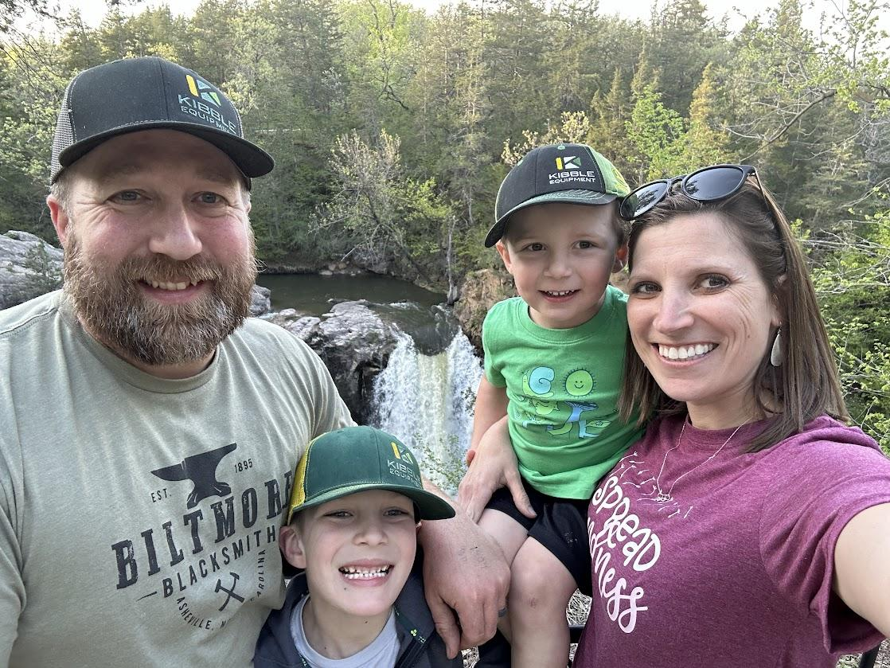
Favorites:
Color: Purple
Food: Pulled Pork
Dessert: Cheesecake or Ice Cream
Candy: Chocolate with Caramel
Store: Target
Sports: Bowling, Softball, and Running
Author: Nicholas Sparks and Colleen Hoover
Hobby: Gardening

