Indian Education District Wide Spirit Days for 2024-2025
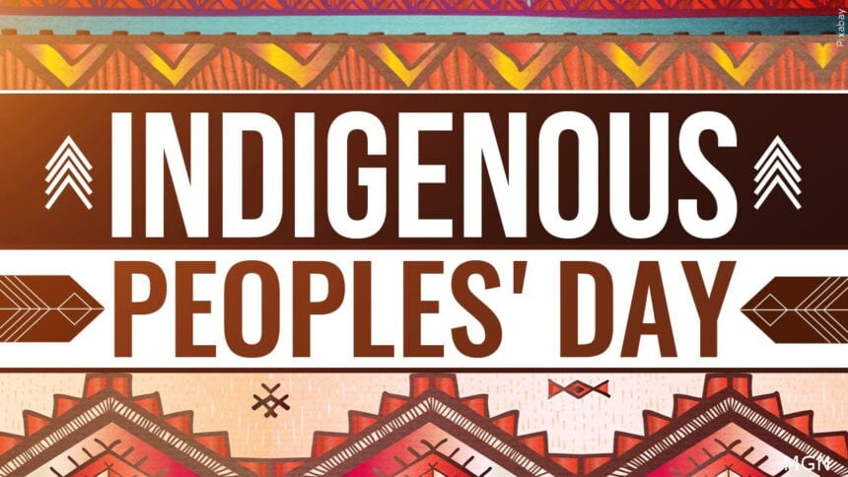
Indigenous Peoples Day
honors the histories, cultures, and perspectives of Indigenous peoples and their ancestors who lived on the land now known as North America

Monday Oct 14th - Wear Orange

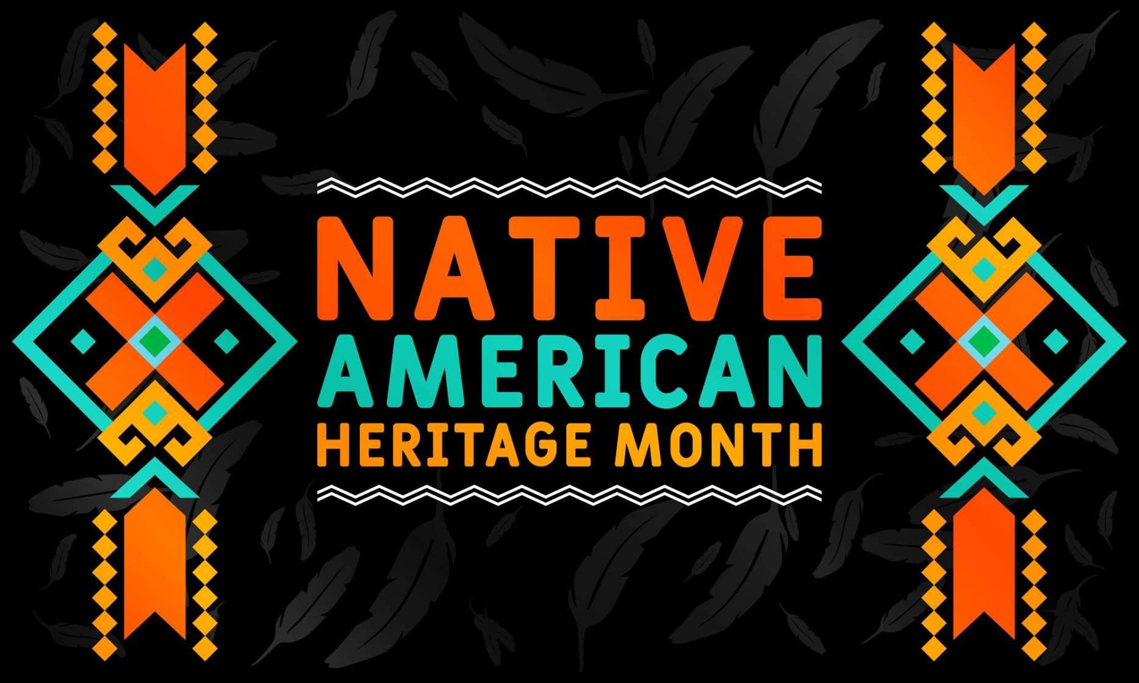
Native American Heritage Spirit Week- November 4 - 8, 2024
*School Dress code must be followed*
Nov. 4 -Monday Jim Thorpe Sports Day (jersey or team shirt)
Nov. 5 -Tuesday Turtle Island Tuesday (wear green)
Nov. 6 -Wednesday Wampum Wednesday (wear purple)
Nov. 7 -Thursday Native American Attire (jewelry, clothes, moccasins)
Nov. 8 -Friday Back the Braids & Rep your tribe (hair braids, t-shirt with tribe name)

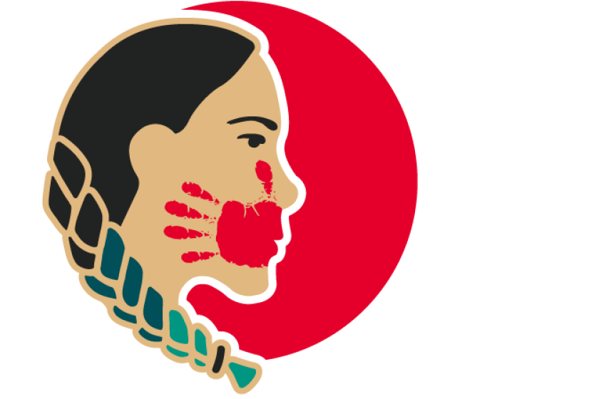

MMIW Day
recognized across the United States and Canada as the National Awareness Day for Missing or Murdered Indigenous Women and Girls.

Monday May 5th - Wear Red

