Set up email with the built-in Android email app
Select the type of account you want to add.
Note: Android mail apps may look different across different devices, and the directions given may not exactly match the options that you see. Use these steps as a guide or consult the manufacturer's help for your particular device. You can also choose to use the built-in Gmail app if your Email app is not available.

Set up an outlook.com account

- Tap Settings > Accounts > Add account > Exchange.
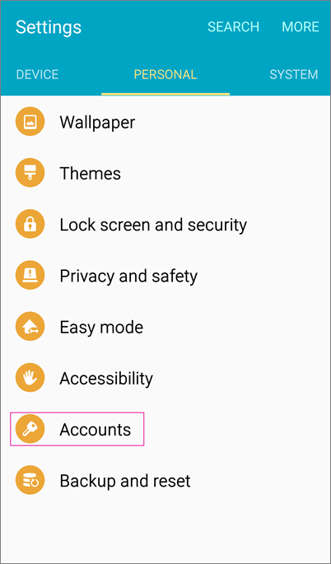
- Type your full email address, for example yourname@scotlandk12.nc.us (If you only want your email account to sync to your phone, tap Next and follow the rest of the prompts.
However, if you want other sync options, such as syncing your calendar and contacts as well, select Manual setup and follow the steps below.
Note: The manual steps below are for Outlook.com accounts only.
On the type of account page, select Exchange > Next.
- Type your password and select Next.
- On the Incoming server settings page set the following:
  - Domain\Username
Make sure your full email address appears. For example, <someone>@scotland.k12.nc.us. If Domain and Username are separate text boxes on your device, leave the Domain box empty, and type your full email address in the Username box.
  - Password
Use the password that you use to access your account.
  - Server name
You might need to replace what's there with outlook.office365.com
  - Port
Use 443 or 993.
  - Security type
Select SSL/TLS or make sure the Use secure connection (SSL) checkbox is checked, then tap Next.
- On Account options, change or accept the default sync settings, and then select Next.
- Name your account if you want and then select Next.
Not working? Make sure you entered your email and password correctly and try again because even one small typo will result in an error.
If you've turned on two-step verification, and you see an incorrect password error, see Troubleshoot email setup on mobile.
If you synced your calendar and contacts, go to those built-in apps on your device to view any items that might be there. If you synced tasks as well, you should see them in the calendar app on your device. It might take a few minutes for everything to sync.

Set up work or school email accounts that use Office 365 or an Exchange-based email account

View these steps in a video. 
- Tap Settings > Accounts > Add account > Email.
- Type your full email address, for example tlocklear@scotland.k12.nc.us, type your password, and then tap Next.
- Select the Exchange option.
- Depending how the Office 365 administrator in your organization set up your account, you might receive a message about additional security features. Select OK to continue.
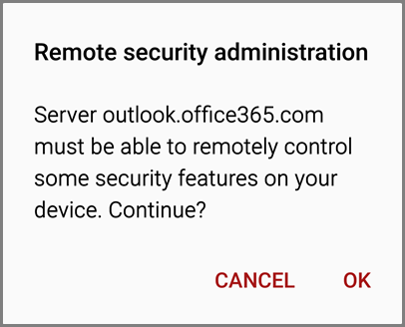
- Once the device verifies the server settings, the Account Options page opens. Accept the defaults or select the options for how you want to receive and send your mail, and then tap Next. (You may need to scroll down to see Next.)
- On the Set up email page you can change the name of your account. When you're finished tap Done.
If you synced your calendar and contacts in step 5 you can go to those apps on your phone to view any items that might be there. If you synced tasks as well, you should see them in the calendar app on your device. It might take a few minutes for everything to sync.

