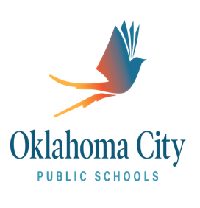
2020-2021
TITLE I SCHOOL-PARENT COMPACT

This compact is an agreement between Douglass High School, its students, and parents detailing the roles and responsibilities of each group in order to improve academic achievement.
Douglass High School is charged with providing standards based instruction, developed through standards based planning, with data collected and analyzed through standards based assessments. We will hold parent teacher conferences, send progress reports and quarterly grades, and provide consistent feedback to our parents. It is our continuous goal to provide a safe, rigorous learning environment for all students and engage them in lessons that will prepare them to be productive citizens and lifelong learners.
Douglass High School students must maintain their eligibility through adhering to high standards of academic achievement, attendance, and conduct. All students are expected to earn a “C” or higher in each course and maintain a minimum GPA of 2.5. Students are also charged with being in their classes 93% of the time. Lastly, students are expected to comply with all behavioral guidelines as outlined in the OKCPS Code of Conduct.
Douglass High School parents are expected to attend a minimum of one parent conference per school year, participate in PTSA or Booster organizations, and work with the school to ensure academic success for their students.

____________________________________ _______________________________
Student Signature Date

____________________________________ _______________________________
Parent Signature Date

