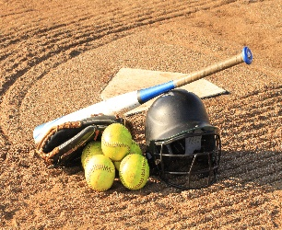
BIEMS Softball 2024

Aug 27th Tues Belle Isle vs. Classen SAS Away
Location Classen SAS H.S. 5:30 pm

Aug 29nd Thurs Belle Isle vs. Taft Away
5:30 pm

Sept 5th Thurs Belle Isle vs. Capitol Hill Away
At CHHS 5:30 pm

Sept 9th Mon Belle Isle vs. Roosevelt Away
5:30 pm

Sept 12th Thurs Belle Isle vs. Western Heights Away
At JMMS 5:30 pm

Sept 19th Thurs Belle Isle vs. Wheeler Away
At CHHS 5:30 pm

Sept 23rd Mon Belle Isle vs. Southeast Away
At SEHS 5:30 pm

Oct 7th & 8th ACAC Tournament

