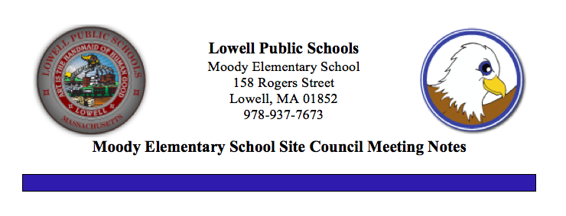

February 12, 2020

Welcome and Introductions

What is SSC
- SSC is an advisory body that meets 7 times a year, consisting of school staff, administration, parents and community members. The School Site Council works together sharing ideas and opinions to assist in the decision making at the Moody School.
- SSC Updates
- SSC parent nominees report
- Election in Process
- Ballots due to the PTO by end of the day on Friday, February 14, 2020 for calculations
- Teachers Mr. Steve Ibarguen, Mrs. Patricia Pappathan and Ms. Priscilla Scannell nominated and elected by their peers to join the SSC

Moody School Enrollment and Demographics
- New students consistently arriving. Most new students are identified as ELL students. Our population is transient so overall enrollment figures remain relatively consistent with a population ranging between 230-235 students. Students move out of the district or transition to charter schools. Grade 4 teacher can only identify 25% of her students starting here in kindergarten. Additional information was sought on mid-year student emergency forms that were sent home for updated contact information asked the status of student preschool experience. This information will be added to our data inventory.

Budget Updates
- Final data based budget decisions need to be made by April with the support of the SSC.
- A lot of SSC activities need to be done by the end of April

Personnel Updates
- Congratulations to Mrs. Lindsey Gill and her husband Randy who welcomed their beautiful daughter, Carly on December 17th.
- We welcomed back Mrs. Amy Costello extend our thanks to Ms. Kristin Farley who did a fabulous job substituting.
- Mrs. Ellen Ulery joined our staff as a Long term substitute teacher for Content Literacy for the remainder of the school year.
- Bilingual tutor, Mrs. Patricia Copello, joined our staff.
- Thank you to Ms. Mary Farley for substituting daily as our Grade 2 paraprofessional. We wish Mary the best of luck as see begins her last college semester as she looks forward to graduation.

Curriculum
- Walkthroughs
- SEL Workshops
- ELL Strategies
- Phonics Instruction
- STEAM Activities
- Playworks
- ST Math
- Writing
- Introduction to Data Wise: A Collaborative Process to Improve Learning and Teaching
- Funds supporting Afterschool Programs

Partnerships/After School Programs
- Kids in Tech
- Girls Inc.
- Bill Haddad On the Move Inc.
- Book Give Away supported by Mrs. Liz Freeman and Mrs. Bonnie Callanan
- Merrimack Valley Food Bank
- Rogers Hall

Assessment Results/Progress Monitoring
- ACCESS Testing is complete
- Wednesday, February 12th ~ Progress Reports for Grades 1-4
- F&P testing began for Grades K-4 on Monday, February 3rd
- i-Ready Math Diagnostic Monday, February 3rd – Friday, February 14th
- i-Ready Reading Diagnostic Monday, February 24th – Tuesday, March 17th

School Improvement Planning
- ITL Team introduced to new document Quality Improvement Plan (QIP)
- Staff survey to make recommendations for funding distributions based on priorities
- ITL Team as well as all teachers participating in online Data Wise course Introduction to Data Wise: A Collaborative Process to Improve Learning & Teaching continue to learn about what is involved in using data wisely to build a culture of collaborative inquiry.
- Attendance, Preschool experience, Performance Data
- Curriculum (research phonics programs and costs)
- Technology needs and upgrades

Facilities/Safety
- Continue safety drills (fire drills, hard lockdown, soft lockdown) etc.
- Requests for fence repair and replacement of worn carpets

Family Events
- Family Project Valentine Cards for WWII Veterans
- MCAS Informational Breakfast Tuesday, February 11th

Upcoming Events/ Updates
- Vacation begins at the close of school on Friday, February 14th
- Schools Reopen on Monday, February 24th
- Preschool and Kindergarten registration will have showcases for parents to assist with registering at the Shaughnessy School on Wednesday, February 26th from 6:30 – 8:30 and the McAuliffe School on Monday, March from 6:30-8:30.
- Kindergarten Open House
- Winter Talent Show – Wednesday, February 26th
- Community Reader Day Friday, February 28th
- Cultural Breakfast Wednesday, March 18th

Ideas/ Suggestions/Topics for Remainder of School Year
- After School tutoring program will be considered. No transportation available

Open Forum
- Calendar updates
Next Meeting: March 11, 2020

