Site Council Meeting
April 1, 2019
3:30PM to 4:30PM

Present: Kevin, Teresa, Mary, Todd, Zach

Meeting Notes from February 4 review and accepted
School Updates

- Volleyball starts Thursday, April 4th
- Cambodian New Year – performance – May 30th during school hours
- Sprit Week – great participation
- Failure Intervention after April vacation (April 22 to June 4)
- Q3 report cards – April 11th, posting by April 8
- DESE visit April 3
- PBIS Update – Event before April vacation- Theme no zeroes
  - 7/8 Dodgeball
  - 5/6 Movie
- Schoolwide Assemblies around MCAS expectations
- Try to reduce anxiety with students for the rigorous MCAS test taking sessions
- May 17th Field Day if weather permits at Cawley Stadium

- 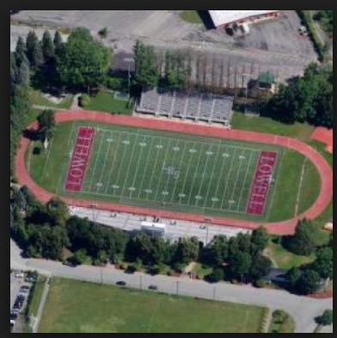

Update on Turnaround Plan

- Budget Inquiries
- Teacher Survey (93%) and Site Visit Reports
  - Reports shared at CPT in March
- Student Focus Groups
- ILT and Stakeholders Meetings: Visioning Results
- Goal to finish turnaround plan by June 4th

