
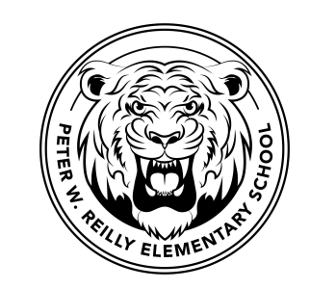
Reilly School
115 Douglas Road
Lowell, MA 01852
978-937-7652
978-446-7423 Fax

Ron Fusco
Interim Principal

September 7, 2022

Dear Reilly Families,

We are excited to be able to offer a Before School Program, free of charge, five days per week for students in grades kindergarten through four. The program begins at 7:30 A.M. All students will enter the building using the front main doors. The schedule of the morning program will be as follows:
Mondays- Fridays:
7:30 Arrival
7:30-7:45 Reading Fun Activity
7:45-8:30 Activity of the Day
8:30 Start of the School Day

Enclosed please find a registration form. Please return the form to school by September 12, 2022. We have limited spots available, so it will be a lottery based acceptance. All families will be notified regarding acceptance into the Before School Program by September 15, 2022.

The Before School Program will begin on September 19, 2022.

If you have any questions, please feel free to contact one of us at the email address below.

Thank you,
Joanne George and Alisha Silvestrone
Program Directors

Joanne George
jgeorge@lowell.k12.ma.us

Alisha Silvestrone
asilvestrone@lowell.k12.ma.us

