

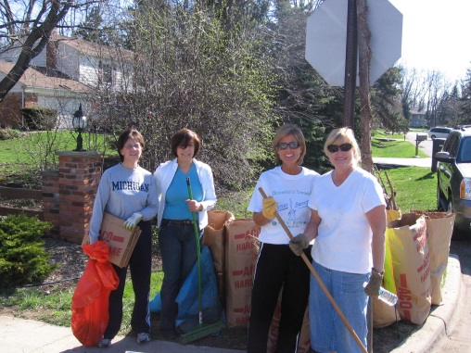
Bloomfield Township
CLEAN SWEEP

Department of Public Works
4200 Telegraph Road
P.O. Box 489
Bloomfield Twp., MI 48303
248-594-2800
www.bloomfieldtwp.org

This year around Earth Day, Township residents can participate in Clean Sweep.

WHAT IT IS?
A weekend event for residents to clean up debris from the safety paths and roadways that is deposited during the winter season in the community.

WHEN IS IT?
April 26 & 27, 2025

HOW DO I SIGN UP?
Print out the volunteer form from the website or call the DPW offices at 248-594-2800 to request one. Only one form per group is necessary.

WHAT DOES THE TOWNSHIP PROVIDE?
We provide trash bags and compost bags.

WHEN IS THE DEBRIS PICKED UP?
All trash and compost will be picked up by Priority Waste at the normally scheduled collection time for each cleanup location.

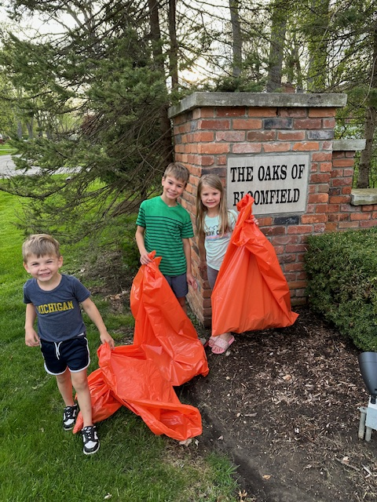

Clean Sweep Event in April
The Township would like to encourage all community members to volunteer some time and effort to help keep the appearance of our roadways and subdivisions looking clean and litter free, thereby maintaining the beauty that both residents and visitors alike have come to expect from Bloomfield Township.

Volunteers are asked to help collect litter and debris deposited during the winter season from safety paths and subdivision entrances.

To ensure a Clean Sweep success, we ask that you help us spread the word to your neighbors, churches, homeowner associations, scout troops, PTA, sports teams and/or anywhere else you might feel would help to spread the word and encourage community members to become involved. Clean Sweep is also a great opportunity for students needing community service hours for their schools.

