School Composite | By June 2022, Union Hill Elementary will increase the school overall performance composite from 35.8% to 40.8% as measured by third through fifth grade NC EOG test.
Reading | By June 2022…  We will Increase 3rd Grade Reading from 33.9% to 36%.  We will increase 4th Grade Reading from 26.4% to 30%.  We will increase 5th Grade Reading from 27.1% to 33%.
Math | By June 2022…  We will increase 3rd Grade Math from 47% to 52%.  We will increase 4th Grade Math from 27.6% to 30%.  We will increase 5th Grade Math from 34.3% to 38%.
Science | By June 2022…  We will increase 5th Grade Science from 59% to 69%.
10/12/21
Attendance: Flowers, Black, Lucas, Stanfield, Johnson, Milton, Halley, Wingfield, Lanier, Anderson, Harris, Spears,
Topic for discussion | Time | Notes
Good Things | 2:46 | - Wingfield has a new grandchild.  - Mrs. Jones’ class received 3 tiger paws.  - Lucas shared she had fun teaching today in 5th grade.
Reports from each Sub-Committee Chairs  - Approve actions steps  - Add dates to the calendar | 2:48 | - Parent Engagement (Harris): Create a survey to determine what staff thinks will be the best platform will be used school wide to communicate to school community. Mrs. Black offered to create a survey for teachers regarding the use or remind or class dojo and the results will be shared by the next staff meeting, 10/19  - IPS(Stanfield): Big idea is to understand the “why” behind MTSS and understand the difference with IST. Actions steps K-2 meeting, and a 3-5 meeting, understand the MTSS paperwork, meet together as a k-5 team and decide MTSS logistics. Mrs. Black added on how all certified staff need to be trained in NumberWorlds which will take place at one of the upcoming staff meetings date TBA.  - TAG (Milton): Increase the number of students receiving AG services. Currently there are only 5 students in 5th grade. They would like to raise the number to 13. Gregg would like to train the staff in how to identify AG students in order to recommend them for services (as well as helping parents identify giftedness in their children). In addition, create more practice opportunities (question of the day) for students to practice the types of questions that are on the test.  - Data (Lanier): Action Steps- Admin/CF Team will continue to do walk throughs while providing concise feedback. Teachers will continue to utilize digital data tracking systems, Classrooms teachers will create data walls/notebooks for students to use and manipulate so that students are aware of their individual goals and standard mastery. PLC Agendas will continue to include time/space to identify areas of teacher strength that can be used for future in house PD.  Data team needs to submit a paragraph as to the “why” and expectations for data walls and data notebooks  Data walls/notebooks should up and running by 11/12 to allow time for reading benchmark data to utilized.  - Sunshine (Spears): Create a monthly list of activities in order to boost staff morale. Each 2nd Monday, Staff can pay $1 to wear jeans. Questions, can teachers wear team jersey’s or do they have to wear UHE shirt with jeans?, Honey baked ham coming soon, End of October- donuts from Krispy Kreme, Any staff member present the entire month will be entered into a drawing to win a McDonald’s sandwich. School wide spirit week next week- Monday-Book character day, Tuesday Twin day, Wednesday Whacky tacky day, Thursday-Sports day, Friday- School Spirit. Next Jean Day- 10/27  - Vertical Alignment (Jump/Hailey)- The grade above will present to the grade below at least 3 major standards in math and reading that students should have a firm grasp on before coming to the next grade at a future staff meeting. Discussed for 5th grade if the middle schools could send over a ppt of expectations or standards that students should are expected to come prepared with.  5th grade present to 4th, 3rd grade present to 2nd, First grade present to Kindergarten during January staff meeting  2nd present to First. 4th present to 3rd, Kindergarten present to PK in February Staff meeting  Teachers visit grade levels at the end of the school year.  Flowers-Action steps will be placed in Indistar and Dates will be placed on Master Calendar
Title 1 Updates | 3:20 | - 6:00-7:10, Pizza from 7:20-8:00  - 10/21- Grade level chairs need to share info with their teams  - Grade levels need to create a sign in sheet or Sign in sheet  - Survey created by black to be done by parents at the end
Updates Community Round Table | 3:33 | Community members are excited to lend support to UHE. Teams have been created to best organize and utilize support.  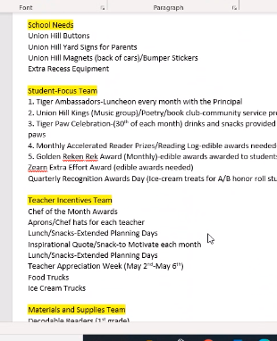  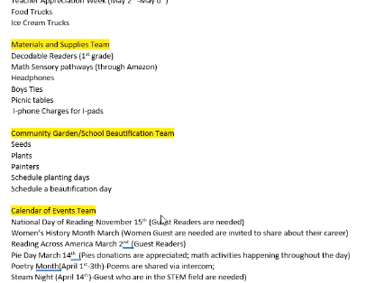
Outdoor Classroom norms & Protocols | 3:40 | Outdoor classroom schedule and norms.  Norms:  - Use classroom voice although outside.  - Structured lessons should be in place  - Not to be utilized for lunch  - Maintain cleanliness of the space  - Don’t allow students to mark on the desks with pens or markers.  - The outdoor classroom is an extension of the indoor classroom. All classroom rules/expectations should extend to the outdoor space.  - Go over classroom expectations prior to using equipment.  - Masks wearing will be left up to the classroom  - Only sign up for what you WILL use and not what you might use.  Schedule: Mrs. Black has created a schedule for teachers to sign up that will be maintained on the Staff Teams Page.  - Grade level chairs please communicate to team the why behind teachers signing up for multiple time slots.  - Pendley suggested that the language for the schedule be changed so that it is clear that each sign up is 1x per class.  - Teachers should sign up for 1 day a week until they have used that day and can sign up for additional days in they are available after that.
Next Steps before our next meeting | 3:55 | - Grade level chairs, please share with your team the minutes and details of the meeting.  - Mrs. Black shared on 10/26 we will not have subcommittees to allow teachers to have time in their classrooms.  - Blooms Taxonomy is still on the 25th (8;30-12:00) Lunch provided, and on the 26th district still has a 2 hour PD.

