**Option 1 – How to earn SL hours with a Teacher**

Completing an opportunity with a classroom teacher or a club. This does NOT require you to complete any paperwork ahead of time for your opportunity. The **FIRST** step is to work on hours for the opportunity. **SECOND** you will search for the classroom teacher’s (or clubs) opportunity in x2VOL under Find Opportunities and click “Add it to my Opportunities”.

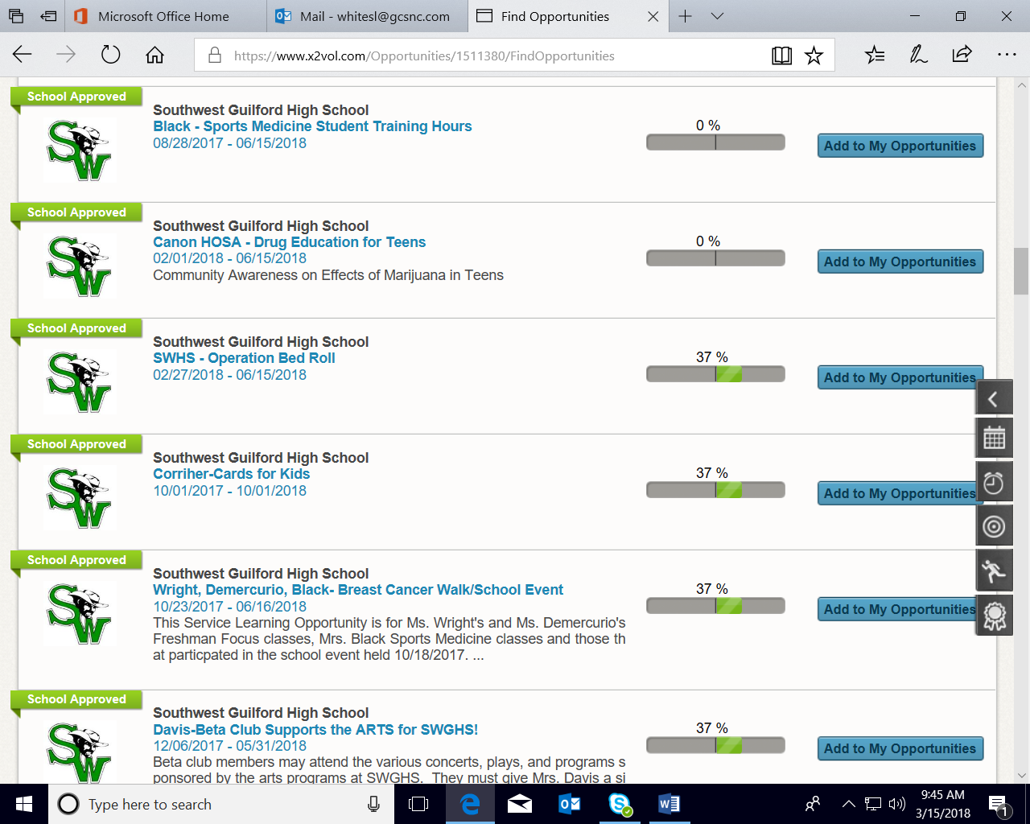

The **THIRD** step is to go to add hours and find the classroom or club hours under Community & Campus Opportunity you want to submit hours for. Click add hours corresponding with that tab. **FOURTH** step is to complete the form, be sure to include a two-three sentence reflection and all of the dates for your teacher/advisor. As well as putting MULTIPLE days on ONE entry!

