**Delete your cache, history and other browser data in  
 Google Chrome**

1. black and red solid arrowClose ALL open tabs in Chrome. In the upper right corner of the Chrome browser, click the three dots.
2. Hover over **More tools**, then select

**Clear browsing data**.

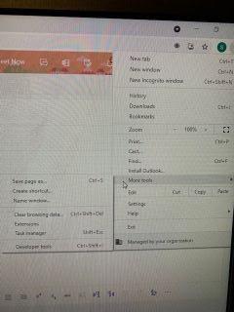

1. Use the dropdown menu to select **ALL TIME** to delete all browsing history.
2. Select the checkboxes to match the screen shot below.

