NEWS FROM ACADEMICALLY GIFTED
The Middle School Edition
Quarter 2
Education is the most powerful weapon which you can use to change the world.
~ Nelson Mandela

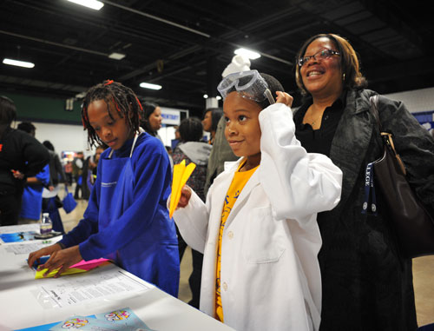

Plan now to attend the 2023
Choice Showcase! GCS is a nationwide leader in magnet and choice schools, just one of the ways the district is personalizing learning. Families have a wide variety of choices for their children’s education—choices that build on or stimulate educational interests, foster academic achievement and provide cultural and ethnic diversity. As you begin to think about your your child’s transition to high school, the AG Department would like to highlight the following programs that may be of interest to students who have been identified for academically gifted services:
Advanced Academic Programming:
- Early College programs
  - Early College at Guilford (Liberal Arts focus)
  - Early College at NC A&T (STEM focus)
- Middle College programs
- International Baccalaureate Diploma Programme
- AP Capstone Program

Career Focused Opportunities:
- Academy of Computer and Information Science
- Academy of Advanced Manufacturing and Engineering
- Academy of Biomedical Technology and Specialized Health Science
- Academy of Transportation, Distribution, and Logistics
- Aviation Program
- Education and Advanced Sciences Program
- Health Sciences Program
- Performing Arts (Weaver or Penn Griffin) – School assignment based on address.

Choice programs are available to students who reside in Guilford County and transportation is provided to most program sites. Although all of our high schools offer programming that will meet the educational needs of your child, the choice programs focus on specific areas that may better align to your child’s interest and post-secondary aspirations. For more information on the choice options, visit Choice Schools and Programs website: https://www.gcsnc.com/Domain/2425

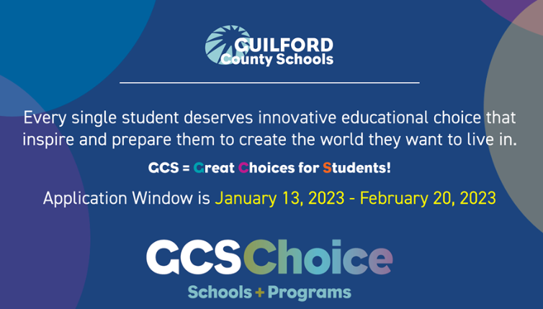

News from our School:



From the GCS
AG Department

Guilford Gifted:
Guilford Gifted, formerly known as Guilford County PAGE, is a 501(c)(3) non-profit organization supporting our community’s brightest young minds with strong advocacy for the advancement of academically gifted education. Guilford Gifted provides the tools to engage and empower all those involved with academically gifted children, thereby building tomorrow’s leaders today. If you have not already done so, please visit their website to take advantage of their FREE membership opportunity.
Website: https://www.guilfordgifted.org/

Social Emotional Article:
The next page provides tips you can use at home to address your academically gifted student’s social and emotional development.
Transition to High School:
Following the Winter Break, the AG Department in conjunction with the Guilford Parent Academy will host a meeting for rising 9th grade students to learn about their transition to high school. The meetings will be held virtually. More details will be shared once the dates have been confirmed. You may monitor the AG website for additional information.


Parenting the Gifted Learner
2022 – 2023 Article Series: Adapted from Parenting Gifted Children 101: An Introduction to Gifted Kids and Their Needs by Dr. Tracy Ford Inman and Dr. Jana Kirchner (2016)

According to the NC General Assembly, “public schools should challenge all students to aim for academic excellence and that academically or intellectually gifted students perform or show the potential to perform at substantially high levels of accomplishment when compared with others of their age, experience, or environment”. This statement from Article 9B, the state’s legislative mandate for academically gifted services, speaks to two of the five areas of giftedness: intellectual, academic, creative, artistic, and leadership. Some students may demonstrate a talent in one or more of these five areas. Article 9B requires districts to identify and serve students with a demonstrated talent in intellectual and/or academic achievement in Reading and/or Math. Once we have identified students who have an intellectual and/or academic talent, we must also address some of the challenges these students may face in the educational setting.

According to Inman and Kirchner (2016), one of the biggest obstacles gifted learners face is the belief that school should be “easy”. Some parents and educators may believe that these students should always demonstrate high performance with very little effort. However, if a student who has an intellectual and/or academic talent spends their educational career earning good grades and receiving high praise (for both parents and teachers) without having to make much effort, they will miss out on the development of lifelong skills such as:

- Work Ethic: The gifted learner needs to value and believe in effort as a conduit to academic success.
- Responsibility: Gifted learners need to develop conscience driven behaviors that acknowledge their role in achieving goals related to their family, school, or personal success. Gifted scholars need to learn about the impact and effect their actions have on their overall success. Additionally, the caring adults in their lives must be prepared to implement natural consequences when expected action is not demonstrated. For example, if your child fails to submit an assignment by a deadline, the natural consequence of earning the poor grade develops the virtue of responsibility better than you, as the parent, stepping in to ask the teacher for an extension.
- Coping with Failure: Failure can be viewed as not meeting self-imposed expectations. For a gifted learner, this means failure can be viewed as earning a “B” instead of an “A”. As the parent of a gifted learner, it is important to help your child see that some of life’s greatest successes come from failure. Through failure, your child can learn how to pick themselves up and develop a plan of action to reach a goal. Learning from failure can also help your child learn perseverance and resilience by learning to separate their identity from the task.
- Time Management: As you know, as adults we constantly juggle multiple roles: parent, spouse, employee/employer, neighbor, friend, etc. With each of these roles comes a different set of demands for our time, talent, and energy. Often the demands of these roles conflict with each other causing us to set priorities on how much of our time, talent, and energy we devote to each role. Inevitability, your child will experience demands from school and extra-curricular activities. Help your child set priorities and boundaries for how to distribute their time, talent, and energy to these tasks.
- Goal Setting: Embracing the notion that school should not always be “easy” is one way of helping your child set goals for how they wish to perform. Such goals should not be unrealistic (e.g., making a perfect score on all assignments). However, the goal should reflect the outcome the student expects based upon the priority they have placed on the task and should be attainable. For example, a high schooler enrolling in seven AP courses with the expectation of earning perfect grades on all assignments and the AP Exam may be an unfeasible goal to set.
- Sacrifice: It is often said that nothing worthwhile comes easy. As parents we must remind our gifted learners that they will experience failures – and that’s okay. What matters to their overall development is learning from those failures by creating goals that align to the time, talent, and energy they wish to put into a task.

When a gifted learner earns high grades and praise without making much effort, they do not learn the values and skills needed to become a productive learner with the tools needed to be successful in their 3 – 12 experiences and beyond.

