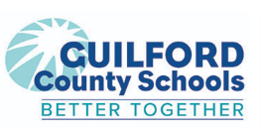
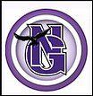  Northern Guilford Middle  “Expect Excellence Everyday”  Kris Wheat  Principal  Wesley Auman Assistant Principal  Justin Thomas  Assistant Principal  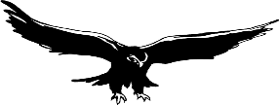  MISSION STATEMENT- Dedicated to creating a  nurturing environment for all students.  Our goal is to inspire students to develop  the skills needed to take control of their lives and actions and to improve the quality of life for themselves, their community, and their world.  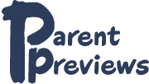  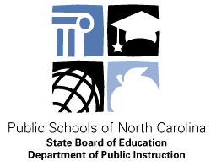  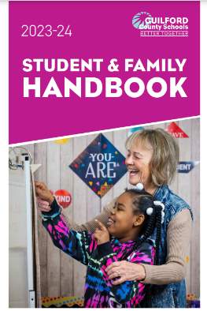  GCS Reproductive Health Classes (page 108)  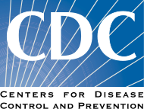    (336) 605-3342  Preview Meeting Friday, September 1, 2023. Please call if you are unable to attend or have questions.  “Unlock the Possibilities”  Greensboro, NC 27455 PHONE:336-605-3342 FAX: 336-643-8435 |  | August 21, 2023  Dear Parent or Guardian:  Welcome to the new school year! I am so excited to have your child in my class this year. I feel lucky to have a job that I am passionate about.  We will begin the 2023-2024 “Nighthawk Nation Strong”! I hope you had a wonderful summer and have been able to enjoy some much-needed rest and relaxation with your families.  The opportunity to teach your student is a privilege and responsibility I take very seriously. I do my best to motivate, comfort and appreciate your student(s) and the individual uniqueness that they bring to the classroom. My goal as the Reproductive Health and Safety Education teacher is to help your student to be a responsible and independent learner. I have been at Northern since the doors first opened in 2006.  I would like you to know that I have high expectations for each student. I want to nurture each student’s love for learning. I will strive to provide a positive and safe environment that is conducive to learning. After teaching for more than 30 years, I have become very aware of the impact teachers can have on the lives of their students. I support parents in helping their students to make good decisions and stand by their decisions. Effective parent communication is a vital factor in a child’s education. It improves the confidence and classroom involvement of students. As you know, when parents and teachers communicate well with one another, we can support your student’s learning together.  Health Education is required for all students in North Carolina Public Schools. Health Education and Physical Education should be divided equally throughout the academic school year. All students will receive lessons within the Reproductive Health and Safety Education / Family Life Curriculum.  Reproductive Health and Safety Education / Family Life is a standard portion of North Carolina’s Health Curriculum. Your child will be taking Reproductive Health and Safety Education/Family Life Classes on or around Tuesday, September 5, 2023. Guilford County School’s Reproductive Health and Safety Education classes are based on the philosophy of Abstinence until Marriage and that parents are the primary sexuality educators of their children.  Reproductive Health and Safety Education is seen as a partnership among parents/guardians, school, and community. The curriculum shall encourage the involvement and acceptance of each. The role of the school is to supplement and assist in the education of the child encouraging learning essential to the development of strong families, positive relationships, and a healthy community. Students are encouraged to discuss information received in the classroom with parents or guardians at home. Homework assignments in grades 7th and 8th require parent signatures to assist in bridging the gap in communication of classroom lessons. This requirement provides opportunities for parent and student interaction.  In preparation for student instruction, a Parent Preview Meeting will be held Friday, September 1, 2023, in the school’s Media Center. The parent preview is intended to provide an overview of the required Common Core Essential Standard Goals and Objectives of the N.C. Standard Course of Study. The session will be for parents of all students in grades sixth through eighth. The Parent Preview Meeting is not required but it is encouraged.  Please visit North Carolina Department of Public Instructions, Healthful Living Section Grades 6-8 Essential Standards website at: www.dpi.nc.gov to view the uniform set of learning standards included in the curriculum for public schools in North Carolina.  NOTE: If you plan to attend, please be sure to check – in the school’s Main Office first.  There will be a morning session for Grade 6 parents ONLY to attend. Grade 6 parents can visit between the hours of 9:30 – 11:30 am. The meeting will begin promptly at 9:30, but you can attend during a time that is convenient to you until 11:30 am.  Parents of students in grades 7-8 can quickly visit to preview the curriculum between the hours of 1:00– 4:00 pm. Parents will gather in the Media Center and move to the Health Classroom #408 to continue the meeting. The meeting will begin promptly at 1:00 pm, but you are welcome to attend at a time that is convenient to you until 4:00 pm.  Grade 6 parents who missed the morning session may also attend during this time as well (1:00 pm- 4:00 pm). Please attend during a convenient time.  6th Grade – ONLY 3-4 Days of instruction include: Communication Do’s and Don’ts, Conflict Resolution, Good Decision Making, Passive, Aggressive and Assertive Behavior emphasizing the importance of being “Assertive” to resist peer pressure, Active listening Skills, using “I” statements when communicating, Friendship Qualities (Video entitled “Friendship Soup”) What is the recipe for friendship? In this video, kids describe the ingredients that go into making friends. Social, Emotional, and typical Physical changes of puberty are also taught. Grade’s 7th – 8th includes 10-13 days of instruction based on the A/B Week. schedule.  As we prepare to return to school for the 2023-2024 academic school year, we need to be mindful of the upcoming flu season in addition to the fact that Covid 19 remains an ongoing public health threat. Parents can help prepare their child to stay healthy in school, maintain good nutrition, get adequate sleep, and exercise. CDC revised guidelines represent an increasing focus on individuals making their own decision about their level of risk and how they want to mitigate that risk. People may choose to mask at any time. CDC is putting less emphasis on social distancing. CDC still advises that people who are in close contact to those with COVID maintain a routine testing regimen, and anyone who tests positive should remain home.  All students will be enrolled in the Standard Reproductive Health and Safety Education/ Family Life Classes unless a letter written from the parent or guardian stating otherwise is submitted to the Health/PE teacher by Monday, September 4, 2022.  I am excited to have students back in the classroom and filling it with energy and enthusiasm for learning. I appreciate any comments you have about the Reproductive Health and Safety Education/ Family Life Education materials.  Thank you for your support in this very important learning experience for your student.  If you have any questions or concerns, please feel free to contact me.  Sincerely,  Mrs. Cathy Hailey  2006-2007, 2018-2019 North Carolina and  Guilford County Schools Health Educator of the Year  NORTHERN GUILFORD MIDDLE SCHOOL  600 SIMPSON CALHOON ROAD-GREENSBORO, NC 27455  Phone – (336) 605-3342 Fax- (336) 643-8435

