Art

Band

Chorus

Dance

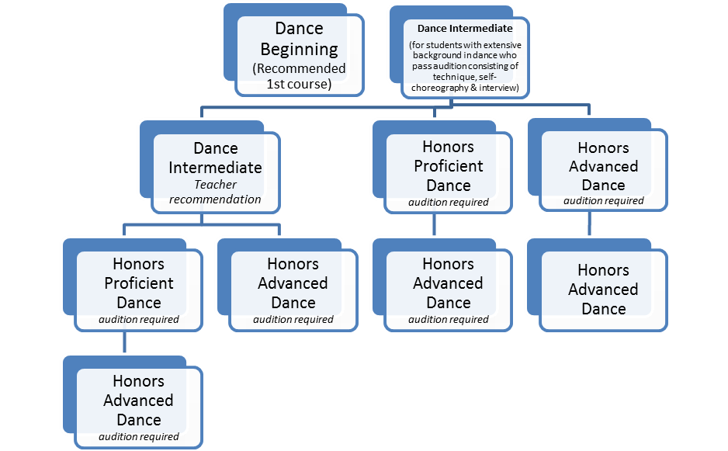

Orchestra

Theatre Arts