

**The**

**RAMily**

**Report**

Monday, January 11, 2021

***Vol. 1, Issue 1***

[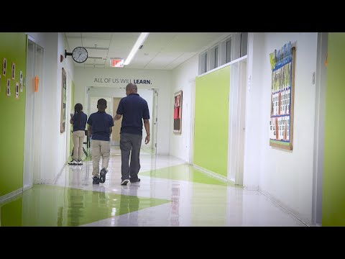](https://www.youtube.com/watch?v=kzvm1m8zq5g)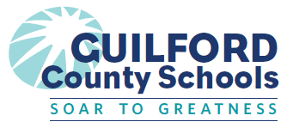

GCS SEL Newsletter Updates

* Listen. Really listen to your students. Let them know you value what they have to say.
* Be willing to change based on what you heard. Be honest if a student gave an idea or suggestion that was better or more effective than what you had planned.
* Engage students in collective problem-solving. Let them help you decide how things will work in your community.
* Teach students appropriate ways to speak up for themselves. Particularly focus on how to talk to an adult or authority figure in ways that are constructive. Let them know it is ok to disagree, but they need to do it in a way that is socially acceptable in their school setting.
* Help students solve conflicts. Don’t solve them for them. Guide students through the process.

**SEL FOCUS OF THE MONTH**

This month’s SEL focus is ***Relationship***. Relationship is the ability to establish and maintain healthy and supportive relationships and to effectively navigate settings with diverse individuals and groups. This includes the capacities to communicate clearly, listen actively, cooperate, work collaboratively to problem solve and negotiate conflict constructively, navigate settings with differing social and cultural demands and opportunities, provide leadership, and seek or offer help when needed. We are in a time and setting where these skills are put on display. Let’s spend the month working to build effective relationships with colleagues, families, and students. Here are some ideas for modeling relationships with students:

Video: The Power of Relationships in Schools



#RAMilyStrong

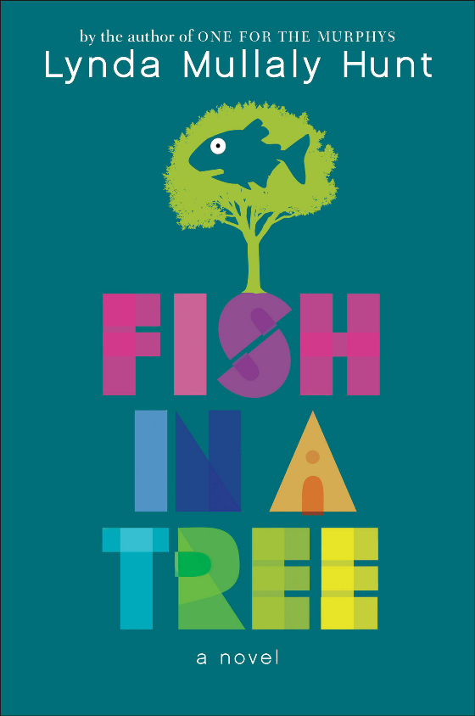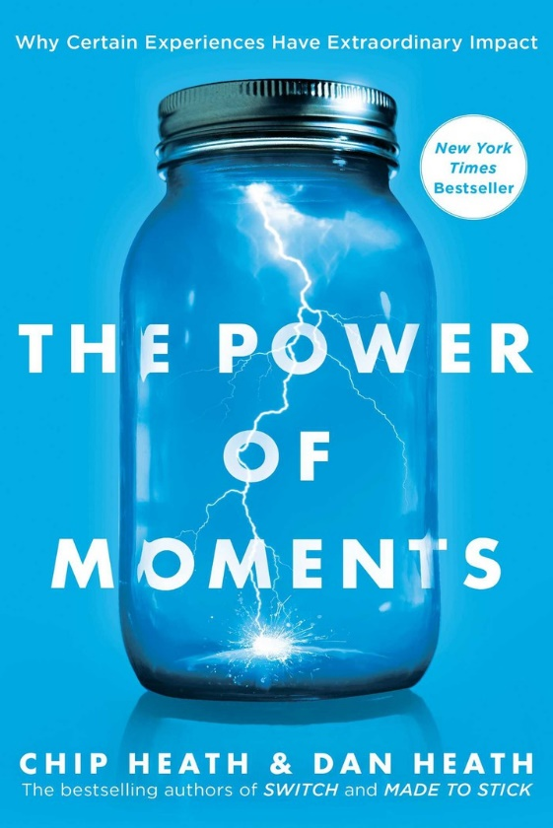

@GCS_SEL_OFFICE

For Staff

For Students

**Be a RAMily Reader!**

**SEL QUICK WINS**

Use relationship-building strategies to work together for the good of the group.

Use the three signature practices.

Listen.

Reflect.

Stop and Smell the Roses.