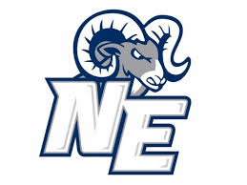

**The**

**RAMily**

**Report**

Tuesday, February 9, 2021

***Vol. 1, Issue 2***



**SEL FOCUS OF THE MONTH**

This month’s SEL focus is ***Identity***. There is obvious value in knowing who we are. However, developing an honest and accurate idea of who we are is not so easy. Recognizing how we see ourselves and how we think others see us is an important skill to develop and help our students to develop. Consider the following as you reflect on who you are.

Your Name

(Where did it come from? Does it have other meanings? What does it mean to you?)

Your Family

Your Friends

Your Friends

Your Social Groups

Your Beliefs

Your Values

Your Race

Your Gender/Gender Identity

Your Strengths

Your Areas for Growth

Your Interests

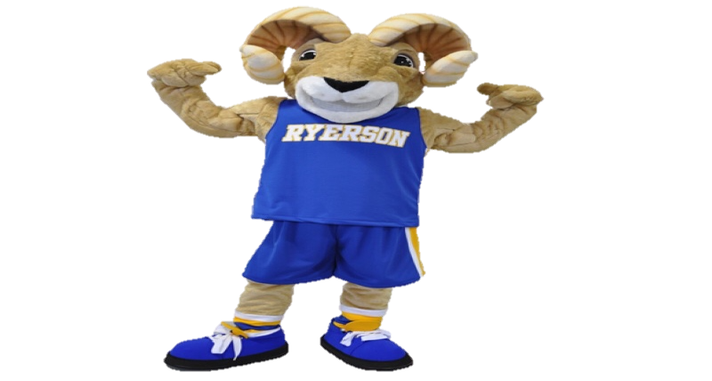

**NEMS**

@GCS_SEL_OFFICE

**SEL QUICK WINS**

**Get to know your strengths. Pay attention to or even journal about the things you think you are good at and the things you enjoy doing. Have students make a list of the natural talents they have and the abilities they have learned to do. Really pay attention to how your strength contributes to who you are.**

**Have a growth mindset. Do not limit yourselves to those things that you are naturally good at. After determining your strengths, think about the things you would like to grow in. Rather than assume you are not good at those things, make a list of strategies to help you get better in those areas. Choose one thing to work on at a time. Notice and log improvements as you work toward the goal.**

**Know your core values. Make a list of those qualities that you value in yourself and others. Chose your top three values. Start to pay attention to when you see those values show up in your life. Reflect on your experiences and revisit the core values you selected or choose another 3 to observe. See the link below for a list of core values from Elena Aguilar.**

[**https://www.onwardthebook.com/wp-content/uploads/2018/09/Core-Values.pdf**](https://www.onwardthebook.com/wp-content/uploads/2018/09/Core-Values.pdf)

GCS SEL Newsletter Updates



#RAMilyStrong

SEL DISTRICT

Northeast Guilford Middle School is a proud Social Emotional Learning Cohort 1 school!

At the beginning of this academic year, the staff engaged in schoolwide professional development with the SEL Lead where they received the “SEL OPTIMISTIC OPENER PLAYBOOK: A GUIDE THAT SUPPORTS CONTINUOUS ENGAGEMENT OF STUDENTS AND STAFF AT NEMS DURING THE 2020 – 2021 SCHOOL YEAR”. This playbook provided staff with the resources that currently assist them with being more in-tune with their scholars and their emotional needs. It is inspired by Guilford County School’s “SEL 3 SIGNATURE PRACTICES PLAYBOOK: A TOOL THAT SUPPORTS SYSTEMIC SEL”. While it has been edited to meet the needs of the students and staff at NEMS, the focus is still on the 3 Signature SEL Practices and 5 core competencies!

The RAMily at Northeast Guilford Middle School believes in CASEL’s SEL Framework, as well as, the work of our district’s SEL Leadership Team. Teachers are given the freedom to modify the activities that fit best for their live lessons and have been volunteering to facilitate an Optimistic Opener at the beginning of the weekly staff meeting. This has been a great way to start the meetings as teachers display for their peers how they are fostering an environment that is deeply rooted in self-awareness, social awareness, and how those take form in sharpening their relationship skills.

The SEL Team at NEMS has charged itself with providing staff with a NEMS themed newsletter every month highlighting the important updates from the district’s SEL Team. The team has also worked closely with the staff, and families to create an SEL Vision Statement and it has been posted to their school website! In this semester ahead, The SEL Team and staff at NEMS look forward to extending this same excitement and practice to their community partners as they truly believe that “it takes ALL of us to keep our RAMily Strong!”

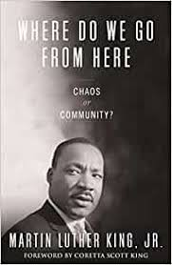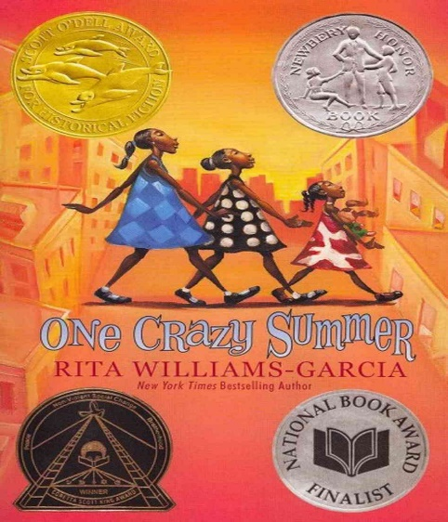

**Be a RAMily Reader!**

For Staff

For Students

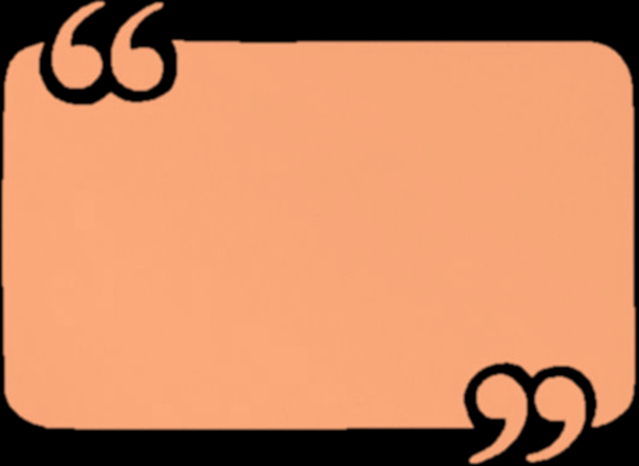

When a child walks into a room, your child or anybody else’s child, do your eyes light up? That’s what they’re looking for.

-Toni Morrison

My culture is my identity and personality. It gives me spiritual, intellectual and emotional distinction from others and I am proud of it.

-M.F. Moonzajer

Be yourself; everyone else is taken.

-Oscar Wilde

QUOTATION STATION

Helping Students Cope with Challenges as they Return to Face-to-Face Learning--->

6 Ways to be an Antiracist Educator

Youth Voices: Locating Personal Identity, Agency, and Belonging in all Learning Spaces

Check out these videos for tips and tricks that can be used in school and online.

#RAMilyStrong