

**The**

**RAMily**

**Report**

Tuesday, March 16, 2021

***Vol. 1, Issue 3***



**SEL QUICK WINS**

**Allow opportunities for voice. Look for ways throughout the day for students to engage and express their ideas and thinking. This can be explaining their understanding of an instructional concept, giving their opinion on a current event, or sharing something about themselves. The same is true for adults. Allow time during meetings for staff members to openly brainstorm, share their opinion or learn more about each other.**

**Take brain breaks and/or moments for reflection. Allowing students moments of reflection gives them a chance to absorb instruction. They have a moment to examine their understanding and misunderstanding. This allows them to ask clarifying questions or contribute more deeply to discussions.**

**Allow for choice. In most classrooms, the teacher is the sole decision-maker. Look for places where students can have a choice. Simple choices such as where to sit (which may not be feasible during COVID) can make an impact on students. But, more significant decisions such as how to present their learning and understandings, how to prioritize tasks, or who to work with on certain projects can go a long way to building agency in students and helping them to feel that they matter in their classroom settings.**

**SEL FOCUS OF THE MONTH**

The SEL Focus of the month is AGENCY. We want to scream, shout, and sing to the entire district that students learn better when they want to learn. Yes, it seems obvious and something that we have heard over and over again, but the research is very clear that giving a student voice and choice is the way to go. The redefined definition of SEL from CASEL emphasizes how imperative promoting students’ personal identities, agency, and a sense of belonging in the classroom, school, and community is to a student’s overall social and emotional development. This month take a moment to ask students what they love about learning and how they learn best. They are the experts in how they learn-not us. When we take a moment to ask questions, we build agency which impact how students experience our classrooms and school. AND friends let’s not just ask questions, let’s ask the right questions!!! Let’s focus on what a student experiences when they enter our learning environment. Some of us may feel like if we ask too many questions of what students need-they may actually tell us, and this may mean that we have to give up some control. Guess what? It is ok. Our students can handle it. They are begging for it.

@GCS_SEL_OFFICE

GCS SEL Newsletter Updates



#RAMilyStrong

Strategies to Promote Agency

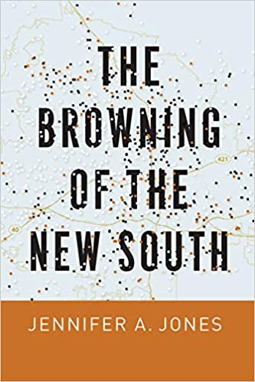

* Create a culture of inquiry and creativity
* Complete one on one check ins with students and ask them for feedback
* Create brave spaces in your classroom where it is ok to take risk
* Honor the perspectives of all students. Think about how your classroom can elevate the quiet voices too (everyone has something to say)
* Be attentive and sensitive to the needs of students, but do not lower standards and neglect agency
* Strive to achieve an environment that is respectful, engaging, and rigorous
* Utilize The 3 Signature Practices in your classroom

**Be a RAMily Reader!**

For Students

For Staff



What does student voice look like?

Inclusion. Integration. Transformation. Empowerment.

QUOTATION STATION

Agency is your power to become. Each choice takes you closer to or further from what you are meant to become.

-Randall L. Ridd

There is no greater agony than bearing an untold story inside you.

-Maya Angelou

Developing Agency with Student-Led Conferences

Teaching Wellbeing: Helping Students Tackle Social Issues

Check out these videos for tips and tricks that can be used in school and online.

#RAMilyStrong