

**The**

**RAMily**

**Report**

Wednesday, April 28, 2021

***Vol. 1, Issue 4***



**SEL QUICK WINS**

**Belonging is not the same as fitting in. Fitting in means we have had to change ourselves to be similar to in order to be accepted. Allow adults and students to come as who they authentically are. Appreciate difference as much as we appreciate commonalities.**

**Circle Time – We talk about circle time often. It’s a great place to have conversations on a variety of subjects. All time during circle for students to share who they are. Ask questions, particularly when noting differences. Teach your students to be inquisitive about each other.**

**Be a model. Some students (and adults) tend to shy away from or even tease someone who looks or acts differently. Be a model for your students in the way that you ask questions, engage with, and appreciate differences. Do this even among adults. Your students are watching.**

**Expose your students to a variety of people. It is important that students see themselves in school, classroom, and curriculum. But it is also important that they see others. Use books and materials that represent diversity. This is not just diversity as it relates to race, but diversity in the ways people live, work, play, and go about their lives.**

**SEL FOCUS OF THE MONTH**

The SEL Focus of the month was “BELONGING: Belonging is the innate human desire to be part of something larger than us. Because this yearning is so primal, we often try to acquire it by fitting in and by seeking approval, which are not only hollow substitutes for belonging, but often barriers to it. Because true belonging only happens when we present our authentic imperfect selves to the world, our sense of belonging can never be greater than our level of self-acceptance.”

–Brené Brown, Daring Greatly: How the Courage to Be Vulnerable Transforms the Way We Live, Love, Parent, and Lead.

@GCS_SEL_OFFICE

GCS SEL Newsletter Updates



#RAMilyStrong

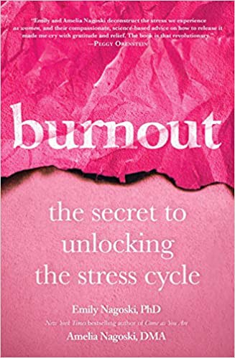

The following is from the Bullying Prevention Coordinator:

The SEL Department continues to make strides in sharing and providing bullying prevention resources with all GCS to help improve student’s physical and emotional safety at school. Unfortunately, children with disabilities are disproportionately affected by bullying. Therefore, to help students achieve their full potential , PACER’s National Bullying Prevention Center has shared 5 important facts to help students with disabilities.

“Although only ten U.S. studies have been conducted on the connection between bullying and developmental disabilities, all of these studies found that children with disabilities were two to three times more likely to be bullied than their nondisabled peers” (Disabilities: Insights from Across Fields and Around the World; Marshall, Kendall, Banks & Gover (Eds.), 2009).

**Be a RAMily Reader!**

For Students

For Staff

Positive Behavior and Bullying Prevention



5 Keys to Social and Emotional Learning Success

Identity cannot be found or fabricated but emerges from within when one has the courage to let go.

-Doug Cooper

To give real service, you must add something which cannot be bought or measured with money, and that is sincerity and integrity.

-Douglas Adams

QUOTATION STATION

Check out this video for tips and tricks that can be used in school and online.

#RAMilyStrong