Directions for changing a student’s password in NCEd Cloud.

Go to the cloud.

Click on profiles

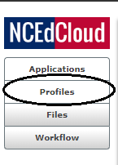

Click on My Students.

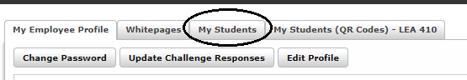

Then choose the box beside the student’s name that you want to change.

Then choose change password. Please note the password Policy.

Enter the New Password

Confirm New Password

After you hit save, make sure you uncheck the box by the students name.