How to Save to your OneDrive

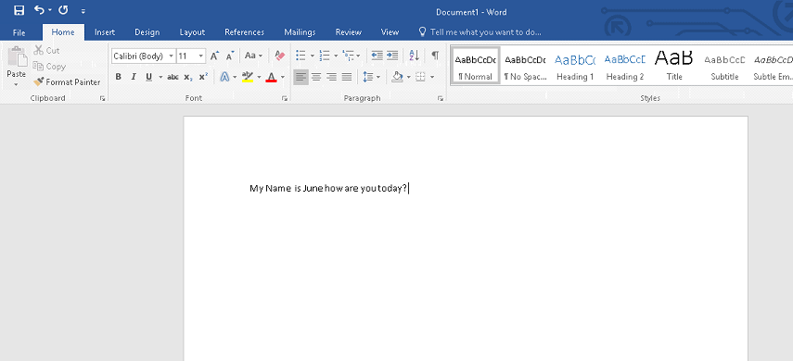

Click File

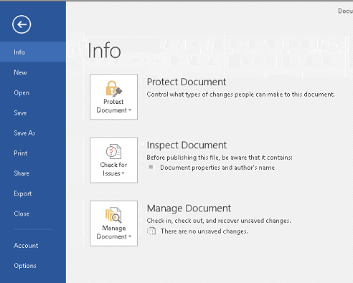

Click Save AS

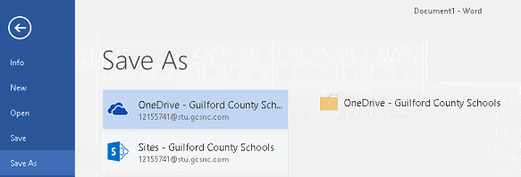

Click OneDrive 1st with Cloud

Then Double Click OneDrive Folder

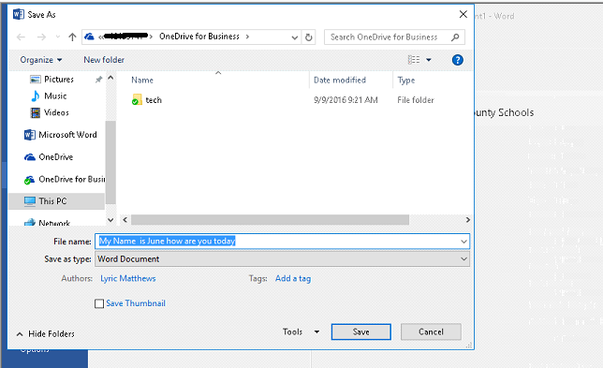

Double Click on YOUR Tech or Technology Folder

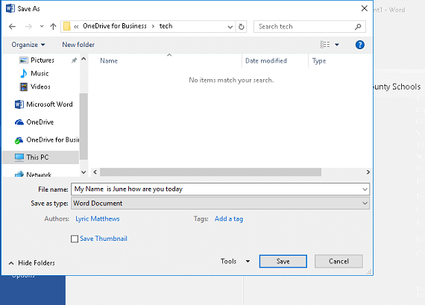

Click Save