**How to Access GCS Google Apps?**

1. Open Google Chrome or Edge browser and visit the following URL:  [https://drive.google.com/a/mygcsnc.com](https://nam05.safelinks.protection.outlook.com/?url=https%3A%2F%2Fdrive.google.com%2Fa%2Fmygcsnc.com&data=02%7C01%7Cjenkins3%40gcsnc.com%7Ca749ada265464a5b25e708d8326a9e18%7C9ae2fb1fdea24c4381947624fcbbb30c%7C0%7C0%7C637314780795505722&sdata=CBVmIUCl%2FfuUeqr1GOCT3QcAszqXDstzvRCDJmOKcNQ%3D&reserved=0)
   * If you are inside of the GCS network or are connected via Virtual Private Network (VPN) you will be taken directly to your google drive.
   * If you are opening from home or public internet you will need to login with your GCS email account (NOT your personal g-mail account)
2. Type your student id for the username and your birthdate for the password.

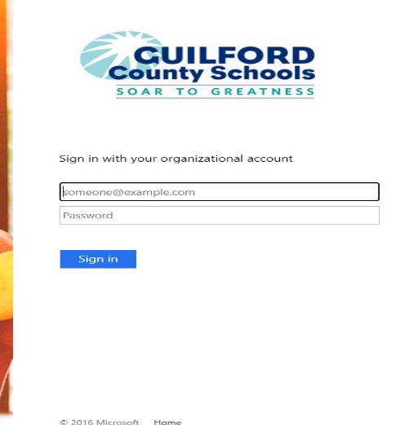

3.    After clicking Sign In, you will need to Accept terms for Google Drive and then you will be taken to the Google Drive as shown below. Your GCS student id and name should show up in the upper right corner.

