**(Free) EBOOKS & Digital Resources**

**Follet Destiny Shelf ~ E-books**

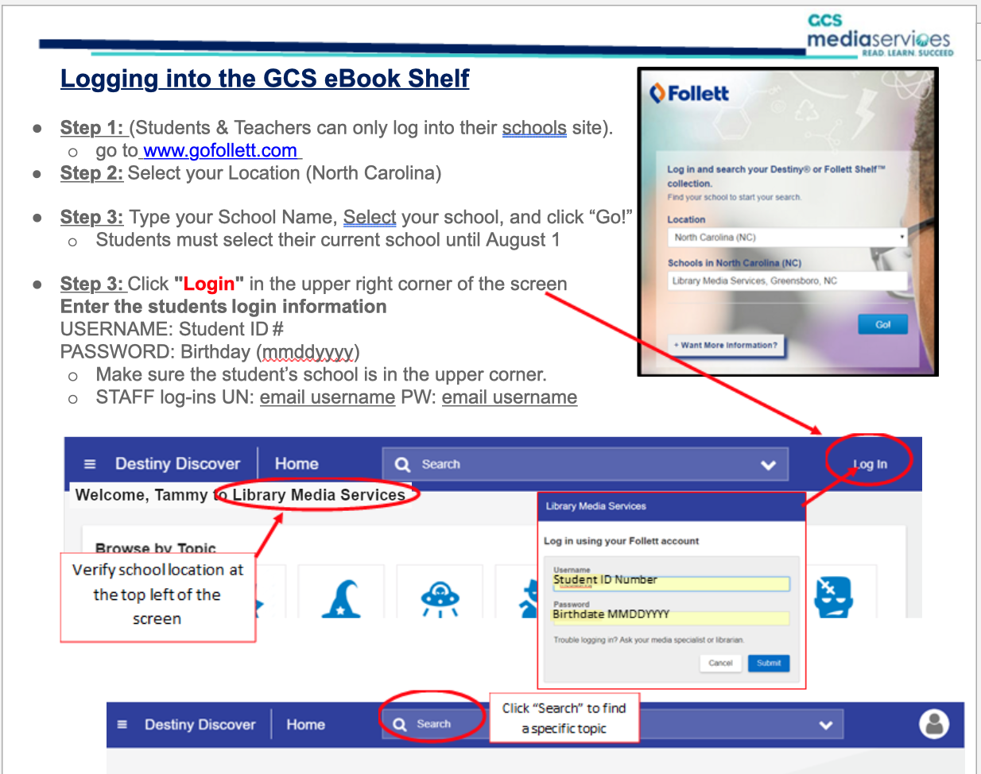

**NC Wise Owl** ~ <http://www.ncwiseowl.org/> ~ 1,000s of free E-Books

* Once on NC Wise Owl there are many different options for free e-books. The largest collection is under the heading “E-books” but under Searchasauraus you can search for books by lexile level.
* If ever prompted for a password ( if you use it at home you will be) the password is wiseowl19

**Open Library** ~ <https://openlibrary.org/> ~ 1 million free e-books

* Some are available in audio format as well.

**International Children’s Digital Library** ~ <http://en.childrenslibrary.org/> ~ 1,000s of free ebook as well as videos and audio books

* Can make a free account to create a bookshelf
* Books available in 61 languages
* Easy search functions. Can even search by front cover color.

**We Give Books** ~ <http://www.wegivebooks.org/books> ~ Picture books for ages 0-10

* You must either login ( it is by First Book ) or create a free account
* The books are newer books and show up beautifully on screen but they do not have audio

**Storyline Online ~**  <http://www.storylineonline.net/> ~ Actors and Actresses read books aloud. Wonderful for Elementary.

**Unite for Literacy** ~ <http://uniteforliteracy.com/> ~ Picture books that have audio in many different languages. Perfect for our ESL students learning to read English.

* Over 100 books that are beginner picture books.
* Has many languages to pick from

**NC Live** ~ <https://www.nclive.org/>

* Free access to ebooks, audiobooks, videos, online magazines, newspapers, journals

**Greensboro & High Point Library**

**Students will login by using GCS + student number. The PIN is birth day + birth year.** It is the same for both Greensboro and High Point Library System.

**QUICK FACTS:**

* Students will gain 24/7 access to an array of online resources provided by both the Greensboro Public Library and the High Point Public Library.
* Students will be able to borrow 10 total items at any given time, with a maximum of 5 electronic items.
* Students will login by using GCS + student number. The PIN is birth day + birth year.
* There are no overdue fines for GOALS library accounts. However, students and their parents/guardians will be responsible for the cost of lost materials.
* All GCS students are automatically enrolled in the GOALS program. Your Principal has an opt-out form available for parents not wanting their child to participate in the initiative.

**Newsela ~** <https://newsela.com/> ~ Online news articles that can be differentiated to different lexile levels within the same article. Now has a comprehension quiz and writing prompt attached.

* Create a free teacher account and then make a class
* Students then create a free account with the code you give them for their class