NGMS Car Rider Drop-off and Pick-up Procedures
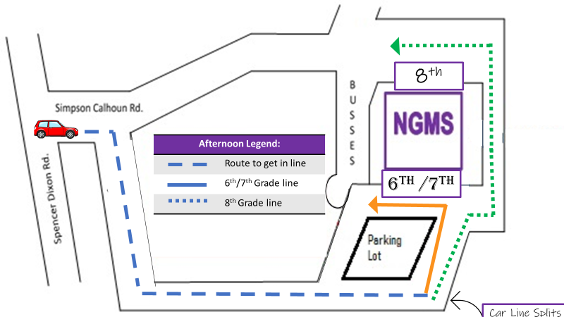
Entering the Car Rider Line
All traffic coming unto campus for drop-off and pick-up should turn right at the softball field.
Arrival
- All Car Riders will drop-off at the front of the building from 7:45 -8:30 for arrival in one line. All car riders must enter through the front of the building in order to go through scanners.
- From 7:45-8:10 students will sit in the gym by grade levels.
- At 8:10, students will be dismissed directly to breakfast or homeroom.
- Students wanting breakfast after 8;10, should report directly to the cafeteria.
Student
First & Last Name
Grade Level
- Any student reporting directly to homeroom will not be allowed to go back to the cafeteria.
- Students are marked tardy if they are not in Homeroom classrooms by 8:30.
Dismissal
- Walkers will be dismissed at 3:30 and car rider names will be called starting at 3:30. Any student needing to leave before this time should be picked up prior to 2:30 for early dismissal.
- Cars should follow the map above to see where to split for 6th/7th and 8th grade car pick up. 6th/7th will go in the left lane to the front of the building and 8th grade only cars move to the right lane and then go around the back of the building.
- Name Tags should be displayed in the front dashboard or hanging from the rearview mirror for
afternoon pick-up. Please write name in large, bold print for the caller to see clearly from a far-away distance. Having signs hanging from rear view mirror or holding them up make it easier for the caller to see. Signs laying on the dash-board may be hard to see.
- Staff member(s) on duty will call names to alert students to come to their designated pick-up area.
6th and 7th Grade (and any car picking up 6th/7th and 8th combination of students)
- 6th and 7th grade will continue left in front of the school.
- 6th and 7th grade will pick up at the front of the school and students will come out the main doors.
- Cars are asked to pull down as far as possible in order to load as many students as possible at once.
8th Grade
- 8th grade will turn right behind the school.
- 8th grade will pick up will occur as close to the outdoor learning center as possible. Students and drivers should follow directions of staff on duty. Once again, please load as many students as possible once cars have stopped.

