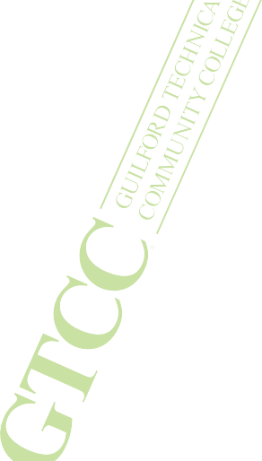
PARALEGAL TECHNOLOGY

The Paralegal Technology program prepares you for an important role in a fast-growing field, working under the supervision of a lawyer to provide high-quality, reasonably priced legal services in a highly competent, ethical and professional manner.

What can I do with this degree/certificate?
> Graduates are trained to assist attorneys in probate work, investigations, public records search, drafting and filing legal documents, research, and office management.
> Employment opportunities are available in private law firms, governmental agencies, banks,
insurance agencies, and other business organizations.
> A paralegal does not practice law, give legal advice, or represent clients in a court of law.
> Graduates qualify to take the N.C. paralegal certification exam.

What will I learn in the program?
> Analyze legal issues using critical thinking and basic law concepts.
> Apply professional standards to ethical dilemmas commonly encountered by paralegals.
> Research legal and factual issues using traditional and emerging technology tools.
> Draft common legal documents using proper legal citation.
> Demonstrate use of computer skills and technology to perform functions relevant to the legal field.

Opportunities for further study
Students who complete a two-year degree often continue their education to get a bachelor’s degree and some even go to law school.

See back of flyer for degree or certificate information and course offerings.

gtcc.edu

PARALEGAL TECHNOLOGY

Two pathways to success:
AAS degree for students who have their High School diploma or GED; or
Certificate for students who have an AA/AS or BA/BS with 18 General Education credits.

AAS PATHWAY – 64-66 credits
Fall Semester I | Fall Semester II
ACA 111 College Student Success | LEX 210 Real Property I
CIS 110 Intro to computers | LEX 140 Civil Litigation I
ENG 111 Writing and Inquiry | LEX 240 Family Law
LEX 110 Intro to paralegal Study | LEX 250 Wills, estates and Trusts
LEX 120 Legal Research & Writing I | LEX 280 Ethics & Professionalism
POL 120 American Government | LEX 271 Law Office Writing
Spring Semester I | Spring Semester II
LEX 121 Legal Research & Writing II | LEX 270 Law Office Management & Tech.
LEX 130 Civil Injuries | LEX 141 Civil Litigation II
LEX 150 Commercial Law I | LEX 160 Criminal Law & Procedure
MAT 143 Quantitative Literacy | LEX Paralegal Elective
LEX Paralegal Elective | LEX Paralegal Elective
Summer Semester I
COM 231 Public Speaking
Humanities/Fine Arts elective

CERTIFICATE PATHWAY – 18 credits

LEX 110 Intro to Paralegal Study
LEX 120 Legal Research and Writing I
LEX 140 Civil Litigation I
LEX 270 Law Office Management & Technology OR LEX 271 Law Office Writing

LEX 280 Ethics and Professionalism
LEX Paralegal Elective
LEX Paralegal Elective

For more information about these programs contact:
Pamela Hollern, J.D.
Program Director, Paralegal Technology
336-334-4822 Ext. 53077/ pehollern@gtcc.edu

