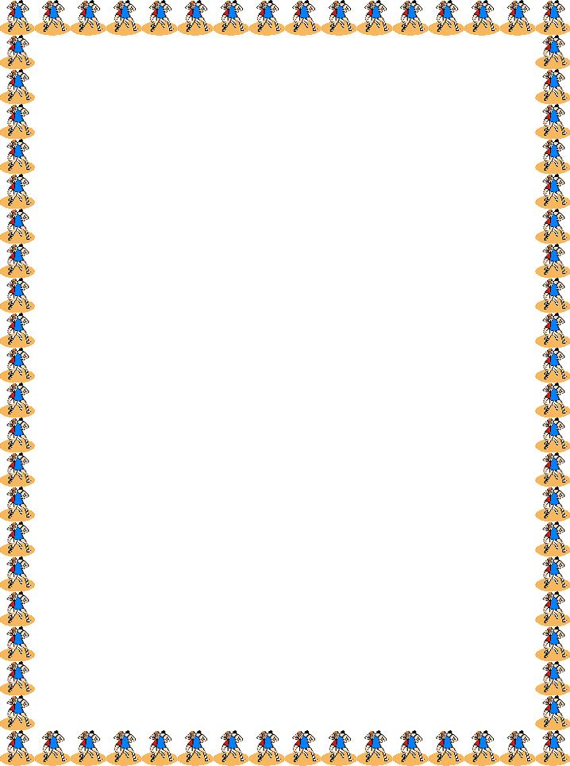

**Mendenhall Middle School**

**2017-2018 Wrestling Schedule**

**Match Time: 5:00 pm (unless otherwise noted)**

**Non-Conference**

Thursday, December 7 vs. Swann (Away)

Tuesday, February 7 vs. Northeast (Away)

**Conference**

Monday, December 11 vs. Northwest (Away)

Thursday, December 14 vs. Northern (Home)

Monday, December 18 vs. Southwest (Away)

Monday, January 8 vs. Kernodle (Home)

Thursday, January 11 vs. Jamestown (Home)

Monday, January 22 vs. Northwest (Home)

Thursday, January 25 vs. Northern (Away)

Monday, January 29 vs. Southwest (Home)

Thursday, February 1 vs. Kernodle (Away)

Monday, February 5 vs. Jamestown (Away)

Tuesday, February 6 vs. Southeast (Away)

Monday, February 12 vs. Southeast (Home)

**Conference Tournament – Saturday, 2/3 @ Northwest High**