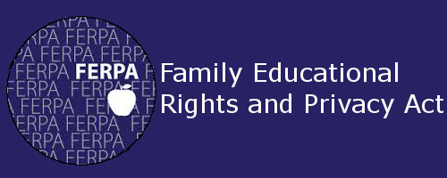

FERPA, or the Family Education Rights Privacy Act, is an important set of federally mandated laws that protects the privacy and personally identifiable information of students in public schools and universities in the United States. This law prevents schools and universities from providing private information about a student to outside individuals.
Due to the fact that students in the junior and senior years at Dudley Early College Academy are considered students of Guilford Technical Community College, those students and their information are protected under FERPA. This means that the university cannot release information about a student's schedule, grades, or other identifiable information to anyone other than the student. In the case of dual enrolled students, FERPA allows the postsecondary institution (i.e. GTCC) to release information about a student to the secondary institution (i.e. Dudley Early College Academy).
"If a student is attending a postsecondary institution--at any age--the rights under FERPA have transferred to the student. However, in a situation where a student is enrolled in both high school and a postsecondary institution, the two schools may exchange information on that student. If a student is under 18, the parent still retain the rights under FERPA at the high school and may inspect and review records sent by the postsecondary institution to the high school." (FERPA FAQs)

What does this mean for you?
FERPA guidelines prevent university professors or staff from sharing student grades or other information with anyone other than the student or a representative of Dudley Early College Academy. This means that professors and university staff cannot legally provide any information to parents about a student's progress or behavior in university classes.
In any instance in which parents have concerns about student grades or performance during the dual-enrolled years, parents should contact the junior or senior advisor. Parents should not attempt to directly contact professors as they will not release any information about the student.

