**PLEASE SHARE WITH FRIENDS AND FAMILY!**

**AMAZON DONATES 5% of our purchases to BROWN SUMMIT MIDDLE SCHOOL**

1. **Go to** [**https://smile.amazon.com/**](https://smile.amazon.com/) **and log in as you would normally do for your Amazon account.**

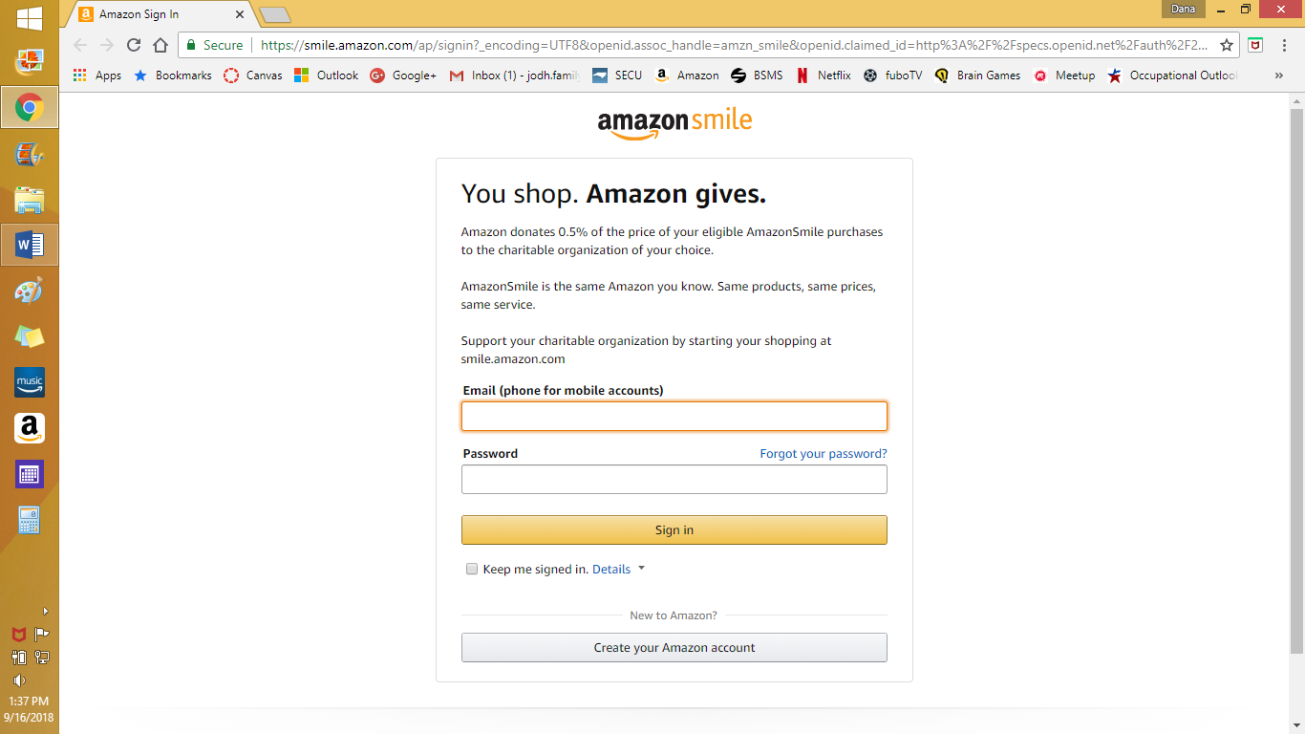

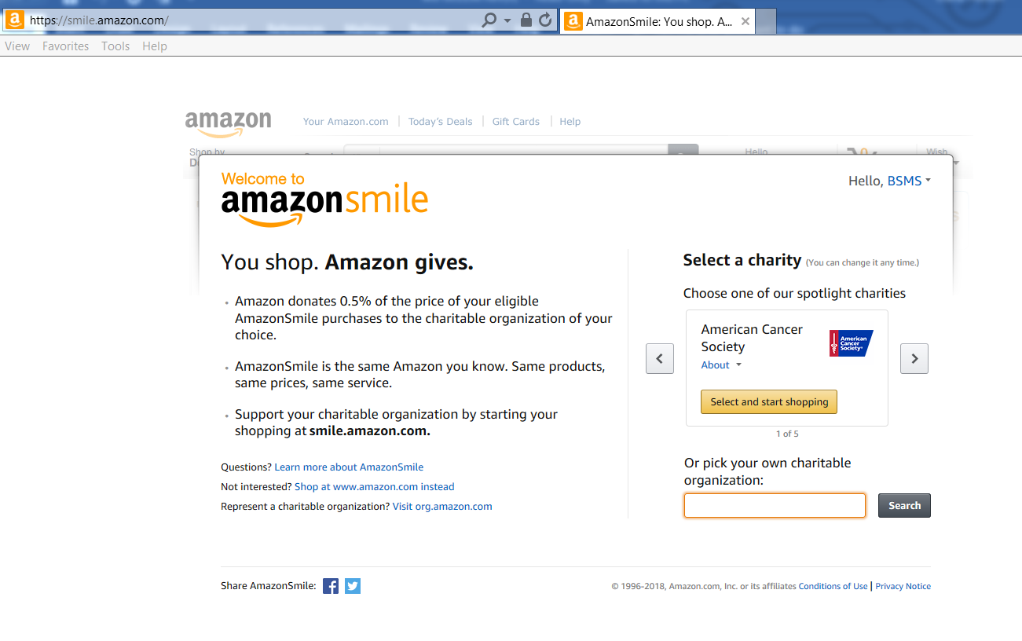

1. **Type in Brown Summit and click SEARCH**

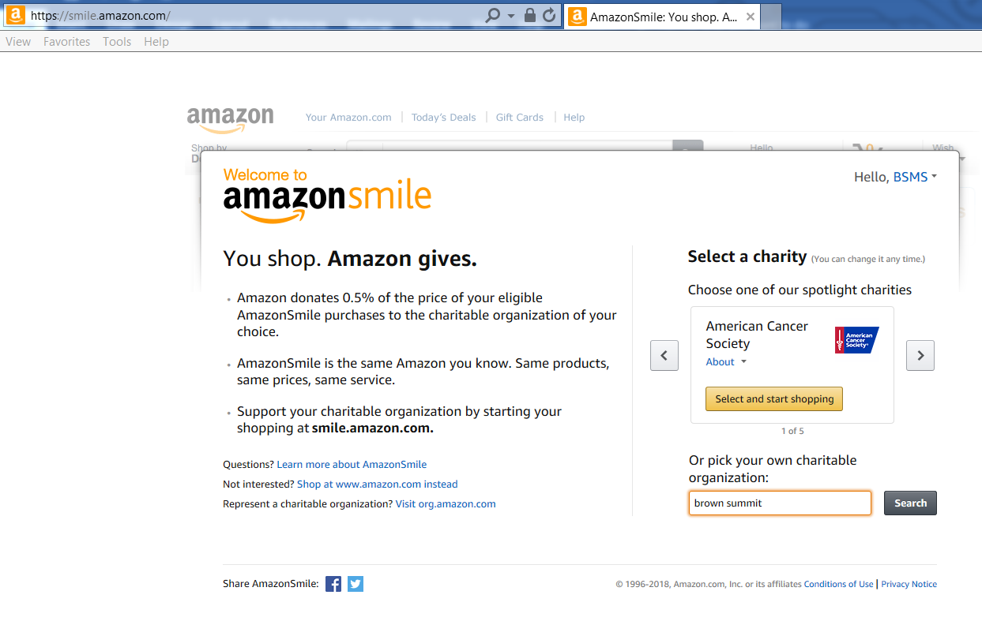

1. **Select “Brown Summit Middle School PTSA” located in Brown Summit, NC**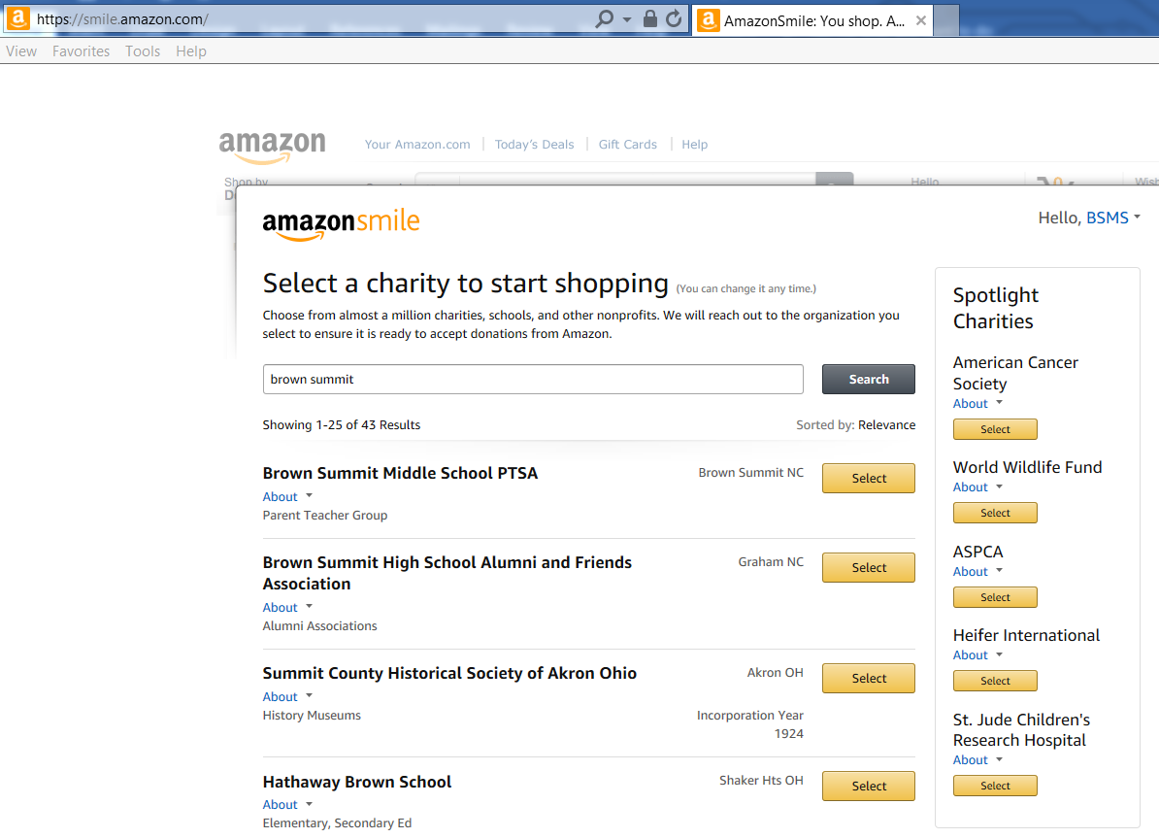
2. **Agree to the reminder**

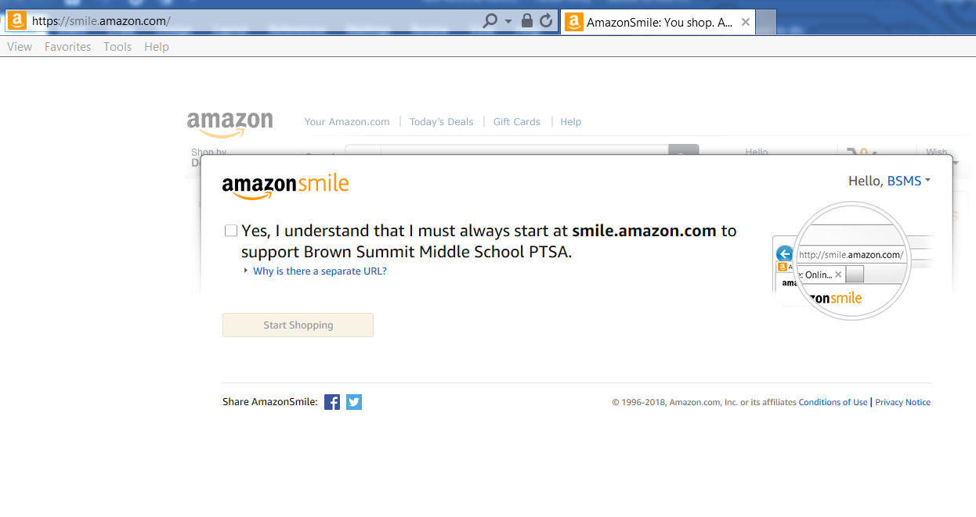

1. **Easy way to remember to go to SMILE.AMAZON.COM:**
   1. Complete your regular Amazon shopping through the app or on-line
   2. Before checking out, go to a shortcut that you have created either on your desktop or phone (**see example below**)
   3. Open the Smile.Amazon shortcut and return to your cart.
   4. Continue placing your order.

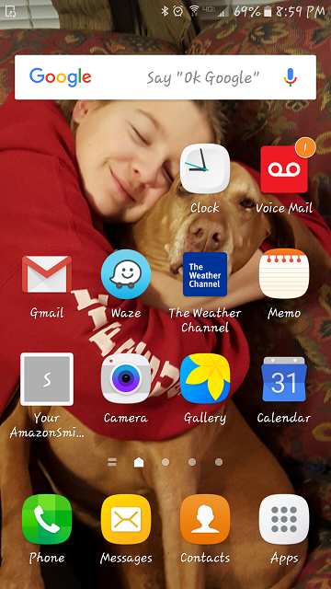

**THANK YOU VERY MUCH for supporting Brown Summit Middle School’s PTSA with just a few extra steps! Brown Summit Middle School PTSA**