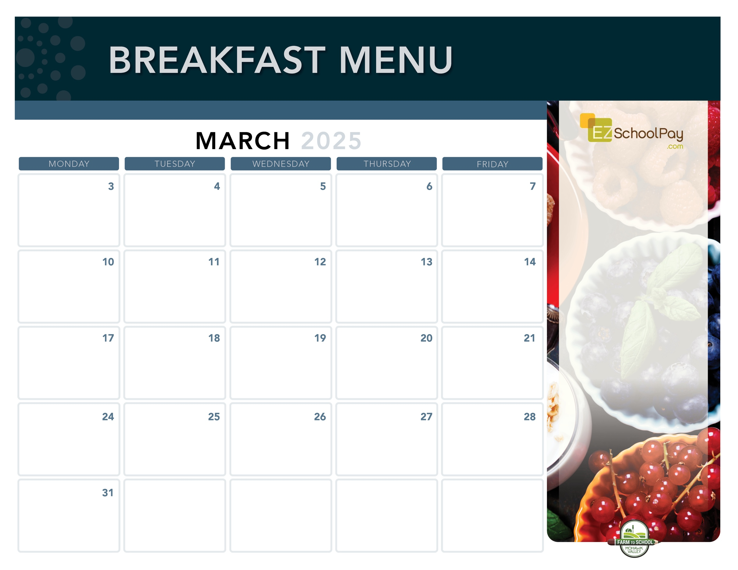
Sauquoit Valley Elementary School
Pancake
Sausage Stick

Snackin’
Waffle

Whole Grain
Pancakes

Homemade
Banana Chocolate Chip Muffin Bars
& Yogurt

Red, White & Blue
Yogurt Parfait

Superintendent’s Conference Day –
No School

Fruit
Frudel

Mini
Cinni
Scrambled Eggs
& Toast
11:30 Dismissal
Parent/Teacher Conferences
No Lunch

Good Morning
Wrap
Breakfast
Pizza
Zee Zee
Bar
Red, White & Blue
Yogurt Parfait

Breakfast
Sandwich

Assorted Whole
Grain Muffins
& Yogurt

Snackin’
Waffle
11:30 Dismissal
Parent/Teacher Conferences
No Lunch

Available Daily
-Yogurt
-Assorted Whole
Grain Cereals
-Fresh Fruit
-Chilled Fruit Juice
-Ice-Cold New
York State Milk
Plain or Chocolate

OHM BOCES Food Service is an Equal Opportunity Employer.

Nature Valley
Oatmeal Rounds
Assorted Whole
Grain Muffins
& Yogurt

Cinnamon
Bun
Fruit
Frudel
Breakfast
Sandwich

Breakfast is Free | Menu is subject to change | For more information, contact hdussault@oneida-boces.org

