­­­ 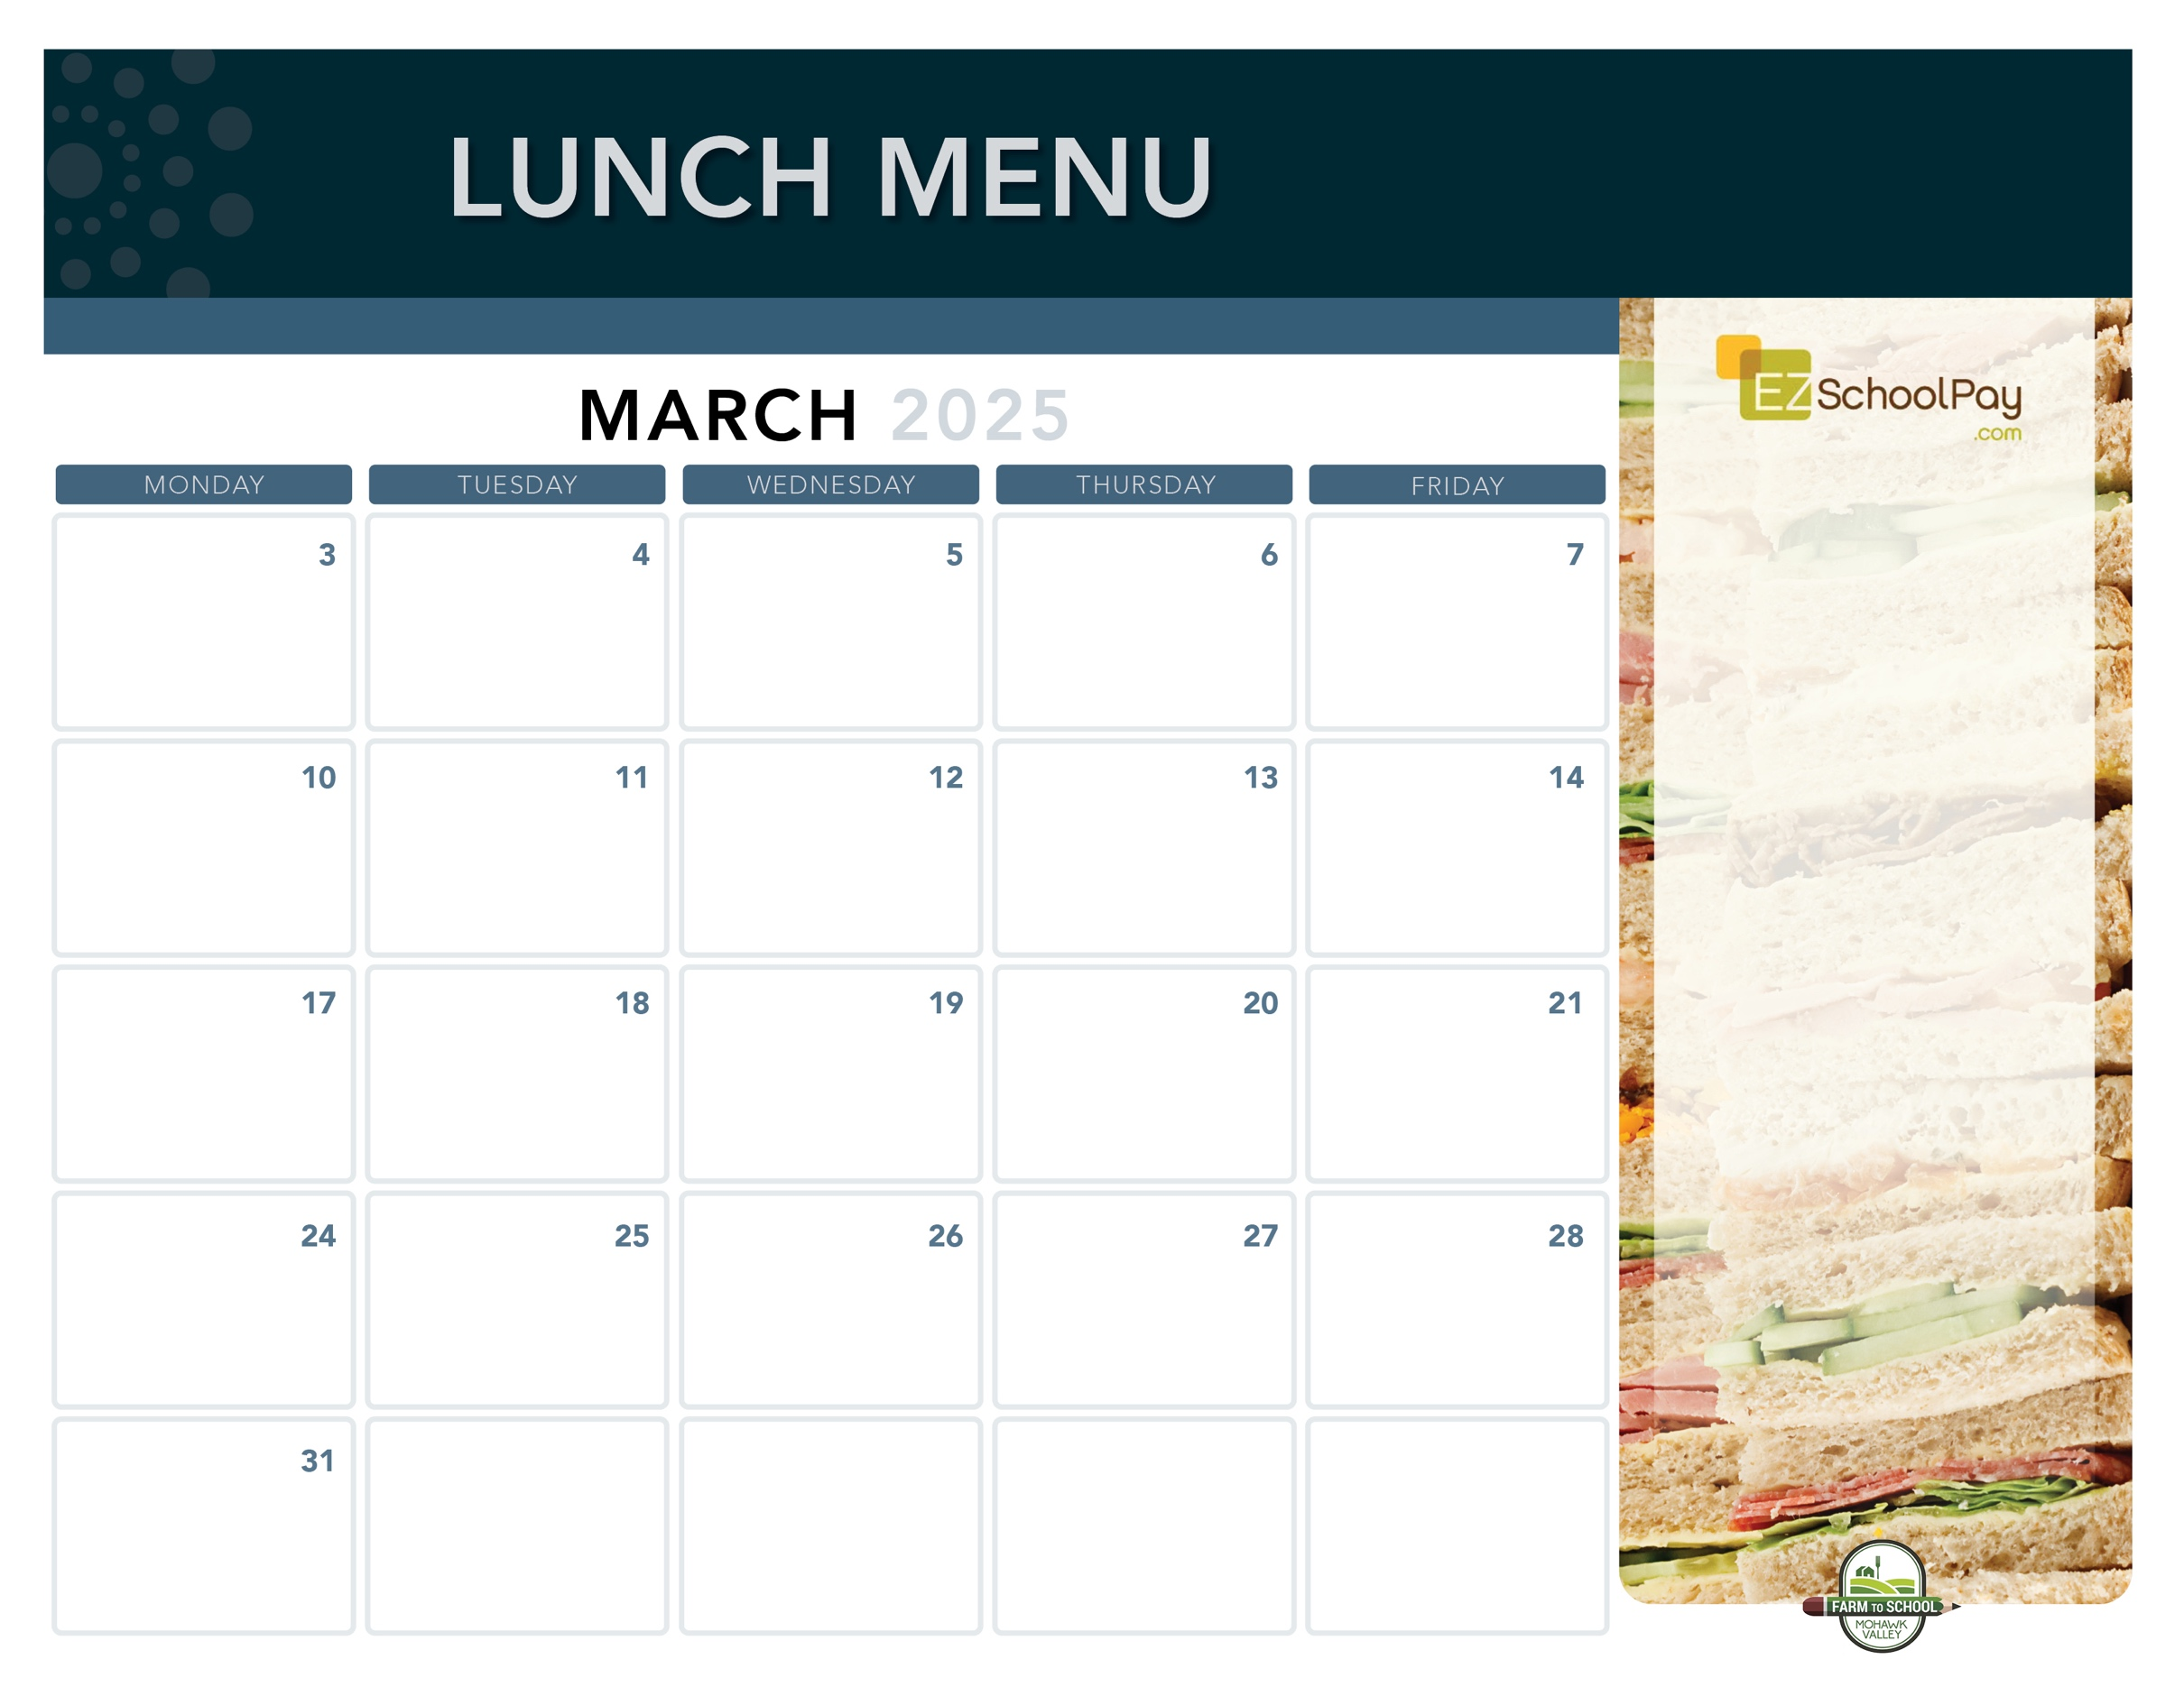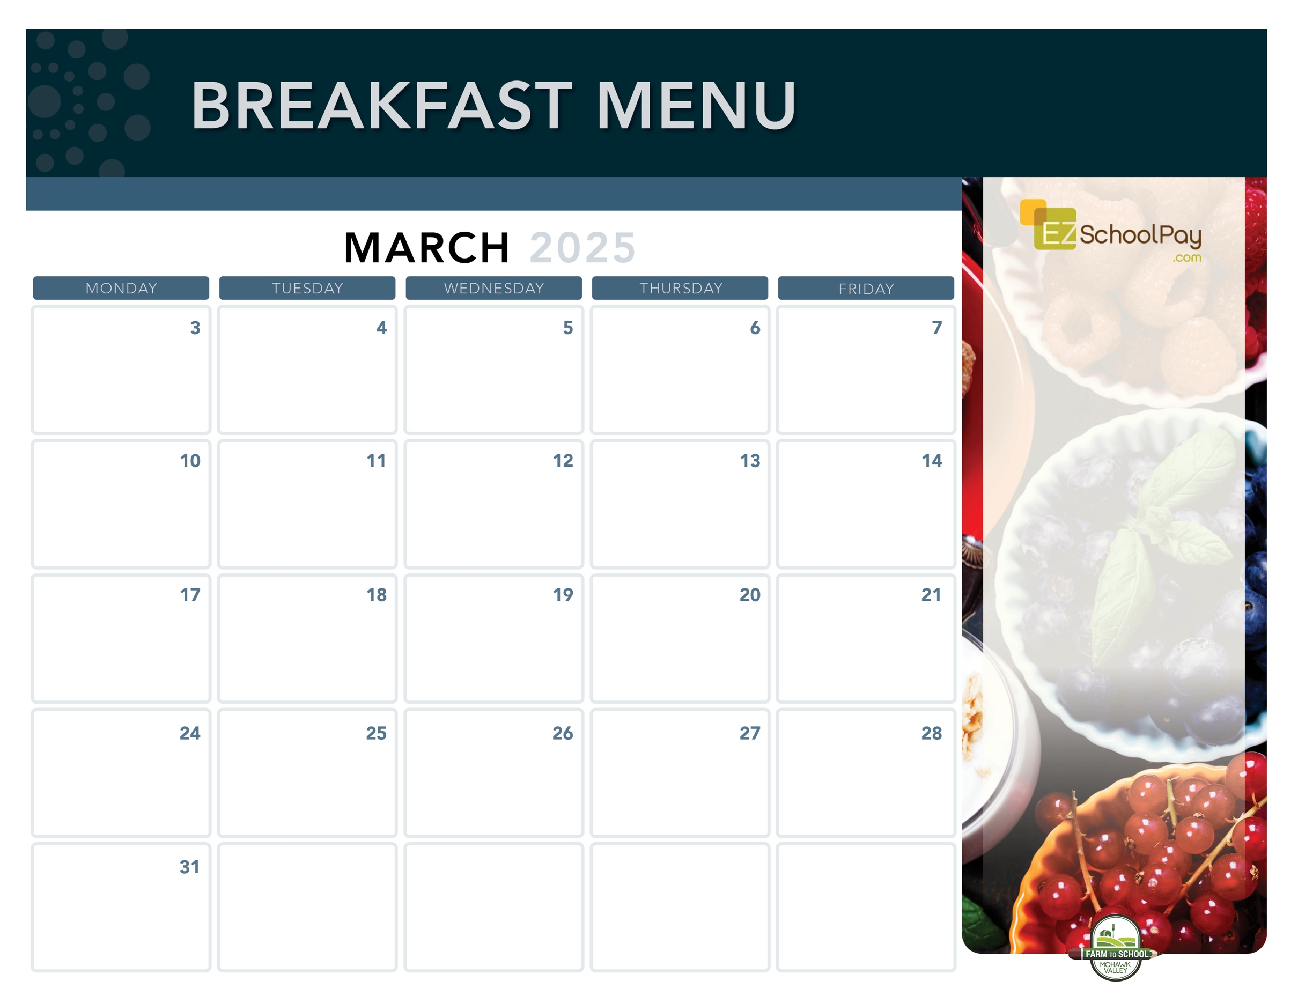

**Superintendent’s Conference Day –**

**No School**

**11:30 Dismissal**

**Parent/Teacher Conferences**

**No Lunch**

**11:30 Dismissal**

**Parent/Teacher Conferences**

**No Lunch**

**New!**

**Pizza Party!**

Cheesy Cheese or

Sausage Pizza

Caesar Salad

**Brunch for Lunch!**

French Toast Sticks

Breakfast Sausage

Mixed Deli Sandwich

Golden Hashbrown

**Pizza Party!**

Cheesy Cheese or

Garlic Pizza

Fresh Green Salad

**Utica’s Famous**

**Chicken Riggies**

Mixed Deli Sandwich

Carrots

**Max Pizza Sticks**

Deli Ham Sandwich

Green Beans

**Homestyle**

**Chicken Tenders**

Goldfish Crackers

Tuna Salad Sandwich

Broccoli

**Sauquoit Valley Elementary School**

**Nachos**

**with Queso**

Deli Turkey Sandwich

Corn

**Crispy Chicken or Chicken Parm Sandwich**

Tuna Salad Sandwich

Broccoli

**Pizza Party!**

Cheesy Cheese or

Chicken, Bacon & Ranch Pizza

Fresh Green Salad

**Taco Tuesday**

Beef Tacos

Lettuce, Tomato & Cheese Cup

Deli Turkey Sandwich

Corn

**Dino’s Own**

**Meatball Sub**

Deli Ham Sandwich

Green Beans

Oreo Whip

**Philly Cheesesteak**

Deli Turkey Sandwich

Tater Tots

Miss Mila’s Cookie

**New!**

**Pizza Party!**

Cheesy Cheese or

Pepperoni Pizza

Fresh Green Salad

**Crispy Chicken**

**Sandwich**

Tuna Salad Sandwich

Broccoli

**Boneless**

**Chicken Bites**

**Plain or Garlic Parm**

Buttered Noodles

Tuna Salad Sandwich

Carrots

**Backyard BBQ**

**Hamburger or Cheeseburger**

Mixed Deli Sandwich

Tater Tots

**Boneless**

**Chicken Bites**

**Plain or BBQ**

Goldfish Crackers

Tuna Salad Sandwich

Broccoli

**Mozzarella Sticks**

**with Dipping Sauce**

Deli Ham Sandwich

Green Beans

**Available Daily**

Fresh Entree Salads

Party Plates

Peanut Butter & Jelly Sandwich

Fresh Sandwiches and Wraps

Assorted Fresh Fruit

Vegetable Cruncher Cups

Variety of Fresh Fruit & Juice

Ice Cold New York State Milk

Plain or Chocolate

**Local Items this Month**

Milk, Yogurt, Meatballs, Corn, Carrots, Green Beans, Dino’s Meatballs, Grape Slushie,

Miss Mila’s Cookie

Local items are indicated with a star on the menu

OHM BOCES Food Service is an Equal Opportunity Employer.

Lunch is Free | Menu is subject to change | For more information, contact hdussault@oneida-boces.org