Dobbins Middle School

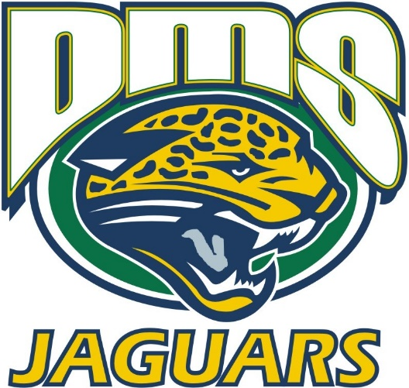

School Improvement Plan

2024 -2025

Dr. Donna Broyles_, Principal

PCSD VISION
PCSD MISSION

The vision of the Paulding County School System is to prepare ALL students for success today and tomorrow.

Engage. Inspire. Prepare.

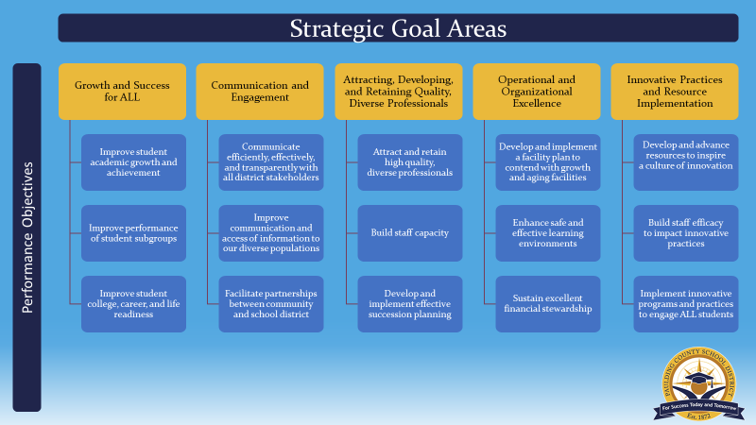
SCHOOL MISSION & VISION

Vision Statement Mission Statement
Disciplined Citizens Engaging our students to be
Motivated Learners liFelong learners in a
Striving for Excellence saFe environment while
prOmoting academic success and
shaRing responsibility in order
To create excellence

Statements of Belief
The faculty and staff of J. A. Dobbins Middle School believe the following:

- We believe in treating each person with respect.
- We believe in providing a safe, secure, and positive learning environment for all students.
- We believe education is a valuable, lifelong process that contributes to future success.
- We believe in the individuality of all students and strive to provide meaningful, engaging and rigorous educational experiences to challenge and motivate all students.
- We believe education is a collaborative effort involving students, parents, and teachers.

Dobbins Middle School PBIS Mission Statement
Dobbins Middle School Students as are expected to ROAR Daily:
R: Ready to Learn
O: Ownership of Actions
A: Actively Engaged
R: Respectful


SMART Goal 1: During the 2024-2025 school year, DMS teachers will increase the school percentage of Level 2, 3 and 4’s on the GMA ELA test for: 6th grade by 5% (from 71 % in 5th grade to 76% in the 6th grade), 7th grade by 5% (from 67% in 6th grade to 72%in the 7th grade) and 8th grade by 5% (from 72% in 7th grade to 77% in the 8th grade).

2023 | 2024 | 2025
6th Grade  % Reading at/or above the Mid Point: 44 %_ | 6th Grade  % Reading at/or above Grade:  _51 %_ | 6th Grade  % Reading at/or above Grade Level:__%_
  Level 1 | 30%
  Level 2 | 31%
  Level 3 | 36%
  Level 4 | 4%
  Level 1 | 33%
  Level 2 | 30%
  Level 3 | 34%
  Level 4 | 3%
  Level 1 | %
  Level 2 | %
  Level 3 | %
  Level 4 | %
 | 7th Grade  % Reading at/or above Grade Level:__69 %_ | 7th Grade  % Reading at/or above Grade Level:__%_
  Level 1 | 27%
  Level 2 | 32%
  Level 3 | 35%
  Level 4 | 5%
  Level 1 | %
  Level 2 | %
  Level 3 | %
  Level 4 | %
8th Grade
Level 1 | %
Level 2 | %
Level 3 | %
Level 4 | %
% Reading at/or above Grade Level:__%_

SY23-24 ELA Writing Data
 | % Reading at or above grade level Lexile Band | Reading and Vocabulary | Writing | Language
6th grade  (last year 5th grade)  Lexile Band  925-1070 | 129 out of 192: 67% | Not received Yet
  Below | Approach | Met
  Below | Approaching | Met
  Below | Approaching | Met
7th grade  (last year 6th grade)  181 scores used  Lexile Band  970-1120 | 51%
  Below | Approach | Met
  58% | 20% | 20%
  Below | Approach | Met
  46% | 25% | 29%
  Below | Approach | Met
  43% | 30% | 26%
8th grade  (last year 7th grade)  182 scores used  Lexile Band  1010-1185 | 69%
  Below | Approach | Met
  52% | 23% | 25%
  Below | Approach | Met
  38% | 29% | 37%
  Below | Approach | Met
  48% | 33% | 20%
School Averages
  Below | Approach | Met
  Below | Approach | Met
  Below | Approach | Met

Strategic Goal Area | Action Steps | Process Goals  (Guide your Action Steps) | Monitoring
Strategic Goal Area | Action Steps | Process Goals  (Guide your Action Steps) | Implementation | Effectiveness
Strategic Goal 1: Growth and Success for All- part 1,2,3 | Teachers will provide consistent Tier 1 vocabulary and writing instruction in their specific content area. | Teachers will participate in a school wide Data Dig PL session on July25 that focuses on student writing weaknesses for the first 9 weeks.  Teachers will separate students based on vocabulary and writing needs for NBI, based on GA Milestones 23-24 ELA data  Teachers will incorporate a bimonthly writing assessment in their content area and use GA State writing rubrics to complete the assessments. This data will be discussed at weekly collaborative planning sessions.  Teachers will participate in weekly PL sessions focused on implementing appropriate scaffolds for vocabulary acquisition.  Teachers will prepare students for the DMS Mock writing assessments and use the GA State writing rubrics to score the assessments.  A Mock Writing Assessment will occur on the following dates: | DMS Department Chair Walk throughs will take place on the following dates: Aug. 27, Oct. 31, Dec. 17, Feb. 6, school leaders will provide effective feedback to teachers regarding instruction and planning  School leaders will participate in the writing data digs.  School leaders will provide PL sessions on Scaffolding for explicit vocabulary instruction.  School leaders will provide PL sessions on Scaffolding for explicit writing instruction.  Teachers will maintain NBI folders and goal setting sheets for their writing NBI groups.  Teachers will meet weekly with their grade level/content area partners as well as their assigned administrator for collaborative planning  During scheduled Data Digs, teachers will use common writing assessments, Beacon Assessment Data and test blue prints to determine student growth and weaknesses. | Students will show growth in writing based on the DMS Mock Writing Assessments  Students will show improvement in writing in content specific quick writes.  Classroom Observations will be documented via TKES in both formal and informal situations  Weekly collaboration will be monitored and mediated by administration:  Dr. Broyles-  W. Mace- Social Studies and ELA  J. Thomas-  R. Simpson-  J.Pierce- Math  .

SMART Goal 2: During the 2024-2025 school year, DMS teachers will increase the school percentage of Level 2, 3 and 4’s on the Math GMA from: 6th grade % (from % in the 5th grade to % in the 6th grade), 7th grade by 5% (from 69% in the 6th grade to 74% in the 7th grade) and 8th grade by 5% (from 74% in the 7th grade to 79% in the 8th grade).

2023 | 2024 (Year 1 ILC) | 2025
6th Grade  1st Group to have Advanced and not Accelerated Math | 6th Grade | 6th Grade
  Level 1 | 28%
  Level 2 | 42%
  Level 3 | 25%
  Level 4 | 5%
  Level 1 | 30%
  Level 2 | 53%
  Level 3 | 13%
  Level 4 | 3%
  Level 1 | %
  Level 2 | %
  Level 3 | %
  Level 4 | %
 | 7th Grade  1st Group to have Advanced and not Accelerated Math | 7th Grade
  Level 1 | 25%
  Level 2 | 39%
  Level 3 | 28%
  Level 4 | 7%
  Level 1 | %
  Level 2 | %
  Level 3 | %
  Level 4 | %
 | 8th Grade  Last Group to have Accelerated Math | 8th Grade  1st Group to have Advanced and not Accelerated Math
  Level 1 | 24%
  Level 2 | 43%
  Level 3 | 24%
  Level 4 | 10%
  Level 1 | %
  Level 2 | %
  Level 3 | %
  Level 4 | %

Strategic Goal Area | Action Steps | Process Goals  (Guide your Action Steps) | Monitoring
Strategic Goal Area | Action Steps | Process Goals  (Guide your Action Steps) | Implementation | Effectiveness
Strategic Goal 1: Growth and Success for All- part 1,2,3 | Teachers will deliver consistent Tier 1 Math instruction in the grade level classroom | DMS teachers will participate in scheduled MTSS Data Discussion days  Teachers will maintain an engaging and visual learning environment with the use of anchor charts and word walls  Math teachers will be provided effective and instructional based feedback on classroom observations  Content Visits from Jenna Barton | DMS Department Chair Walk throughs will take place on the following dates:  School Leaders will provide effective feedback to teachers regarding instruction and planning  Title I Math Coach will assess classroom instruction and provide feedback to the Title I ILC.  Math Teachers will meet every Thursday with their grade level/content area partners as well as Title I ILC.  Title I ILC will determine coaching cycles for the 24-25 SY. | Increase in consistency for Tier I instruction  Increase in consistency for Math planning  Students will show improvement in writing in content specific quick writes.  Classroom Observations will be documented via TKES in both formal and informal situations  Weekly collaboration will be monitored and mediated by administration:  Dr. Broyles-  W. Mace- Social Studies and ELA  J. Thomas-  R. Simpson-  J.Pierce- Math

Dobbins Middle School Improvement Action Plan

SMART Goal 3: During the 2024-2025 school year, Dobbins Middle School will decrease the total number of days that students spend in ISS by 20 % (from 724 to 580 ) and decrease the total number of days in OSS by 20% (from 680 days to 544 days).

 | Total Days in ISS | Total Days in OSS | Total Repeat Students in ISS/OSS
22-23 SY | Total: 285.5 | Total: 455.5 | Total: 66
   | 1st | 2nd
  6th | 56 | 69.5
  7th | 63.5 | 20.5
  8th | 44 | 32
   | 1st | 2nd
  6th | 36.5 | 87
  7th | 60.5 | 95
  8th | 53.5 | 123
  6th | 25
  7th | 20
  8th | 21
23-24  SY | Total: 724  313 Events  175 Contributing Students | Total: 680  141 Events  116 Contributing Students | Total: 71  Total of Students without Behavior Referrals
   | 1st | 2nd
  6th | 71.5 | 82
  7th | 120.75 | 141
  8th | 162.5 | 146
   | 1st | 2nd
  6th | 66.5 | 31
  7th | 160.6 | 158.5
  8th | 163.3 | 99.5
  6th | 13
  7th | 32
  8th | 26
   | #w/o behaviors | # of kids in grade  level | % of kids w/o behaviors per grade level
  6th | 123 | 212 | 58%
  7th | 108 | 204 | 53%
  8th | 110 | 215 | 51%
24-25 SY | Total: ______Events  _____Contributing Students | Total: _____Events  _____Contributing Students | Total:  Total of Students without Behavior Referrals
   | 1st | 2nd
  6th
  7th
  8th
   | 1st | 2nd
  6th
  7th
  8th
  6th
  7th
  8th
   | #w/o behaviors | # of kids in grade  level | % of kids w/o behaviors per grade level
  6th |  |  | %
  7th |  |  | %
  8th |  |  | %

Strategic Goal Area | Action Steps | Process Goals  (Guide your Action Steps) | Monitoring
Strategic Goal Area | Action Steps | Process Goals  (Guide your Action Steps) | Implementation | Effectiveness
Strategic Goal 4: Operational and Organizational Excellence:  Part 2 | Teachers will implement the ROAR PBIS Program and Minga with fidelity. | PL will be held regarding the ROAR behavior flow chart  SWIS data will be entered weekly for monitoring.  MINGA will be used consistently throughout the building. | The number of points awarded by teacher will be monitored by the PBIS team and shared at DMS professional learning segment.  Student discipline data (# of infractions, grade level of infractions, location of infractions) will be monitored and reported to teachers monthly.  Teachers will participate in a PBIS Self-Assessment Survey to monitor/reflect on the PBIS system in place  The PBIS team will meet monthly to monitor data and to make adjustments to the ROAR procedures as necessary  SWIS Data will be used to monitor student behaviors | Teachers will reward students daily for appropriate ROAR behaviors.  Student discipline numbers will decrease because of the positive reinforcement strategies being employed.  The PBIS Self- Assessment results will move the Roar System from Partial in Place to In Place.  The number of students participating in Roar Friday will increase monthly
Strategic Goal 4: Operational and Organizational Excellence:  Part 2 | All students will become familiar with PBIS goals and process | Teachers will teach the ROAR system to students during NBI for the first 2 weeks of school  Teachers will model appropriate ROAR behaviors  Teachers will reward students with PBIS Points when appropriate ROAR behaviors are demonstrated by students. | DMS will have monthly ROAR Friday Celebrations during Connections  DMS will celebrate students w/o any discipline referrals every 2 months. | Students will earn more PBIS Rewards points  Increase in number of students being celebrated monthly for attendance, a/b honor roll each 9 weeks and semester, outstanding behavior and growth on the BEACON assessments.

Dobbins Middle School Professional Learning Plan

Professional Learning Strategy/Support  (Should be connected to effectiveness monitoring of action steps in the SIP) | Audience | Presenter | Timeline | Monitoring
 |  |  |  | Implementation | Effectiveness
PCSD Technology PL Sessions:  July 29, Aug. 28, Oct. 2, Jan. 15, Mar. 5 | All Grade level teachers | Cassie Backus | Aug. -May SY 24/25 | Canvas Pages  Engaging Lesson Plans | Beacon Growth Data  24-25 GMA Data  Results of Mock Writing Test  24-25 ACCESS Scores  Reduction of MTSS Tier II
Data Discussion Days:  Sept. 12-ELA/SS  Sept. 16 M/SC  Jan. 23- M/SC  Jan. 27-SS/ELA | All Grade level teachers | Wendy Mace  Jamye Pierce | Aug. -May SY 24/25 | Using Data Protocols to encourage data collaboration  Understanding Data to drive instructional decisions | Beacon Growth Data  24-25 GMA Data  Results of Mock Writing Test  24-25 ACCESS Scores  Reduction of MTSS Tier II
MTSS Data Days:  Aug. 21, Oct. 16, Nov. 13, Dec. 18  Jan. 29, Feb. 12, March 19, April 23  May 7 | All Reading and Math Intervention Teachers  MTSS Case Managers  School Psychologist (as needed) | Karen Slate  Jon Thomas | Aug. -May SY 24/25 | MTSS Data Collection and Parent Communication | Beacon Growth Data  24-25 GMA Data  Results of Mock Writing Test  24-25 ACCESS Scores  Reduction of MTSS Tier II
DMS Department Chair Walk:  Aug. 27, Oct. 31, Dec. 17, Feb. 6 | Department Chairs/Leadership team | Wendy Mace  Donna Broyles  Ronnetta Simpson  Jon Thomas  Jamye Pierce | Aug. -May SY 24/25 | TKES Fact Sheets  Feedback Forms  Adjustments to SIP | TKES Observations  Beacon Growth Data  24-25 GMA Data  Results of Mock Writing Test  24-25 ACCESS Scores
Vertical Department Meetings:  July 31, Aug. 9, Aug. 30, Nov. 5, Dec. 20,  Jan. 3, Jan. 17, Mar. 7 | Content Area Teachers | Kim Vinson  Chritina Banks  Susan Merchant  Jeremy Adomnik | Aug. -May SY 24/25 | PL Strategy  Feedback Forms  SIP adjustments | Beacon Growth Data  24-25 GMA Data  Results of Mock Writing Test  24-25 ACCESS Scores
PBIS/MINGA PL: Date July 25, 2024 | All Grade level teachers | Ronnetta Simpson | Aug. -May SY 24/25 | PBIS Power point  SWIS Data  PBIS Rewards App | Discipline Data  SWIS Data  PBIS Rewards Data
Scaffolding PLC: July 24- Welcome  And Beacon, July 25- MINGA, Writing NBI, Title I, Aug. 9- Beacon and TKES, Aug. 14- Scaffolding, Sept. 4, Sept. 18, Oct. 9, Oct. 23  Oct. 30, Nov. 6, Nov. 20, Dec. 4, Dec. 11  Jan. 8, Jan. 22, Feb. 5, Feb. 26, Mar. 12  Mar. 26, May 14-SIP Review | All Grade level teachers | Wendy Mace | Aug. -May SY 24/25 | PLC Logs  Kick Up Registrations and | Beacon Growth Data  24-25 GMA Data  Results of Mock Writing Test  24-25 ACCESS Scores

Supports that may be included:
- PLC work
- Coaching sessions with Individual Teachers
- Mentors
- Online Professional Learning Opportunities
- Paraprofessional PL Opportunities
- Ongoing District or School provided PL

