Mentee Commitment FY24
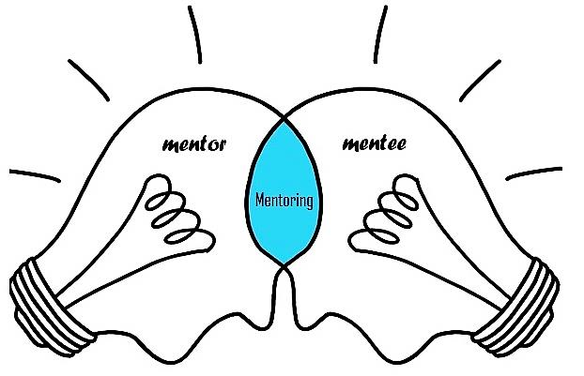

Ensure that mentoring is done with the context of an ongoing, caring relationship with your mentor.

As a beginning teacher, be open to peer support and guidance to help ensure your success.

Collaborate with your mentor in defining and developing effective instructional practices and classroom management techniques.

Be committed to teacher support and be willing to devote the time needed (minimum of 20 hours) to working with your mentor.

Have effective interpersonal skills.

Maintain confidentiality and trust.

- Stay on track with your mentor and complete the required hours (10) by mid-year check and (20) by end of the year.

- Ensure you initial the time log after each time you meet with your mentor.

- Conduct (3) observations by mentor of mentee & (1) observation by mentee of mentor.

_______________________ __________ _____________________
Mentee Signature Date School

_______________________
Mentee Name - printed

