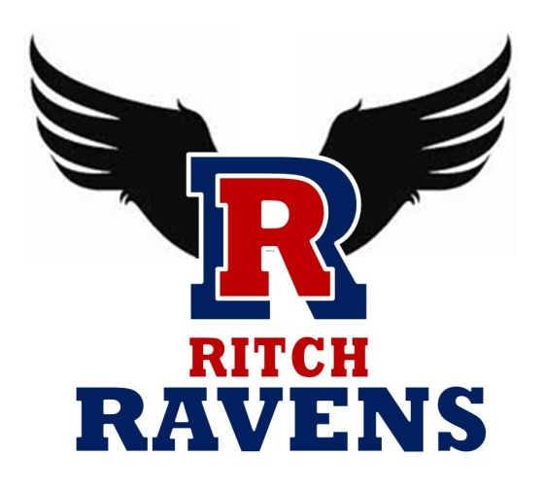
P.B. Ritch Middle School
Local School Council Meeting Minutes
February 1, 2024

Inv | Att | Name
Council Members
X | X | Christine M. Carson – Principal
X |  | Donitra Smith – Chairperson
 |  | TBD – Vice Chairperson
X | X | Aimee Buchanan – Secretary
X | X | Dennis Casey
X | X | Scot Gutierrez
X | X | Tamika McNeal (w/daughter Kendall)
Other

1. 2023-2024 School Improvement Initiatives
- School Improvement Plan at a Glance (Handout provided)
- RMS showed tremendous gains on the District Math Growth Measure compared to all PCSD Middle Schools (6th grade – 1st place, 7th grade – 4th place, 8th grade – 2nd place)

2. Parent & Community Information Night on February 12, 2024 at 6-8pm
- District event for all PCSD middle schools hosted at PBR with sessions on various topics. (Handout provided)
- Childcare for K-5th grade will be provided in the gym with procedures for check-in and check-out

3. 2023-2024 RMS Calendar
- Remaining events listed for the year:
  - 2/1 Family Fun Night at 6:30pm
  - 4/11 Raven Ensembles Performance/PTSA at 6:30pm
  - 4/16 STEM/Curriculum Night at 6:30pm-8:00pm
  - 5/7 Chorus Concert at 6:30pm
  - 5/9 Band Concert at 6:30pm

4. Comments/Notes
- Alanna Bowie has moved. The position of Vice Chairperson is open.
- 8th Grader Sumaya Bell, District Spelling Bee Champion for 2024. Previously 2023 District Spelling Bee Champion as a 7th Grader. Will be competing at Region 1 Championship on February 24th.
- PBR has benefited as a Title Support (not Title I) school with smaller class sizes in math.
- Role of the School Council (Handout provided)
  - Quarter vs. Semester Grades provided by printout to parents?
  - Topics we would like to address in future meetings? Example of previous issue discussed was uniforms.
- Dr. Carson to address addition of naming conventions to standardize use in CANVAS
- Future meeting/invitation possible to see classrooms including Ms. Nunn’s (PBR TOY) special ed. Ms. Nunn is in the running for GaDOE’s Teacher of the Year.

5. Future Agenda Items
- TBD

Next Meeting Time & Location:
Thursday March 14, 2024 at 4:00pm

Please send corrections, additions, questions via e-mail to lovethebunnies@gmail.com.

