Name__________________________________________________________Date__________Per._____
Math 7 Unit 1 Study Guide
- How do you know if the sum of two rational numbers will be positive or negative?
- Give an example of a real life problem involving negative numbers.
- What is absolute value? Show it on a number line. Give an example of an absolute value problem.
- (-9) – (-5) =
- (-5)(-2)(6) =
- (-48) ÷ (12) =
- $-\frac{1}{4} ÷\frac{2}{3}$ =
- (-14) – (7)
- (-5)(6 - 9)
- $-\frac{5}{16}-(-\frac{3}{8}$)
- $\frac{5}{6} ÷-3$
- If x represents a negative number is x² positive or negative?
- If x represents a negative number, is x ∙ x ∙ x ∙ x a positive or negative number?
- A hot air balloon 450 feet above the ground descends 100 feet before ascending another 275 feet. Describe the location of the hot air balloon.

- Find two integers with a product of -30 and sum of -1.
- The temperature at 8 am was 15°F. The temperature dropped 3 degrees per hour for the next 6 hours. What was the temperature at 2 pm?

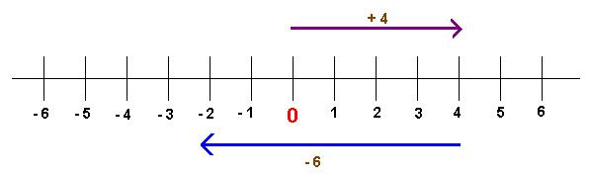
- Which expression is represented by the model below?

- Which expression is represented by the model below?
Key

= -1

= 1

- Write a number expression and solve: One half of negative five eighths
  - $\frac{1}{2}$ b. - $\frac{5}{8}$ c. $-\frac{5 }{16}$ d.$\frac{3}{8}$
- You want to buy an I pad but you don’t have enough money for it. Best Buy lists the Ipad 2 for $399. You have $75 in your savings account and get another $100 as a birthday gift from your parents. You babysat the neighbor’s kids last night for 5 hours at $6.50 an hour plus a tip of $4. You a find a job walking dogs for $25 a week. How many weeks will it take for you to have enough money to buy the I pad?

