Name: __________________________ Vocabulary Choice Board Due Tuesday, September 13th.
You will choose 3 options -one of which must be the middle.
*You cannot use the same words for your 2nd and 3rd choices.
Create a “meme” for 10 words that helps explain what the word means.    Be sure to include the term with each. | 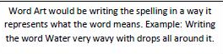  Make Frayer Models for at least 10 vocabulary words. 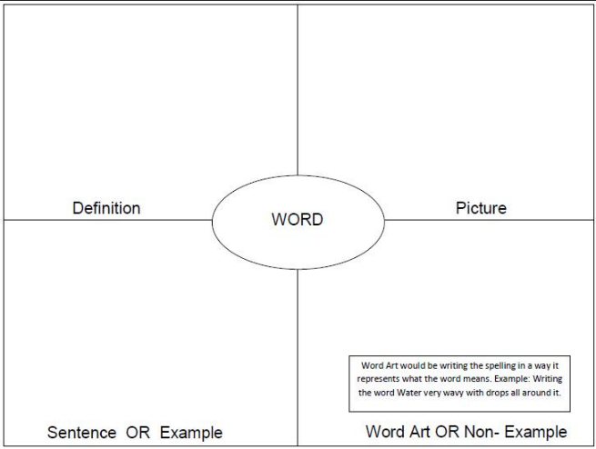 | Make a song that includes at least 5 vocabulary words. The song should be at least 1 minute long when sung.
Comic Strip  You can draw one comic strip that uses at least 5 of the words or create a separate strip for each word.  (www.makebeliefscomix.com) | Required Vocabulary Activity  Create Flash Cards for all vocabulary.  This can be handwritten on index cards or made on quizlet. | Make a booklet of at least 10 words and their meaning using your own drawing.
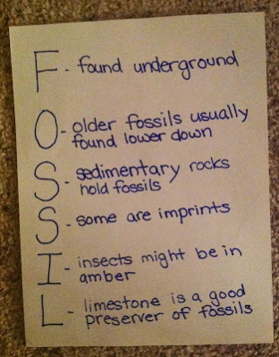  Make an acrostic for at least 5 of your vocabulary words. The words you choose for each letter should be related to the word written downward. | Using at least 15 of your vocabulary words, create a crossword puzzle. Be creative in the clues that you use. Do not always use the definition for that clue. | Use at least 5 of your vocabulary words in a children’s story with illustrations. The story must explain the words in a way that a second grader could understand.
* You must choose at least one of the corners.
Ecology Vocabulary Words
1. Biosphere
2. Carnivore
3. Carrying Capacity
4. Pioneer Species
5. Commensalism
6. Community
7. Competition
8. Consumer
9. Decomposer
10. Ecology
11. Ecosystem
12. Immigration
13. Energy Pyramid
14. Food Chain
15. Food Web-
16. Habitat
17. Herbivore
18. Host
19. Limiting Factor
20. Mutualism
21. Niche
22. Primary Succession
23. Omnivore
24. Parasite
25. Parasitism
26. Population
27. Emigration
28. Predation
29. Predator
30. Prey
31. Producer
32. Species
33. Symbiosis
34. Secondary Succession

