Name ________________________ Date _______________
Energy Flow in Ecosystems PPT Notes

True or False. Each organism has a role in the movement of energy through its ecosystem. _________: Although each organism’s role is different, all parts of the ecosystem are necessary for the ecosystem to work.
An organism’s energy role is determined by how it obtains energy and how it interacts with other organisms within the ecosystem. The energy roles within an ecosystem are _____________________, consumer, and __________________________.

Producers are organisms that _______________ their own ________ by using the sun’s energy to turn water and carbon dioxide into food through a process called ____________________________. Producers are the source of all the __________________ in an ecosystem. Examples of produces are plants, ___________________, and some bacteria.
- Energy enters most ecosystems as ______________________, but the rest enters the ecosystem through _________________.

Consumers are organisms that obtain energy by _________________ on other organisms.
- Herbivores eat __________ ____________________.
- Carnivores eat __________ ____________________.
- Omnivores eat both ____________ and __________________.
- Scavengers eat ____________________ organisms.

Decomposers are organisms that break down ___________________ and other dead organisms. The two major groups of decomposers are _________________________ and __________________________.
- Decomposers return raw materials to the _________________.

Food Chains & Food Webs
A series of events in which one ____________ eats another and obtains raw __________ is called a food ______.
The many overlapping food chains in an ecosystem make up a ____________ ______.

Energy Pyramids

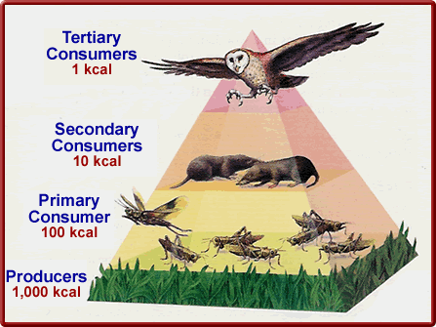
As you move up the energy pyramid, each level has ________ energy available than the ______________ _________. Energy pyramids show… The amount of energy that moves from one feeding level to another in a _______ ____.
Food Webs
___________________ form the base of the food web. First-level _____________________ feed on the producers, and the movement of energy is from the _____________ to the first-level ______________. Second-level consumers feed on the first-level consumers, and the _________________ of ____________ is from the first-level to the second-level consumers; they may be __________________ or _________________. Note: An organism may play more than one role in a food web.
Example:
Grass is a __________________.
A mouse is a ____________________ consumer.
A kestrel is a ___________________ consumer.
If the kestrel died, and a buzzard was eating the kestrel, then the buzzard would be a ___________________.

True or False: Most food webs only have three or four feeding levels.

Why are there usually few organisms at the top of a food web?
…because there is a limited amount of ______________ ___________________ at that level of a food web.

Succession and Changes in Ecosystems

Video Questions:
1. What are the two different types of succession? ________________
2. How have organisms become dependent upon frequent changes in their ecological environments? _______________________________
- Changes in Communities
  - ______________ _____________ – a series of changes that occur in an area where NO ______ or _______________ exist.
    - In a barren area, a new community is established with ___________ ___________ (first species in the area), like mosses, that do well with little or no soil.

  - ______________ Succession – a series of changes that occur in an area where the ecosystem has been _______________.
    - When a disturbance (_______, ____________, _________________, or _________________) damages a community but soil ____________, the community gets reestablished from seeds and roots left behind. Grasses grow then small shrubs, and eventually trees.

Complete the following chart:
Factors in Succession | Primary (1°) Succession | Secondary (2°) Succession
Possible Cause(s) | - Volcanic ______________  - _____________ retreating | - Fire  - ______________  - Tornados  - ______________
Type of Area | Barren: _______ soil or  ______________ exist | An area where ________ and organisms existed but have been  __________________.
Existing Ecosystem?

Results of changes to the ecosystem:
- Threatened Species – species that could become ________________________ in the near future.
- Endangered species – species in danger of becoming _________________ in the near future.
- Extinction – the ___________________________ of all members of a species from Earth.
How Changes Impact the Food Web

Use the QR code below to research how food
webs are affected by changes in ecosystems.
Click on Problems and choose some of the topics listed.

After your research, choose one problem to answer the following:

- Summarize the problem.
________________________________________________________________________________________________________________________________________________________________________________________________________________________________________________
- Which organisms are most immediately effected by the problem?
________________________________________________
- What is the long term effect on a food web in that ecosystem?
________________________________________________________________________________________________
- Should humans intervene in the problem or should we let nature take its own course? Defend your reasoning.
________________________________________________________________________________________________________________________________________________________________________________________________________________________________________________________________________________________________________________________________________________
________________________________________________
- If humans were to intervene, what specific steps could we take to limit the future impact or reverse the problem?
________________________________________________________________________________________________________________________________________________________________________________________________________________________________________________

