1. A diver dives 32 feet below the surface, then dives down 13 more feet. Where is she now?
2. Find the sum. -23 - (-12.5)
3. -⁵/₈ + ²/₃
4.Simplify. 7 - (-5)2
5. Is the answer going to be positive or negative? -6 ¹/₂ - 6¹/₂
6. A hiker is 42.5 ft below sea level. A plane is 2030 ft above sea level. How far apart are they?
7. It costs $0.73 to make a brownie. I sell them for $1.50 each. What is my profit?
8. 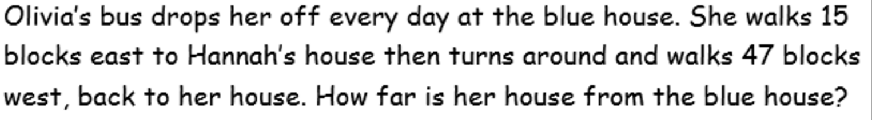
9. -1 ¹/₆ (-2 ²/₅)
10. Simplify. (-1)²
11. Simplify. [-7.6 + (-4.2) – (-12 ½)] (-1.1)
12. -125 ÷ (-40)
13. -2¹/₅ ÷ ⁵/₁₁
14. Use the distributive property to rewrite the expression. 8 ½ (-4 + x)
15. Simplify: 8 (2 - 3m) - 5 (4m + 10)
16. The water level rose 1¼ inches over a 2¼ week period. What was its weekly average change?
17. Simplify. 5 - 3 [9 + (-12)]
15. Use the distributive property to rewrite the expression. 8 ½ (-4 + x)
16. Simplify. 8 (2 - 3m) - 5 (4m + 10)
17. The water level rose 1¼ inches over a 2¼ week period. What was its weekly average change?
18. Simplify. 5 - 3 [9 + (-12)]

